
Al-Muyassar: Journal of Arabic Education
Vol. 3, No. 1, Juli 2024, pp. XX–XX
E-ISSN 2829-095X
Article Submitted - ■ Revised - ■ Accepted -

MAKE AN ARABIC LANGUAGE QUIZ USING THE KAHOOT APPLICATION
Samsul Ma’arif^{1*}, Ahmad Sirojudin ², Siti Shalihah³ Yuyun Rohmatul Uyuni ⁴
¹ University Islamic Center Sultan Maulana Hasanuddin, Banten
² University Islamic Center Sultan Maulana Hasanuddin, Banten
³ University Islamic Center Sultan Maulana Hasanuddin, Banten
⁴ University Islamic Center Sultan Maulana Hasanuddin, Banten
E-mail: 232622109.samsul@uinbanten.ac.id
E-mail: 232622103.ahmad@uinbanten.ac.id
E-mail: siti.shalihah@uinbanten.ac.id
E-mail: yuyun.rohmatul@uinbanten.ac.id

Abstract
The Kahoot application is a game-based learning platform that is used as educational technology in schools and other educational institutions. The platform allows users, including students and teachers, to create and take interactive learning quizzes called "Kahoots". Kahoot is a multiple choice quiz that can be accessed via a web browser or the Kahoot app. With Kahoot, users can create fun and interactive learning experiences.
This research uses a qualitative research approach where qualitative research as a scientific method is often used and carried out by a group of researchers in the field of social sciences, including educational sciences. A number of reasons were also put forward, the essence of which is that qualitative research enriches the results of quantitative research. Qualitative research is carried out to build knowledge through understanding and discovery.
Kahoot allows you to create interactive quizzes that can help participants learn Arabic in a fun and interesting way, and Arabic Quiz can be used as a tool to test participants' understanding of the material that has been taught, thereby helping identify areas that need improvement. To reduce the negative impact of using technology, there are also fights between students in the world of education. This can support the learning process by utilizing technological sophistication. This advantage is not only found in the speed factor of obtaining information but also in facilities that can make learning more interesting, such as visuals and interactive
Keywords: kahoot, Arabic lamguage, and education.

Citation:
Faedurrohman & Hakim, L. (2023). “Article Title”. Al-Muyassar: Journal of Arabic Education, 2 (2): p– p.
Copyright (c) 2023: Al-Muyassar: Journal of Arabic Education
This work is licensed under a Creative Commons Attribution-ShareAlike 4.0.
1. Introduction.
In this internet era, studying no longer needs to be boring. Kahoot already exists as an interactive game-based platform so that the learning process in class can be more fun. Not only as a learning tool, Kahoot is also suitable for holding trivia quizzes when hanging out with friends or just to fill your free time.
The Kahoot application is a game-based learning platform that is used as educational technology in schools and other educational institutions. The platform allows users, including students and teachers, to create and take interactive learning quizzes called "Kahoots". Kahoot is a multiple choice quiz that can be accessed via a web browser or the Kahoot app. With Kahoot, users can create fun and interactive learning experiences.
In the era of globalization, progress in science and technology is growing rapidly. Almost everyone from young people to old people already have gadgets, laptops or tablets. There are many things that can be utilized by revolutions or major developments in this life. Technological progress also has a good impact. for the world of education today.
To reduce the negative impact of using technology, there are also fights between students in the world of education. This can support the learning process by utilizing technological sophistication. This advantage is not only found in the speed factor of obtaining information but also in facilities that can make learning more interesting, such as visual and interactive..
According to Purwadi in Zainiyati, learning media is an element that teachers must pay attention to when designing a learning process. Therefore, there is a need for dynamics in learning that are able to follow each student's development. Like using application-based interactive learning media (kahoot).
The Kahoot application is an application designed like a game in general, but this application can be used as a learning medium. In the teaching and learning process teachers must be able to invite students to listen, present media for students, provide opportunities to write and convey students' opinions so that creative dialogue occurs. It cannot be denied that the use of learning media really helps teaching and learning activities in the classroom.
Sometimes educators want to choose the minimum possible load in the teaching and learning process. This was proven by Assyidiq, in the results of his research, it was found that the problem with students not liking Islamic religious education lessons was that teachers provided material in a monotonous manner so that students were less able to absorb the learning well. This is very popular among the world of education. Technological advances that have an impact on the development of learning media cannot be avoided. All students must have gadgets and then bring their gadgets to school and use them during the learning process.
Therefore, to avoid using gadgets that have a negative impact, teachers as facilitators must guide students to utilize and empower existing facilities for personal change for the better. Like making the Kahoot application an interactive learning medium.
The advantages of the Kahoot application in the evaluation process include that the evaluation results are immediately neatly organized, this makes the assessment process more efficient and practical. Apart from that, this application gives teachers the freedom to set a time limit for working on each question so that the teacher can set the working time according to the level of difficulty of each question. This application presents questions in a new, more exciting atmosphere equipped with music, color variants and attractive images so that the psychology of children who take part in the evaluation process is more relaxed..
The evaluation through Kahoot is carried out simultaneously, thereby reducing student cheating, especially in the application of each question and the answer options can be arranged randomly between one student and another. And also student rankings and scores can be immediately seen and recapitulated by the system. According to Nugroho, the Kahoot application makes students play an active and enthusiastic role in participating in the evaluation process.
2. Research Method.
This research uses a qualitative research approach where qualitative research as a scientific method is often used and carried out by a group of researchers in the field of social sciences, including educational sciences. A number of reasons were also put forward, the essence of which is that qualitative research enriches the results of quantitative research. Qualitative research is carried out to build knowledge through understanding and discovery. The qualitative research approach is a research and understanding process based on methods that investigate social phenomena and human problems.
In this research, researchers create a complex picture, examine words, detailed reports from respondents' views and conduct studies in natural situations. Qualitative research is carried out in natural conditions and is discovery in nature. In qualitative research, the researcher is the key instrument. Therefore, researchers must have theoretical knowledge and broad insight so they can ask questions, analyze and construct the objects being studied more clearly. This research places more emphasis on meaning and value. In this research, researchers create a complex picture, examine words, detailed reports from respondents' views and conduct studies in natural situations. Qualitative research is carried out in natural conditions and is discovery in nature. In qualitative research, the researcher is the key instrument. Therefore, researchers must have theoretical knowledge and broad insight so they can ask questions, analyze and construct the objects being studied more clearly. This research places more emphasis on meaning and value.
Qualitative research where the researcher's role is as a key instrument in collecting data and interpreting data. Data collection tools usually use direct observation, interviews, document studies. While the validity and reliability of data uses triangulation using inductive methods, the results of qualitative research emphasize meaning rather than generalization.
Qualitative research is used if the problem is not yet clear, to find out hidden meanings, to understand social interactions, to develop theories, to ensure the correctness of data and to research historical developments. Bearing in mind that this research aims to understand and interpret various phenomena that exist or occur in reality as a characteristic of qualitative research, in this case how the Kahoot media attempts to improve Arabic in students in class V of Madrasah Ibidaiyah Al-Uyun, the researcher used the method descriptive qualitative research. Apart from that, as stated by Moleong, qualitative methods are carried out with several considerations, firstly, adapting qualitative methods is easier when dealing with multiple realities; second, this method presents a direct relationship between researchers and respondents; third, this method is more sensitive and more adaptable to many sharpening collective influences and to the value patterns encountered.
Bogdan and Taylor explained that qualitative research methodology is a research procedure that produces descriptive data in the form of written or spoken words from people and observable behavior. In qualitative research, a researcher speaks directly and observes several people, and interacts for several months to study the background, habits, behavior and physical and mental characteristics of the people being studied.
Bogdan and Biklen stated that the characteristics of qualitative research are:
1) natural
2) the data is descriptive, not numbers
3) inductive data analysis
4) meaning is very important in qualitative research.
Research on Kahoot Media Efforts to Improve the Arabic Language of Students in Class V of Madrasah Ibtidaiyah Al-Uyun, is relevant to using qualitative research because it fulfills the characteristics of qualitative research, especially in terms of disclosing data in depth through interviews, observation, documentation and data collection.
3. Discussion.
. Learning media is an integral component of the learning system, meaning that learning media cannot be separated from the learning process because without learning media the teaching and learning process cannot occur and there are no good learning outcomes. kahoot is an interactive learning platform that can be used by teachers to improve student learning outcomes.
Media Quizizz's efforts to improve learning outcomes at Madrasah Ibtidaiyah Al-Uyun include the following:
a) Interactivity and Student Involvement
Quizizz allows students to participate in interactive quizzes in real-time. This makes learning more fun and interesting, so students are more motivated to learn and participate actively in class activities.
On December 18 2023, researchers found and saw that the majority of MI Al-Uyun students were very enthusiastic and more active in learning the Aqidah Akhlak subject. The sound of laughter, smiles and focus accompanies them, making things more conducive and running smoothly. Some of them also feel comfortable and exciting when quizizz is given to them.
I also conducted several interviews with several students, homeroom teachers and the principal of MI al-Uyun. "Sis, we'll study again later, it's really exciting," said one of the fifth grade students who had taken part in teaching and learning activities through quiziz media. Several questions were asked by the researcher to one of the Madrasah Ibtidaiyah Al-Uyun teachers, especially regarding Quizizz media learning which is applied at Madrasah Al-Uyun.
According to Ustadz Mansyur Rosyadi, as Principal of Madrasah Al-Uyun, "kahoot media is a platform that is quite effective in learning at Madrasah Al-Uyun, especially in the subject of aqidah, morals, so that students and students can easily absorb what is taught by the teachers. here, however, there are several obstacles, especially in learning facilities and media such as Infocus and Infocus stands, which we don't have yet, so when we want to hold a learning model like this we can't do it routinely and often, but I hope that next semester we have it... amen”
According to Ustadzah Lia Indriyani, the homeroom teacher of class V MI Al-Uyun, stated that the students were very interested in the method brought by the researchers, namely the platform-based quizizz media which displays several time-limited questions so as to enable the students to be more focused and reactive in answering questions displayed by the Kahoot media platform.
a) Game Based Learning
Quizizz uses a game-based learning approach that makes students feel like they are playing while learning. With game elements such as points, leaderboards and virtual prizes, students become more motivated to achieve the best results.
In implementing Quiziz media learning, the researcher gave paper containing barqouts which were then distributed to each student and answered each question displayed on the projector by rotating the barqout paper.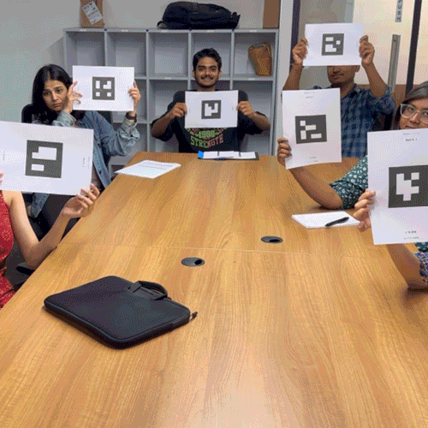
In the picture above, several people can be seen showing their barqout paper, so that a teacher can immediately correct the answer by typing the barqout via a teacher's/teacher's cellphone which has been set up and connected according to the questions and answers displayed on the infocus to students and students..
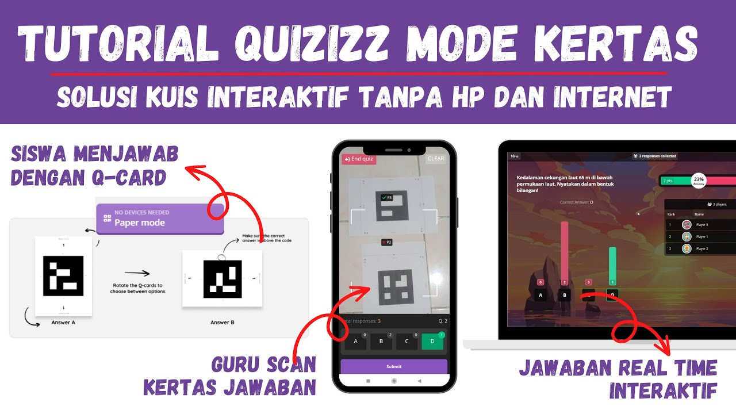
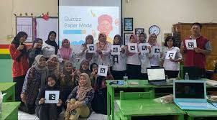
a) Immediate Feedback
When students answer questions on Quizizz, they get immediate feedback on their answers. This helps students understand their mistakes and learn from them immediately, improving their understanding of the course material.
Several students and students at MI Al-Uyun felt that they had fun answering every question presented by the researcher. It was proven that some of them were very enthusiastic about learning moral aqidah using the quizizz method so that the material presented was easy for students and students to understand, especially class V MI Al-Uyun. Come on.
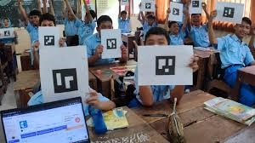
Gambar mengenai suasana dan antusias siswa di kelas.
There is one KMI class V student who has great difficulty in understanding the subject of moral aqidah, but when using the kahoot method it becomes easier to understand and memorize these subjects, especially in the lesson of moral aqidah.
a) Analysis of Learning Results
Kahoot provides detailed quiz results reports and analysis, which can be used by teachers to evaluate students' understanding of the material being taught. Teachers can identify topics that are still difficult for students and pay more attention to these topics.
Reporting and data collection on learning outcomes through Quizzizz media is very easy and is saved automatically in the platform itself, making it easier for researchers and teachers to calculate grades and determine final results and neatly arranged from the smallest value to the largest value..
In this case, the researcher simply opened and looked at the Kahoot platform application to see the answers and grades of the students, from the highest to the lowest. It was even very helpful in collecting data on students who had great difficulty understanding the lesson..
4. Conclusion.
This tutorial has explained how to create a game on Kahoot!, how to become a host, and also how to answer it as a player. Not difficult, right? Kahoot! It is indeed a platform that is suitable in all situations, whether in the professional realm or as an activity at a party.
There is another little trick that will be useful for you. If you want to play it remotely, you just need to use the screensharing feature on Zoom or Google Meet. In this way, Kahoot! It can also be used in groups even without meeting physically.
5. Acknowledgement (optional)
Kahoot can be accessed anytime and anywhere, so students can learn flexibly according to their convenience. This allows students to review material and practice quizzes outside of class time, thereby improving their learning outcomes
6. References.
Abdillah, Rahman, Adhityo Kuncoro, Fajar Erlangga, and Vickry Ramdhan. “Pemanfaatan Aplikasi Kahoot! Dan Quizizz Sebagai Media Pembelajaran Interaktif Berbasis Gamifikasi.” Jurnal Pendidikan Sains dan Komputer 2, no. 01 (2022): 92–102.
Daryanes, Febblina, Diah Anugrah Dipuja, and Fitra Suzanti. “MELALUI PENGGUNAAN APLIKASI KAHOOT DAN QUIZIZZ BAGI A . LATAR BELAKANG Berpengaruh Pada Semua Sektor Kehidupan . Sektor Kesehatan , Ekonomi , Dalam Situasi Saat Ini . Sejak Merebaknya Kasus Covid-19 Di Indonesia Pada Bulan Maret 2020 , Pemerintah Indonesi.” JMM (Jurnal Masyarakat Mandiri) 6, no. 2 (2022): 1–3.
Febriani Chandra, Maya, and Nofri Yuhelman. “Literatur Review : Pengembanganmedia Kahootsebagai Media Pembelajaran Siswa.” JIPMuktj:Jurnal Ilmu Pendidikan Muhammadiyah Kramat Jati 4, no. 1 (2023): 42–46. https://jurnal.pcmkramatjati.or.id/index.php/JIPMUKJT/index.
Ginting, J M, and R K Mahfudin. “Pelatihan Penggunaan Aplikasi Quizizz Dan Kahoot Serta Penyuluhan Vaksinasi Covid-19.” journal Elektronik 3, no. 1 (2021): 312–316. https://journal.uib.ac.id/index.php/nacospro/article/view/5950.
Mohammad, Marwah Mariam, and Prima Mutia Sari. “Efektivitas Kuis Interaktif Aplikasi Kahoot Dalam Pembelajaran IPA Di Sekolah Dasar.” Jurnal Educatio 7, no. 3 (2021): 1194–1198.
Setiawan, Agung, Sri Wigati, and Dwi Sulistyaningsih. “Implementasi Media Game Edukasi Quizizz Untuk Meningkatkan Hasil Belajar Matematika Materi Sistem Persamaan Linear Tiga Variabel Kelas X Ipa 7 Sma Negeri 15 Semarang Tahun Pelajaran 2019 / 2020.” Edusainstek (2019): 167–173. http://prosiding.unimus.ac.id.
Suharsono, Agus. “Penggunaan Aplikasi Quizizz Dalam Pelatihan Dasar Cpns.” Paedagoria: Jurnal Kajian, Penelitian dan Pengembangan Kependidikan 11 (2020): 60–66. http://journal.ummat.ac.id/index.php/paedagoria.
Syafiyatul, Mafruhah, Ika Ratih Sulistiani, and Fita Mustafida.
l-Jannah, Mutia, Mutmainnah Mutia Kahar, Hilmi Hambali, and Hasan Hasan. “Persepsi Siswa Terhadap Penggunaan Aplikasi Quizizz Sebagai Media Pembelajaran Pada Mata Pelajaran Bahasa Inggris.” Guru Pencerah Semesta 1, no. 2 (2023): 193–202.
Al-Khalafi, Abdul Azim Bin Badawi. Al-Wajiz Ensiklopedi Fiqih Dalam Al-Qur‟an As-Sunnah As-Shahih. jakarta: Pustaka As-Sunnah, 2006.
Al-Zuhayli, Wahbah. Al-Fiqh Al-Islami Wa Adillatuh. damaskus: Dar al Fikr, 2004.
Bunyamin. Belajar Dan Pembelajaran. UPT UHAMKA Press, 2021.
Daryanes, Febblina, Diah Anugrah Dipuja, and Fitra Suzanti. “MELALUI PENGGUNAAN APLIKASI KAHOOT DAN QUIZIZZ BAGI A . LATAR BELAKANG Berpengaruh Pada Semua Sektor Kehidupan . Sektor Kesehatan , Ekonomi , Dalam Situasi Saat Ini . Sejak Merebaknya Kasus Covid-19 Di Indonesia Pada Bulan Maret 2020 , Pemerintah Indonesi.” JMM (Jurnal Masyarakat Mandiri) 6, no. 2 (2022): 1–3.
Djamaluddin, Ahdar, and Wardana. Belajar Dan Pembelajaran. CV Kaaffah Learning Center, 2019.
Drs. Harun, MH. Fikih Muamalah. Surakarta: Muhammadiyah University Press, 2017.
Fauzi, Ahmad, and dkk. Metodologi Penelitian. Suparyanto Dan Rosad (2015, 2022.
hasil Observasi dan Wawancara. Bersama Kepala Sekolah MI Al-Uyun. Cirende, Rangkasbitung, 2024.
———. Bersama Wali Kelas. Cirende, Rangkasbitung, 2024.
———. Wawancara Dengan Siswa. Cirende, Rangkasbitung, 2024.
Hidayat, Muhammad Itsnan, and Rahmita Nurul Muthmainnah. “Pengaruh Metode Kuis Berbantuan Quizizz.” Prosiding Seminar Nasional Penelitian LPPM UMJ (2020): 1–4.
Martini, Nawawi dan. Metode Penelitian, 2010.
Ngatno. “BUKU AJAR METODOLOGI PENELITIAN.Pdf,” 2015.
Nuramanah, Syifa Agestrisna, Cecep Darul Iwan, and Selamet Selamet. “Pengaruh Penggunaan Aplikasi Quizizz Terhadap Efektivitas Pembelajaran Pendidikan Agama Islam.” Bestari | Jurnal Studi Pendidikan Islam 17, no. 1 (2020): 117.
Nurdin, I., dan Hartati Sri. METODOLOGI PENELITIAN SOSIAL. Media Sahabat Cendikia, 2019.
Nurliana, Ega, and Oktian Fajar Nugroho. “Analisis Hasil Belajar Dalam Penggunaan Quizizz Pada Pembelajaran IPA” (2021): 15–17.
Pagarra H & Syawaludin, dkk. Media Pembelajaran. Badan Penerbit UNM, 2022.
Prof.Dr.Sri Adningsih, S.E., M.Sc. Transformasi Ekonomi Berbasis Digital Di Indonesia. jakarta: PT Gramedia Pustaka Utama, 2019.
Rajab, Abd. “Pemanfaatan Aplikasi Quizizz Sebagai Media Pembelajaran Untuk Meningkatkan Minat Belajar Pada Siswa SMP Negeri 1 Takalar” (2020): 1.
Ramadhani, Khori Putri, and Havid Ardi. “Penggunaan Aplikasi Quizizz Sebagai Media Pembelajaran Dan Asesmen Pada Materi Bahasa Inggris.” Abdi Humaniora 3, no. 1 (2022): 2022.
Salsabila, Unik Hanifah, Iefone Shiflana Habiba, Isti Lailatul Amanah, Nur Asih Istiqomah, and Salsabila Difany. “Pemanfaatan Aplikasi Quizizz Sebagai Media Pembelajaran Ditengah Pandemi Pada Siswa SMA.” Jurnal Ilmiah Ilmu Terapan Universitas Jambi|JIITUJ| 4, no. 2 (2020): 163–173.
Sartika, Septi Budi. Buku Ajar Belajar Dan Pembelajaran. Buku Ajar Belajar Dan Pembelajaran, 2022.

J M Ginting and R K Mahfudin, “Pelatihan Penggunaan Aplikasi Quizizz Dan Kahoot Serta Penyuluhan Vaksinasi Covid-19,” journal Elektronik 3, no. 1 (2021): 312–316, https://journal.uib.ac.id/index.php/nacospro/article/view/5950.
Muhammad Aditya Wisnu Wardana, Kundharu Saddhono, and Ani Rakhmawati, “Peningkatan Pemerolehan Dan Pembelajaran Bahasa Pada Siswa Disleksia Melalui Metode Team Games Tournament Dengan Menggunakan Media Pembelajaran Berbasis Quizizz,” JDMP (Jurnal Dinamika Manajemen Pendidikan) 7, no. 1 (2022): 71–82.
Maya Febriani Chandra and Nofri Yuhelman, “Literatur Review : Pengembanganmedia Kahootsebagai Media Pembelajaran Siswa,” JIPMuktj:Jurnal Ilmu Pendidikan Muhammadiyah Kramat Jati 4, no. 1 (2023): 42–46, https://jurnal.pcmkramatjati.or.id/index.php/JIPMUKJT/index.
Febblina Daryanes, Diah Anugrah Dipuja, and Fitra Suzanti, “MELALUI PENGGUNAAN APLIKASI KAHOOT DAN QUIZIZZ BAGI A . LATAR BELAKANG Berpengaruh Pada Semua Sektor Kehidupan . Sektor Kesehatan , Ekonomi , Dalam Situasi Saat Ini . Sejak Merebaknya Kasus Covid-19 Di Indonesia Pada Bulan Maret 2020 , Pemerintah Indonesi,” JMM (Jurnal Masyarakat Mandiri) 6, no. 2 (2022): 1–3.
Ginting and Mahfudin, “Pelatihan Penggunaan Aplikasi Quizizz Dan Kahoot Serta Penyuluhan Vaksinasi Covid-19.”
Agus Suharsono, “Penggunaan Aplikasi Quizizz Dalam Pelatihan Dasar Cpns,” Paedagoria: Jurnal Kajian, Penelitian dan Pengembangan Kependidikan 11 (2020): 60–66, http://journal.ummat.ac.id/index.php/paedagoria.
Rahman Abdillah et al., “Pemanfaatan Aplikasi Kahoot! Dan Quizizz Sebagai Media Pembelajaran Interaktif Berbasis Gamifikasi,” Jurnal Pendidikan Sains dan Komputer 2, no. 01 (2022): 92–102.
Mafruhah Syafiyatul, Ika Ratih Sulistiani, and Fita Mustafida, “VICRATINA : Jurnal Pendidikan Islam Volume 4 Nomor 2 Tahun 2019,” Vicratina 4, no. 1 (2019): 65–71.
Daryanes, Dipuja, and Suzanti, “MELALUI PENGGUNAAN APLIKASI KAHOOT DAN QUIZIZZ BAGI A . LATAR BELAKANG Berpengaruh Pada Semua Sektor Kehidupan . Sektor Kesehatan , Ekonomi , Dalam Situasi Saat Ini . Sejak Merebaknya Kasus Covid-19 Di Indonesia Pada Bulan Maret 2020 , Pemerintah Indonesi.”
Wardana, Saddhono, and Rakhmawati, “Peningkatan Pemerolehan Dan Pembelajaran Bahasa Pada Siswa Disleksia Melalui Metode Team Games Tournament Dengan Menggunakan Media Pembelajaran Berbasis Quizizz.”
Ahmad Fauzi, Metodologi Penelitian, Suparyanto Dan Rosad (media pustaka, Jakarta 2022). Hal. 47
Sugiono, “Metode Penelitian Pendidikan.” ( Media Cipta, Jakarta 2019) hal. 46
M. Andi Setiawan, “Belajar Dan Pembelajaran,” Uwais Inspirasi Indonesia 3, no. 2 (2017) hal. 199.
Sugiono, “Metode Penelitian Pendidikan.” (Media Cipta, Jakarta 2019) hal. 33
Upi Sarbini, Hasil Pengamatan Dan Observasi Peneliti (MI AL-UYUN, 2024).
hasil Observasi dan Wawancara, Wawancara Dengan Siswa (Cirende, Rangkasbitung, 2024).
hasil Observasi dan Wawancara, Bersama Kepala Sekolah MI Al-Uyun.
hasil Observasi dan Wawancara, Bersama Wali Kelas.
hasil peneliti, Hasil Pengamatan Dan Observasi Peneliti.
hasil penelti, Hasil Pengamatan Dan Observasi Peneliti.
Zainiyati, “Model Dan Strategi Pembelajaran Aktif (Teori Dan Praktek Dalam Pembelajaran Pendidikan Agama Islam).” ( Gramedia Press, 2019) hal. 61

