IMPLEMENTATION OF ENTREPRENEUR KIDS PROGRAM WITH TRADISIONAL GRESIK SNACKS (PUDAK) IN DEVELOPING EARLY CHILDHOOD’S SOCIAL-EMOTIONAL

Ubaidillah¹, Indi Muti’atul Chasana², Nur Albania Arisanti³, Nahdhiyatul Fitri Lisanda⁴, Nur Hidayatul Ilmiyah⁵
^{1,2,3,4,5} Institut Agama Islam Daruttaqwa, Gresik, Indonesia
e-mail: *¹ubaidillah@insida.ac.id, ²indychasanah2@gmail.com., ³albaniaarisanti23@gmail.com., ⁴nahdhiyadhiya27@gmail.com., ⁵nurhidayatulilmiyah0709@gmail.com

ARTICLE INFO
Article history:
Accepted:
Revised:
Published:
Keywords:
Entrepreneur Program; Traditional Snacks; Social Emotional.
DOI http://dx.doi.org/10.31000/ceria.v_i_.____

ABSTRACT
This study aims to describe: Implementation of the Entrepreneur Kids Program with Gresik Traditional Snacks (Pudak) to Develop Social Emotional Skills in Early Childhood. This type of research is qualitative research with a descriptive method. Data sources come from primary data, which is data received directly by researchers and secondary data is complementary or supporting data related to the research. Data collection techniques are observation, interviews, documentation. Data analysis techniques are data collection, data reduction, data presentation, and drawing conclusions. Data validity testing uses triangulation of sources, techniques and time. The results of this study indicate that entrepreneur kids activities with traditional snacks to develop social emotions in early childhood can increase insight into Gresik local culture, one of which is introducing pudak, as well as gaining experience in learning how to make pudak and developing social emotions in children, especially being able to be responsible for completing activities from start to finish.

Introduction
Multiculturalism is a concept where communities in the context of nationality can recognize diversity, differences, and plurality of culture, race, tribe, ethnicity, and religion. A concept that provides an understanding that a plural and diverse nation is a nation filled with diverse or multicultural cultures. A multicultural nation is a nation whose ethnic or cultural groups can live side by side peacefully in the principle of co-existence which is marked by a willingness to respect other cultures (Ubaidillah, 2018).
The rapid flow of globalization and modernization is feared to erode the sense of love for local culture. The current flow of globalization has had many influences on the development of Indonesian culture. The rapid flow of information and telecommunications has actually created a tendency towards the fading of cultural preservation values. As well as the western style that has now spread widely in Indonesia, especially among the nation's children (Sa’roni, 2019).
The culture that Indonesia has is a national treasure that must continue to be maintained at all times. Local culture must always be maintained to create and strengthen character in the nation's children. In fact, if we know and understand local culture in Indonesia, it is no less interesting than foreign cultures out there. Because, basically in Indonesia there is a lot of cultural diversity and linguistic richness (Durrotun Nafisah, 2020).
There is also the culture in Gresik Regency which is part of the territory of Indonesia. Gresik city is located in East Java province, bordering the city of Surabaya and the Madura Strait, known as a city of santri, the majority of whose people are Muslim. Gresik Regency is a very large area (Finna Rohmawati, 2021).
Some of the people in Gresik consist of various cultures, traditions, tribes and religions. The cultures and traditions in Gresik include: (1) Bandeng Market, Bandeng Market is one of the traditions inherited from Walisongo which is still preserved until now. This tradition was first held by Sunan Giri to improve the local economy. (2) Malam Selawe, One of the traditions in Gresik and has been going on for hundreds of years in the month of Ramadan is Malem Selawe (25th Night of Ramadan). Actually, Malam Selawe is the peak night for pilgrims to come to the Tomb of Sunan Giri, both local pilgrims and pilgrims from outside the city, this is because one of the reasons is to get the blessing of the Night of Lailatul Qadar. Because of the many pilgrims who come, this is used by traders to sell and offer their merchandise. (3) Sedekah Bumi, The tradition of sedekah bumi is one form of traditional ritual of the people on the island of Java which has been carried out for generations. This earth alms ritual is usually carried out by Javanese people who have the potential to be farmers, fishermen who depend on their families and relatives or family members to earn a living by exploiting the natural resources on earth. (4) Pencak Macan Performance, Pencak Macan is a typical Gresik art that is claimed to originate from the village of Lumpur and was created by Kiai Sindujoyo whose name is now immortalized as a street in the village of Lumpur. (5) Damar Kurung Festival, Damar Kurung is a tradition of Muslim residents of Gresik to welcome Lailatul Qodar in the month of Ramadan in the Hijri calendar, which hangs Damar Kurung lanterns in front of the house. According to Jaseters Research, in terms of language Damar means a lamp that emits light from a small fire. while Kurung is interpreted as a place for animals to live which is more like a cage or bird cage made by humans by being hung. The overall meaning of Damar Kurung is a lantern in the form of a bracket by being hung.
The typical Gresik snacks are: pudak, jubung and so on. and snacks that are easy to introduce to children are pudak by introducing pudak to children indirectly children will get to know traditional Gresik snacks through cooking class media inviting children to make pudak to selling their own pudak and selling it. Pudak is the name of a type of cake, the word pudak is an abbreviation of "PUsat DAKwah" Pudak is a traditional snack typical of Gresik which is made from rice flour, coconut milk, sugar, and eggs, which is packaged using a wrapper often called ope. Ope is made from dried areca nut stems which are then sewn with a pattern like the letter L after that the dough is filled and cooked by steaming, and to store pudak is very easy by hanging it and just letting it air out (Herdanti Rahmania Firdaus & Rita Ismawati, 2022). And there are still many interesting things about pudak to introduce to children.
Gresik culture can be introduced in a simple and fun way by inviting children to watch videos about the city of Gresik and inviting children through cooking class media to make pudak to sell their own pudak and sell it. Entrepreneurship selling pudak at school indirectly children will get to know Gresik's typical snacks and learn how to be an entrepreneur and grow social emotions in children when making pudak. Therefore, before inviting children to become entrepreneurs, we should know what Entrepreneurship for children (entrepreneurial kids) is an activity that trains entrepreneurial skills in children, is important and needs to be trained from an early age. Instilling an entrepreneurial spirit when their children are at an early age is an important early stimulation (Fitroh, S. F & D. M. Sari, 2017). In reality, entrepreneurship is more about moving to change the mentality. Entrepreneurship learning for early childhood must use the concept of learning by playing, learning by doing, and learning through stimulation. The essential values ​​of entrepreneurship aim to form (1) self-confidence, (2) task and result orientation, (3) courage to take risks, (4) leadership, (5) future orientation, (6) originality. The entrepreneurial spirit can be channeled to children through various activity strategies such as family day, modeling, observation, market day (Marini, 2019).
By introducing entrepreneurship and inserting culture in it, we can also find out about social development in children. Social development is a person's ability to socialize with others. In carrying out socialization, children go through 3 processes, namely (1) children learn to be liked or accepted by their social environment, (2) children learn to play social roles that are acceptable to the surrounding environment, (3) this is the peak process, namely social development itself at this stage children begin to socialize well with their friends (Mudjaidah, S, 2022). This cultural instillation must be started as early as possible, by instilling love gradually and practicing skills repeatedly and continuously. In addition, it is reinforced in the specific objectives of early childhood education listed in the generic menu stating that "Children are able to recognize the natural environment, social environment, the role of society, and appreciate social and cultural diversity and are able to develop self-concept, positive attitudes towards learning, self-control, and a sense of belonging". So it is appropriate if natural wealth and local cultural wisdom become part of the learning activities that can be carried out by managers and educators.
Based on the analysis of the needs of teachers and students, the learning practices so far have not emphasized the learning of local culture, this is due to the lack of specific teaching materials discussing the local culture of Gresik's typical snacks. Teachers and students want teaching materials that are in accordance with the characteristics of early childhood, taking the appeal that can motivate children to learn the local culture of Gresik's typical snacks. The desired teaching materials are teaching materials that have many color combinations and examples of processed Gresik snacks. So, in addition to children knowing various types of snacks, they also know how to process them and teach children to minimize eating unhealthy snacks and in this way can be inserted to foster an entrepreneurial spirit in children by introducing entrepreneurial kids activities with traditional Gresik snacks (Lestari & Su’ad, 2023).
Implementation of the implementation of the entrepreneur kids program with traditional Gresik snacks to develop children's social emotions. Entrepreneurship values ​​are one alternative. Entrepreneur services in children should be started early, namely during the child's golden age so that later students can live and improvise with the environment well. Introduction to entrepreneurship can be done through meaningful habits so that children become more capable in these activities.

Methods
This study uses a qualitative research type with a descriptive qualitative approach. Qualitative research itself is data in the form of descriptive or explanatory information (AA Makarisce, 2020). This approach method is usually known as the naturalistic research method, because the research is in a natural situation. The theory is built based on data. And the presentation of this approach is presented and analyzed narratively.
This research was conducted in 2024. This research was conducted at KB-TK YIMI, Jl. Kramat Langon, Sumberrejo, Pulopancikan, Kec. Gresik, Gresik Regency. The subjects selected were students of Kindergarten A. which consists of two classes, namely A1 consisting of 13 students and A2 consisting of 12 students, a total of 25 children, precisely carried out in the even semester.
Data collection techniques as methods that can be used by researchers: 1) Observation, 2) Interviews, 3) Documentation (Sugiyono, 2019). Meanwhile, the data analysis techniques that will be used in this study are: 1) Qualitative Analysis, 2) Descriptive Analysis (Lexy. J. Moleong, 2017).
Qualitative research activities, researchers are required to be present directly in the field, because researchers are the main research instruments to collect data directly. Success in research is also held by researchers so that efforts can be made to provide a supportive atmosphere in the success of data collection. A good relationship between researchers and research subjects is the main key to successful data collection, such as being able to guarantee trust and mutual understanding. So that the desired data can be obtained easily and in detail. in connection with this, the following steps can be taken by researchers: a) Researchers ask permission from the head of the institution formally by introducing themselves, submitting a permit letter, and conveying the intent and purpose, b) Researchers ask permission from the head of the institution to introduce themselves to the school community through meetings organized by the school, both formal and semi-formal, c) Researchers conduct observations in the field to understand the real research background, d) Researchers make a schedule of activities based on the agreement between researchers and research subjects, e) Implementation of research to obtain the required data with a schedule that has been mutually agreed upon. The presence of researchers in the field is an absolute key to research. Because it is related to the research that has been chosen, namely research with a descriptive qualitative approach. Researchers here act as observers, data collectors, data analysts, and at the same time as reporters of research results.

Result and Discussions
Implementation of the Entrepreneur Kids Program with Gresik Traditional Snacks in Developing Early Childhood Social Emotional
The implementation of entrepreneur kids with Gresik traditional snacks in developing early childhood social emotional through 3 stages, namely the planning stage, the implementation stage, the evaluation stage. This is also supported by the opinion of Fathoni, Riyana, and Sukirman explaining that the components of learning include planning, implementation, and evaluation of learning, all three will influence each other so that each aspect cannot be avoided:
(a) Planning Stage, at this stage, the planning carried out includes: (1) Preparing materials regarding the introduction of Gresik traditional snacks, one of which is pudak, cooking class, and role-playing buying and selling. (2) Preparing learning media. (3) Preparing tools and materials that will be used in the activity. (4) The use of methods that will be used are Q&A, direct practice and work results. (5) Creating teaching modules;

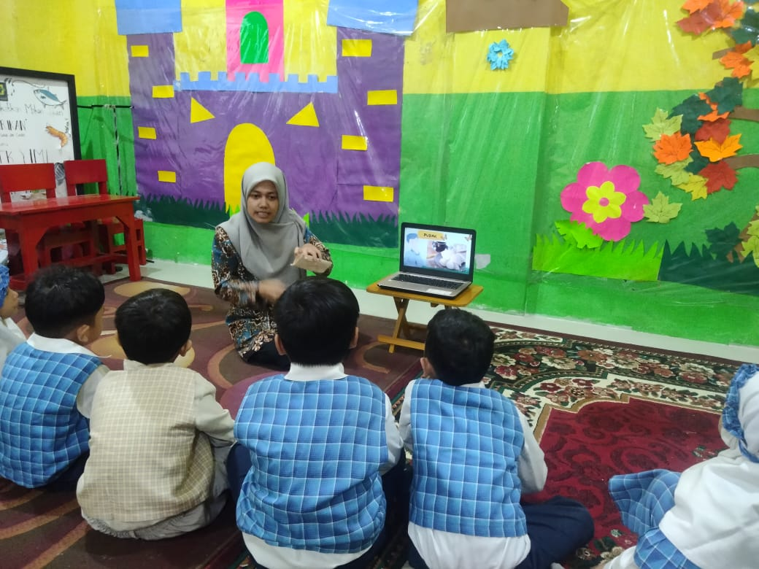

Picture 1. Introduction to Pudak Market Snack Products

(b) Implementation Stage, this stage is implemented in accordance with the Teaching Module that has been designed as a guideline for activities. The implementation of activities is carried out in a real and meaningful form where students can be directly involved in the activity. The strategies used in the activities vary according to the implementation of the activities to be carried out using several question and answer methods, direct practice and work results. The media used in learning is using real or original media. In its implementation, it is divided into 3 times, namely opening activities (15 minutes), core activities (120 minutes) and closing activities (40 minutes). Opening activities include rows, gymnastics and morning person. Core activities include discussing the activities to be carried out, direct practice and making works. Closing activities are reflections or reviewing activities from the beginning to the end, and asking how they feel;
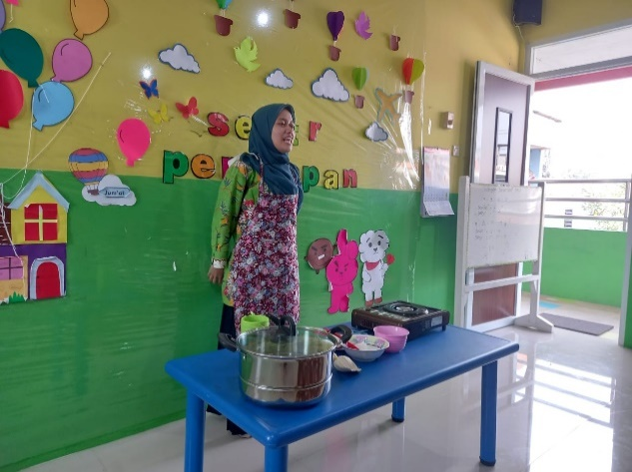

Picture 2. Introduction to Materials and Tools for Making Pudak

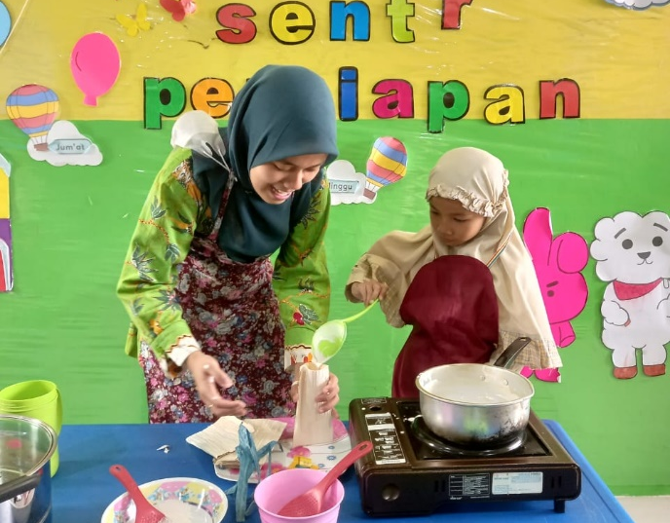

Picture 3. The Process of Making Pudak

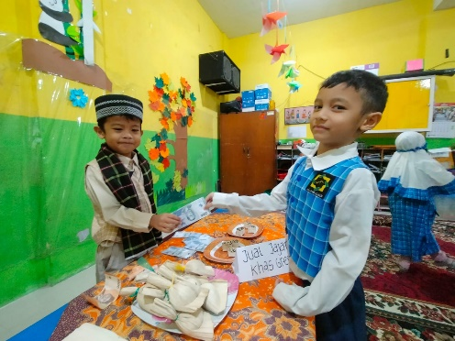

Picture 4. Role Play Buying and selling and Currency Introduction

(c) Evaluation Stage, at this stage, an assessment activity is carried out on the level of development of students' abilities according to the indicators in STPPA (Standard Level of Achievement of Child Development). The average results of group A in participating in the introduction of Gresik traditional snacks, one of which is the introduction of traditional pudak snacks, cooking class, role-playing buying and selling group A which consists of 25 children according to the results of observations on the presentation of sata is (BSB) (Developing According to Expectations) can be interpreted that with the Implementation of entrepreneur kids with Gresik traditional snacks to develop the social emotions of early childhood, it is said that they can accept the activity and can be applied again in learning at school.
The stages of planning, implementation and evaluation which contain several components in accordance with the theoretical basis of constructivism of the learning process that focuses on strategy. The learning process in children through social interaction with the assistance of adults around them who will guide and provide assistance in achieving child development.
Impact of the implementation of the entrepreneur kids program with Gresik traditional snacks in developing the social emotions of early childhood
There are impacts or benefits that are supported, namely: (a) Increasing insight into Gresik culture, one of which is its snacks, through the implementation of the entrepreneur kids program with Gresik traditional snacks, children can learn about local culture through traditional snacks; (b) Gaining learning experience on how to make Pudak, children can find out the source of knowledge to learn how to make pudak and can be applied at home; (c) Developing social emotions in children, especially being able to be responsible for completing activities from start to finish.
Based on the discussion of the research results that have been described above, the implementation of the entrepreneur kids program with traditional Gresik snacks in developing the social emotions of early childhood has been proven to be able to introduce Gresik culture even through traditional Gresik snacks, by designing activities that are interesting and not boring and inviting children to participate directly in activities. From the results of the study, it was found that through the above activities, there are benefits in developing the social emotions of early childhood, namely: 1) Increasing insight into Gresik culture, one of which is its snacks, 2) Getting the experience of learning how to make Pudak, 3) Developing social emotions in children, especially being able to be responsible for completing activities from start to finish.

Conclusion
Based on the results of the research and discussion that has been done, it can be concluded that the implementation of the entrepreneur kids program with traditional Gresik snacks in developing social emotions in early childhood is carried out through three stages, namely: 1) The planning stage includes preparing materials, media, tools and materials that will be used in learning, 2) The implementation stage, namely students are directly involved in making pudak and playing the role of buying and selling, 3) The evaluation stage by assessing the level of development of students' abilities according to the indicators. The impact of the implementation of the entrepreneur kids program with traditional Gresik snacks in developing social emotions in early childhood is that children can get to know Gresik culture through traditional snacks, increase insight, and can develop social emotions in children as seen from the child's responsibility in following activities from start to finish, being patient and being able to take turns with friends.

References

AA Makarisce. (2020). Teknik Pemeriksaan Keabsahan Data pada Penelitian Kualitatif. JIKM.

Durrotun Nafisah. (2020). Peran Pendidikan Muatan Lokal terhadap Pembangunan Karakter Bangsa. Citizenship, Jurnal Pancasila dan Kewarganegaraan, Vol.4 No.2, 454.

Finna Rohmawati. (2021). Transforasi Tradisi di Kabupaten Gresik Akibat Adanya Pandemi Covid 19. Journal of Economie, Management, Accounting, and Technology (JEMATech), Vol. 4 No.2, 4–5.

Fitroh, S. F, & D. M. Sari. (2017). Kreativitas Enterpreneurial Leadership. Jurnal Pendidikan Anak, Vol.6, No.2, 171–180.

Herdanti Rahmania Firdaus, & Rita Ismawati. (2022). Pengaruh Penambahan Jumlah Telur dan Ekstrak Daun Kelor terhadap Hasil Uji Sesnsory Pudak sebagai Jajanan Khas Gresik. Jurnal Tata Boga, Vol.11, No.3.

Lestari, & Su’ad. (2023). Pengembangan Bahan Ajar Budaya Lokal untuk Anak Usia Dini Melalui Program Entreoreneur Kids Makanan Khas Gresik. Jurnal Mandala Education (JIME), Vol.9, No.2.

Lexy. J. Moleong. (2017). Metodelogi Penelitian Kualitatif. PT. Remaja Rosdakarya.

Marini. (2019). Menanamkan Nilai-Nilai Keirausahaan pada Anak Usia Dini. Atfaluna: Journal of Islamic Early Childhood Education, Vol.2, No.1.

Mudjaidah, S. (2022). Implementasi Budaya Antri Melalui Kartu Angka untuk Meningkatkan Kemampuan Sosial Emosianal pada Anak Usia Dini di RA Perwanida Pacet Mojokerto. Atthiflah: Journal of Early Childhood Islamic Education, Vol.4, 92–111.

Sa’roni. (2019). Pengaruh Globalisasi Terhadap Eksistensi Kebudayaan Daerah. Jurnal Ilmiah Kedirgantaraan, Vol.15 No.1, 73–74.

Ubaidillah. (2018). Model Pendidikan Berwawasan Kebangsaan Bagi Anak Usia Dini Sebagai Sarana Integrasi Bangsa. JCE (Journal of Childhood Education), Vol. 2 No. 2, 193–221. https://doi.org/10.30736/jce.v2i1.38

