Lampiran 3 Dokumentasi Pre-test

Dokumentasi Pre-Test
Kelompok Eksperimen


Gambar 3. Pre-Test Eksperimen Gambar 4. Pre-Test Eksperimen

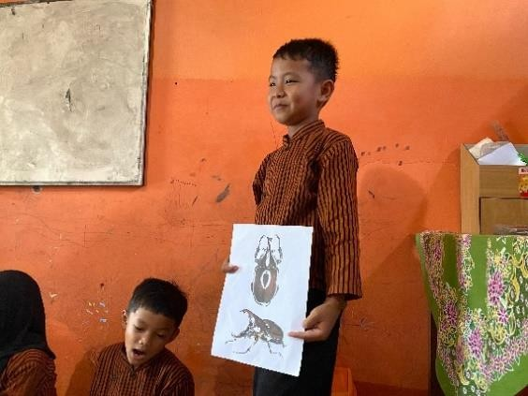
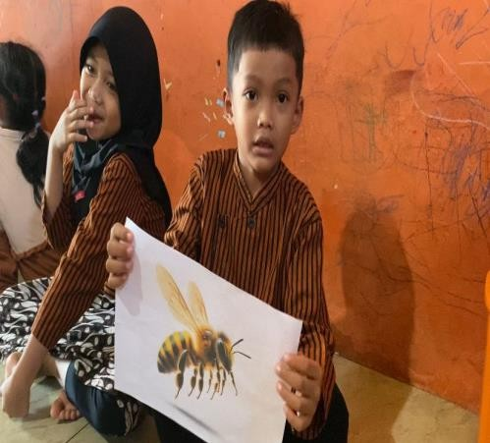
Gambar 5. Pre-Test Eksperimen Gambar 6. Pre-Test Eksperimen

Kelompok Kontrol
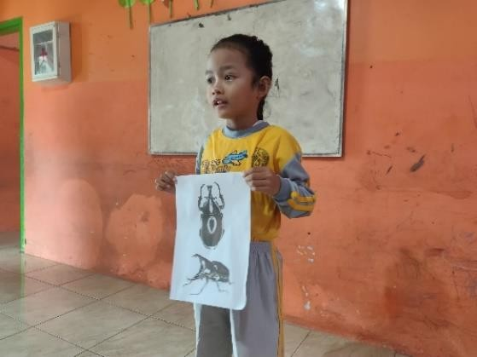
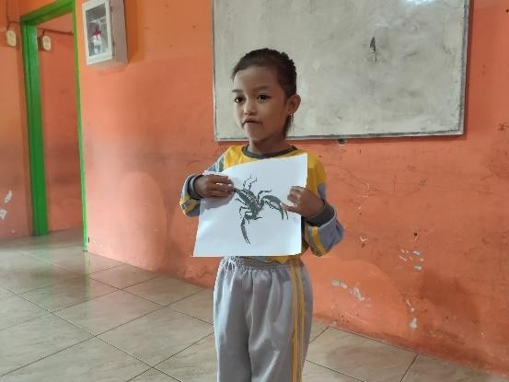
Gambar 7. Pre-Test Kontrol Gambar 8. Pre-Test Kontrol
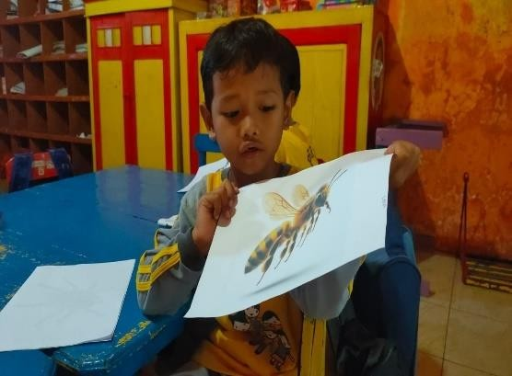

Gambar 9. Pre-Test Kontrol Gambar 10. Pre-Test Kontrol

Lampiran 4 Dokumentasi treatment
Dokumentasi Treatment

Treatment 1

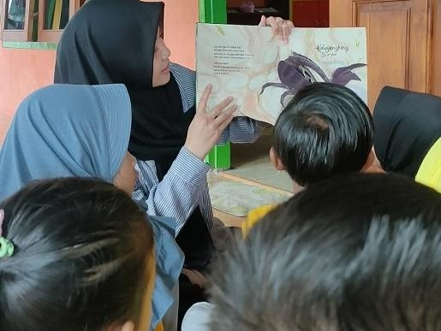
Gambar 11. Treatment 1 Gambar 12. Treatment 1
Treatment 2
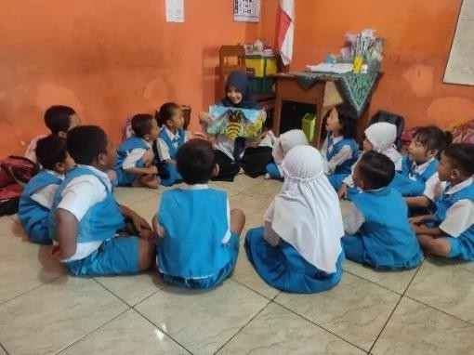

Gambar 13. Treatment 2 Gambar 14. Treatment 2
Treatment 3

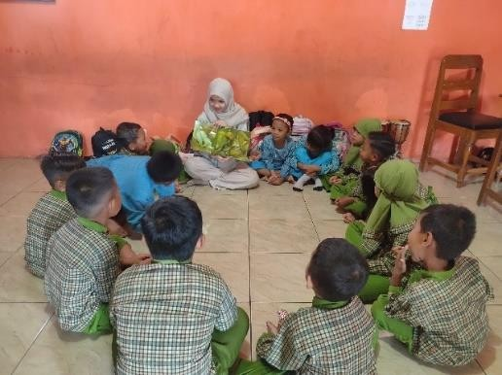
Gambar 15. Treatment 3 Gambar 16. Treatment 3

Lampiran 5 Dokumentasi Post-test
Dokumentasi Post-Test
Kelompok Eksperimen
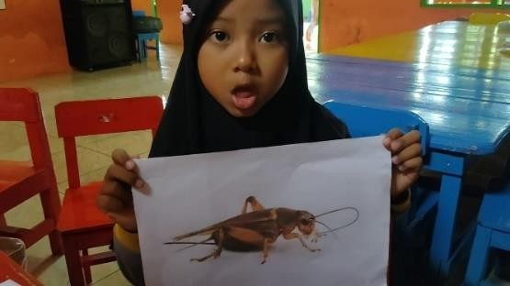

Gambar 17. Post-Test Eksperimen Gambar 18. Post-Test Eksperimen


Gambar 19. Post-Test Eksperimen Gambar 20. Post-Test Eksperimen
Kelompok Kontrol




Gambar 21. Post-Test Kontrol Gambar 22. Post-Test Kontrol
Gambar 23. Post-Test Kontrol Gambar 24. Post-Test Kontrol

Lampiran 6 Media Pretest – Posttest

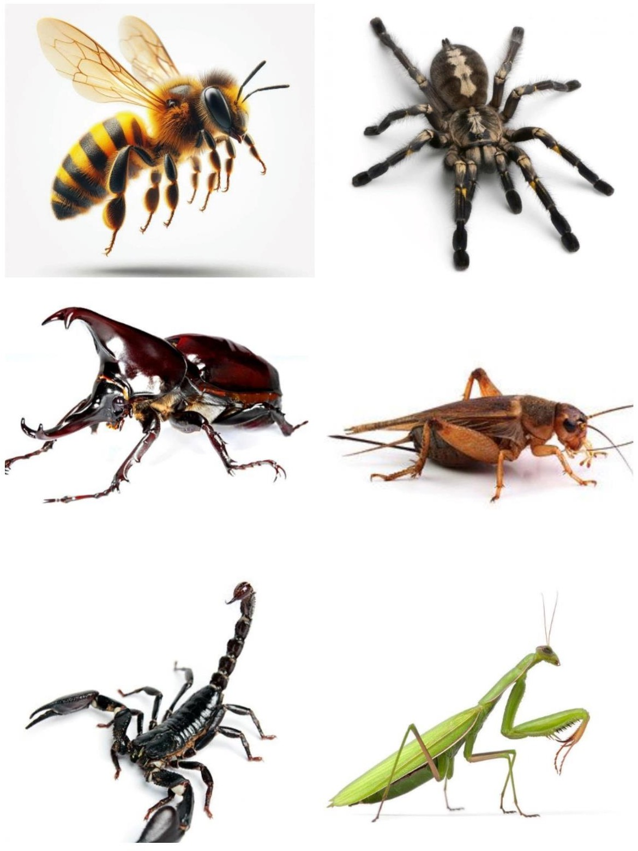
Gambar 25. Media Pre-Test Gambar 26. Media Post-test

