“THE IMPACT OF DKI JAKARTA’S MOBILE LIBRARY SERVICES ON THE READING INTEREST OF 4–5-YEAR-OLD CHILDREN AT PAUD ASH-SHOLIHIN, SOUTH JAKARTA”
Sumardiana¹, Desy Ayu Ningrum²
^{1,2} Universitas PTIQ Jakarta, Jakarta, Indonesia
e-mail:*¹sumardiana_22@mhs.ptiq.ac.id, ²desyayuningrum@ptiq.ac.id

ARTICLE INFO
Article history:
Accepted:
Revised:
Published:
Keywords:
Mobile Library
Reading Interest
Early Childhood
Emergent Literacy
Dialogic Reading
Qualitative Research

ABSTRACT
This study aims to examine the impact of DKI Jakarta’s Mobile Library Services on the reading interest of 4–5-year-old children at PAUD Ash-Sholihin, South Jakarta. The topic was chosen because reading interest among early childhood learners is a crucial foundation for literacy development, and mobile libraries serve as an accessible medium to promote it. The research employed a qualitative descriptive method with data collected through observation, interviews, and documentation. The participants included 10 children aged 4–5 years, 3 teachers, and 1 mobile library staff member selected purposively from a total of 110 students. The study was conducted over four consecutive monthly visits by the Jakarta Library and Archives Office (Perpusip DKI Jakarta). Data were analyzed using the Miles and Huberman interactive model, encompassing data reduction, display, and conclusion drawing. The findings revealed that children showed increasing enthusiasm for reading activities, improved focus during storytelling sessions, and greater initiative in choosing and discussing books. Teachers observed that children became more expressive and communicative after each mobile library visit. The study concludes that mobile library programs effectively cultivate early reading motivation and literacy engagement, serving as an innovative model for equitable and enjoyable early childhood literacy development.

Introduction
Early childhood is a critical period for cultivating foundational literacy skills and a sustained interest in reading; habits and attitudes formed at ages 4–5 substantially influence later reading achievement and school readiness (Brown, C. S, 2014). Research in early literacy consistently shows that regular exposure to books, dialogic reading, and access to diverse reading materials improve vocabulary, narrative skills, and emergent literacy behaviours in preschoolers, which in turn predict later comprehension and academic success (Kennedy, C., & McLoughlin, A, 2023).
Mobile (bookmobile) and outreach library programs have emerged worldwide as a pragmatic strategy to reduce access gaps and stimulate reading interest among underserved populations. Studies across diverse contexts report that mobile libraries can increase library use, broaden children’s exposure to age-appropriate books, and foster positive reading attitudes when services incorporate storytelling, read-aloud sessions, and active engagement activities (Naidoo, J. C, 2014). In Indonesia and comparable settings, recent evaluations and program reports indicate promising effects of mobile-library initiatives on community literacy practices, showing improvements in reading interest and engagement where fixed-library access is limited. At the same time, practitioner reports and national reviews highlight persistent literacy challenges in Indonesia, underscoring the need for scalable, context-sensitive outreach models.
Despite this growing literature, important empirical gaps remain. Much of the existing evidence on mobile libraries focuses on school-age children, community users, or program descriptions and often examines outcomes at the elementary level or in rural underserved communities; rigorous, targeted investigations of mobile-library effects on preschool children's reading interest especially within urban Indonesian ECE settings are scarce (Ejikeme, A. N., Mmadu, G. M., & Ugwu, F. N, 2025).
This study addresses those gaps by empirically examining The Impact of DKI Jakarta’s Mobile Library Services on the Reading Interest of 4–5-Year-Old Children at ECE Ash-Sholihin, South Jakarta. Its novelty and contribution are threefold: (1) focusing specifically on the preschool age band (4–5 years) within an urban ECE context where evidence is limited; (2) evaluating the municipal (DKI Jakarta) mobile-library program rather than ad-hoc community projects, thereby informing city-level policy and program design; and (3) using a mixed-methods approach that triangulates child engagement observations, standardized interest measures, and stakeholder interviews to link service features with child-level outcomes. By doing so, the study aims to produce actionable insights for librarians, early childhood educators, and policymakers seeking to strengthen early literacy through outreach services in Indonesian cities (Nasrullah, R., Laksono, K., Prayogi, A., Parmin, P., & Inayatillah, F, 2024).

Methods
The present study employed a qualitative research design to explore the impact of DKI Jakarta’s Mobile Library Services on the reading interest of 4–5-year-old children enrolled at PAUD Ash-Sholihin, South Jakarta. A qualitative approach was chosen because it allows the researcher to capture natural interactions, behaviors, and meanings constructed by children, teachers, and library staff in the context of early literacy activities (Creswell & Poth, 2018). The research was conducted at PAUD Ash-Sholihin, an early childhood education institution located in South Jakarta that collaborates regularly with the DKI Jakarta Mobile Library Unit. The institution serves a total of 110 students, of whom 55 are aged 4–5 years, supported by 6 teachers and 2 educational staff members (an operator and a treasurer). The participants were selected through purposive sampling, focusing on 10 children aged 4–5 years who actively participated during mobile library visits. In addition, three teachers and one mobile library officer were included as key informants to provide contextual insights into the implementation and perceived outcomes of the program.
Data were collected through classroom observations, semi-structured interviews, and documentation analysis. Observations were conducted during four consecutive mobile library visits to record children’s levels of engagement, enthusiasm, and curiosity toward books and reading-related activities. Semi-structured interviews were held with teachers and mobile library personnel to gain deeper understanding of how mobile library services influence reading motivation among young children and how educators support the program in classroom practices. The interviews were recorded, transcribed verbatim, and analyzed thematically. To enhance data validity, documentation such as attendance lists, literacy activity records, and photo archives of reading sessions were examined following triangulation principles (Flick, 2018).
The research instruments consisted of observation and interview guides developed based on relevant studies on early literacy engagement and motivation in early childhood education (Fitriani & Nurjanah, 2020; Nurhayati & Hadi, 2022). Before data collection, the instruments were validated by two experts—a university lecturer in early childhood education and a literacy development specialist—to ensure that the items were clear, relevant, and aligned with the research objectives. The collected data were analyzed using the interactive model of Miles, Huberman, and Saldaña (2019), which includes data reduction, data display, and conclusion drawing or verification. This analytical process enabled the researcher to identify patterns, themes, and relationships that explain how the mobile library program contributes to children’s interest in reading.
Performance benchmarks or indicators of success were based on observable behavioral cues commonly used to assess reading interest among young children, including verbal expressions of enthusiasm toward books, sustained attention during storytelling, voluntary book selection, and participation in post-reading activities (Rahmawati, 2019; Susanti & Marlina, 2021). These qualitative indicators served as interpretive criteria to evaluate the impact of the mobile library services. Data were collected over a one-month period during which the mobile library visited PAUD Ash-Sholihin weekly. Each visit provided opportunities for direct observation and follow-up discussions with teachers to track consistent behavioral changes in children’s reading engagement. Ethical procedures were strictly followed by obtaining informed consent from parents, teachers, and the school principal. All participants were assured of confidentiality, and children’s participation was conducted in a safe, non-intrusive, and enjoyable manner, consistent with the ethical standards for qualitative research involving young learners (Tracy, 2020).
Overall, this study provided rich, contextual insights into how DKI Jakarta’s Mobile Library Services foster early reading interest among preschool-aged children, highlighting the significance of community-based literacy initiatives in enhancing early childhood education and promoting equitable access to learning resources.
Result and Discussions
The findings of this study revealed that DKI Jakarta’s Mobile Library Services have a significant and positive influence on the reading interest and engagement of 4–5-year-old children at ECE Ash-Sholihin, South Jakarta. The institution serves a total of 110 students, including 55 children aged 4–5 years who participated as the primary focus of this research. Six teachers and two educational staff members (an operator and a treasurer) support daily learning activities. The mobile library, operated by the Jakarta Library and Archives Office (Perpusip DKI Jakarta), visits the school once a month—on the second Thursday—between 8:30 and 10:30 a.m., providing children with access to a range of age-appropriate books and storytelling sessions.

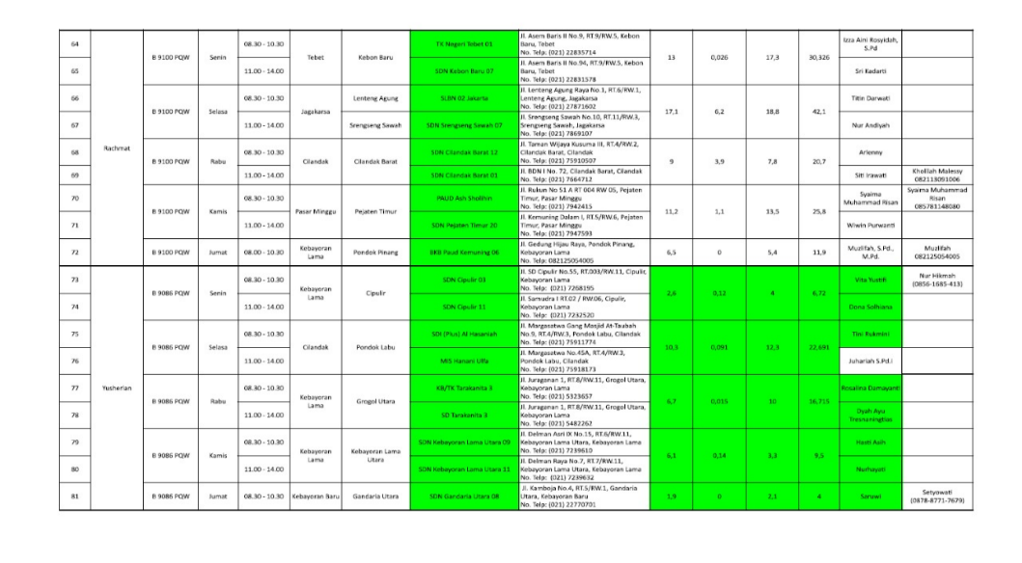
Picture 1. Mobile Library Service Schedule (pusling)
Throughout four consecutive observation cycles, children’s responses toward the mobile library were consistently enthusiastic. Many were visibly excited upon the arrival of the mobile library vehicle, rushing to explore the bookshelves and eagerly choosing storybooks.
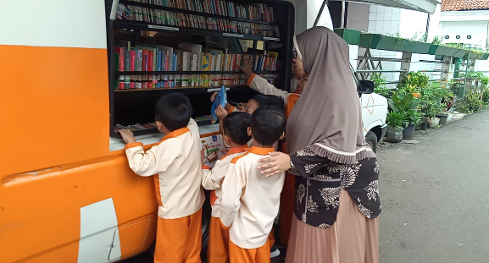
Figure 1. Depicts children gathered around the mobile library vehicle

Smiling as they browse colorful picture books and share them with their peers. These behaviors reflect Brown’s (2014) foundational theory that joyful, socially interactive literacy experiences lay the groundwork for emergent reading motivation and comprehension. Teachers observed that the mobile library environment created a strong sense of curiosity and excitement that extended into classroom reading sessions.
Interview data further supported the observational findings. One teacher shared, “The children become more curious and excited after each mobile library visit. They always ask to repeat the stories they heard at school.” Another teacher added, “Some children who used to be quiet now want to describe pictures and tell what happened in the story.” These remarks indicate that the mobile library program not only strengthened reading motivation but also enhanced children’s expressive language skills. This finding aligns closely with Kennedy and McLoughlin’s (2023) systematic review, which concluded that dialogic reading characterized by active interaction between adults and children during storytelling significantly enhances comprehension and verbal participation.
The librarian from the DKI Jakarta Mobile Library described the service’s goal as follows: “Our mission is not only to bring books but to bring joy in reading. When children feel happy around books, that’s where literacy begins.” This statement highlights the affective dimension of early literacy, in which emotional engagement and enjoyment are critical for fostering sustained reading habits (Brown, 2014; Kennedy & McLoughlin, 2023). The joyful atmosphere observed during each visit exemplifies this concept, as children associated reading with positive emotions, collaboration, and discovery.
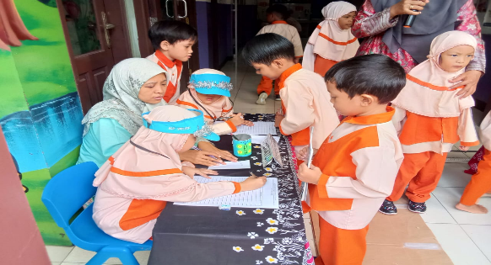
Figure 2. Shows a storytelling session facilitated by the mobile library staff.

The children listened attentively while responding to the librarian’s questions, predicting story outcomes, and sharing their own interpretations. This scene demonstrates the dialogic reading model described by Kennedy and McLoughlin (2023), where guided conversation during shared reading helps children internalize narrative structures and strengthen oral comprehension.
The cultural dimension of literacy was also apparent. Many storybooks provided by the DKI Jakarta Mobile Library featured local Indonesian themes and illustrations that reflected children’s everyday experiences. Naidoo (2014) highlighted the importance of culturally relevant and diverse library programming in enhancing children’s sense of belonging and empathy. Similarly, the children at PAUD Ash-Sholihin showed increased engagement when reading stories that mirrored their community life, suggesting that cultural familiarity deepened their emotional connection to reading.
Furthermore, the mobile library initiative illustrates the role of equitable access in supporting educational inclusivity. The findings correspond with Ejikeme, Mmadu, and Ugwu’s (2025) argument that mobile libraries are effective tools for bridging educational gaps by providing accessible information services to children. Although PAUD Ash-Sholihin is located in an urban setting with relatively good infrastructure, the mobile library program broadened learning opportunities and offered children diverse reading experiences beyond the classroom collection.
Overall, the combination of observational and interview data confirms that DKI Jakarta’s Mobile Library Services significantly foster reading interest, expressive language, and cultural literacy among preschool-aged children. These findings strongly support Brown’s (2014) theoretical framework of emergent literacy, which underscores that early exposure to meaningful, socially interactive, and emotionally positive literacy experiences leads to long-term reading motivation. The program’s interactive design—encompassing storytelling, dialogue, and exploration—demonstrates how early literacy can flourish through accessible and community-based educational interventions.
While the short-term results are highly encouraging, future longitudinal studies are recommended to examine the long-term sustainability of children’s reading motivation after repeated exposure over several semesters. Nevertheless, the present research confirms that mobile library programs serve as effective catalysts for promoting reading interest and early literacy skills, aligning with Indonesia’s broader efforts to strengthen literacy equity and educational excellence (Nasrullah et al., 2024).

Conclusion
This study concluded that DKI Jakarta’s Mobile Library Services play a significant role in enhancing the reading interest and emergent literacy development of 4–5-year-old children at PAUD Ash-Sholihin, South Jakarta. The research findings demonstrate that regular exposure to mobile library activities—such as interactive storytelling, independent book exploration, and dialogic reading sessions effectively foster children’s enthusiasm, attention span, and language expression. These outcomes confirm the hypothesis that access to engaging, culturally relevant, and socially interactive literacy experiences can stimulate early reading motivation. The children’s observable joy and eagerness to participate indicate that literacy learning becomes most effective when supported by affective engagement and meaningful interaction, in line with Brown’s (2014) and Kennedy and McLoughlin’s (2023) frameworks on early literacy and dialogic reading.
The study also reaffirms the importance of community-based literacy interventions in promoting equitable educational opportunities. The DKI Jakarta Mobile Library serves as a practical model for extending access to diverse reading materials and enriching learning environments beyond the classroom. Its presence not only bridges resource gaps but also strengthens collaboration between schools and local government in building a reading culture from an early age. These findings are consistent with previous research emphasizing the role of mobile libraries in fostering literacy inclusion and social participation (Ejikeme et al., 2025; Nasrullah et al., 2024).
Theoretically, the results contribute to the growing body of evidence that emotional engagement and cultural relevance are key drivers of early literacy success. The findings suggest that children’s reading interest develops most effectively when literacy programs integrate joy, interaction, and cultural familiarity into the learning process. This supports the view that early literacy development is not merely a cognitive skill but a holistic social experience involving curiosity, communication, and belonging.
In practical terms, this study implies that policymakers and educators should continue to support and expand mobile library programs as sustainable tools for literacy promotion. Strengthening collaboration between librarians, teachers, and parents will ensure that literacy initiatives are continuous and impactful. Future studies could extend this research through longitudinal observation to examine the long-term influence of mobile library exposure on children’s literacy outcomes. Overall, the DKI Jakarta Mobile Library exemplifies an innovative and effective approach to cultivating early reading motivation and language development, reinforcing Indonesia’s ongoing efforts to build a literate and inclusive society.

References
Brown, C. S. (2014). Language and literacy development in the early years: Foundational skills that support emergent readers. Language and Literacy Spectrum, 24, 35-49.

Kennedy, C., & McLoughlin, A. (2023). Developing the emergent literacy skills of English language learners through dialogic reading: A systematic review. Early Childhood Education Journal, 51(2), 317-332.
Naidoo, J. C. (2014). Diversity programming for digital youth: Promoting cultural competence in the children's library. Bloomsbury Publishing USA.

Nasrullah, R., Laksono, K., Prayogi, A., Parmin, P., & Inayatillah, F. (2024). Establishing Literacy Foundations: Policies and Interventions for Indonesia's Future Excellence. Jurnal Kependidikan, 10(3), 1219-1230.
Creswell, J. W., & Poth, C. N. (2018). Qualitative Inquiry and Research Design: Choosing Among Five Approaches (4th ed.). Sage Publications.

Flick, U. (2018). An Introduction to Qualitative Research (6th ed.). Sage.

Fitriani, S., & Nurjanah, R. (2020). Early literacy development in Indonesian preschools: A qualitative approach. Journal of Early Childhood Research, 18(4), 357–370.

Miles, M. B., Huberman, A. M., & Saldaña, J. (2019). Qualitative Data Analysis: A Methods Sourcebook (4th ed.). Sage Publications.

Nurhayati, D., & Hadi, F. (2022). Stimulating reading motivation through literacy-rich environments in early childhood. Indonesian Journal of Early Childhood Education Studies, 11(1), 45–53.

Rahmawati, N. (2019). Indicators of reading interest in early childhood education. PAUD Journal of Education, 8(2), 112–120.

Susanti, L., & Marlina, E. (2021). Reading engagement among preschoolers: Teachers’ strategies and challenges. Early Childhood Literacy Studies, 3(1), 22–33.

Tracy, S. J. (2020). Qualitative Research Methods: Collecting Evidence, Crafting Analysis, Communicating Impact (2nd ed.). Wiley-Blackwell.

