Attachments

Table 1
List of Sample Research Company

CODE | Company Size
ANTM | Aneka Tambang Tbk.
CPIN | Charoen Pokphand Indonesia Tbk.
CTRA | Ciputra Development Tbk.
ERAA | Erajaya Swasembada Tbk.
EXCL | XL Axiata Tbk.
ICBP | Indofood CBP Sukses Makmur Tbk.
INDF | Indofood Sukses Makmur Tbk.
INTP | Indocement Tunggal Prakarsa Tbk.
JPFA | Japfa Comfeed Indonesia Tbk.
KLBF | Kalbe Farma Tbk.
MNCN | Media Nusantara Citra Tbk.
PGAS | Perusahaan Gas Negara Tbk.
PTBA | Bukit Asam Tbk.
PTPP | PP (Persero) Tbk.
SCMA | Surya Citra Media Tbk.
TLKM | Telekomunikasi Indonesia (Persero) Tbk.
UNVR | Unilever Indonesia Tbk.
WIKA | Wijaya Karya (Persero) Tbk.

Table 2
Data on Variable Research List

CODE | Company Size |  |  | Likuiditas |  |  | Capital Structure
CODE | 2017 | 2018 | 2019 | 2017 | 2018 | 2019 | 2017 | 2018 | 2019
AKRA | 23,55 | 23,72 | 23,79 | 1,62 | 1,40 | 1,24 | 0,86 | 1,01 | 1,13
ANTM | 24,12 | 24,23 | 24,13 | 1,60 | 1,45 | 1,50 | 0,67 | 0,64 | 0,81
CPIN | 17,02 | 17,13 | 17,19 | 2,32 | 2,98 | 2,56 | 0,56 | 0,43 | 0,28
CTRA | 17,27 | 17,35 | 17,40 | 1,95 | 2,02 | 2,17 | 1,05 | 1,06 | 1,04
ERAA | 29,81 | 23,26 | 23,00 | 1,32 | 1,30 | 1,50 | 1,39 | 1,63 | 0,96
EXCL | 17,85 | 17,87 | 17,86 | 0,47 | 0,45 | 0,43 | 1,60 | 2,14 | 2,12
ICBP | 17,27 | 17,35 | 17,47 | 2,43 | 1,95 | 2,54 | 0,56 | 0,51 | 0,45
INDF | 18,30 | 18,39 | 18,40 | 1,52 | 1,07 | 1,11 | 0,88 | 0,93 | 0,89
INTP | 17,18 | 17,14 | 17,14 | 3,70 | 3,14 | 3,31 | 0,18 | 0,20 | 0,20
JPFA | 16,81 | 16,95 | 17,04 | 2,35 | 1,80 | 1,73 | 1,31 | 1,26 | 1,20
KLBF | 30,44 | 30,53 | 30,64 | 4,51 | 4,66 | 4,35 | 0,16 | 0,19 | 0,21
MNCN | 16,53 | 16,61 | 16,70 | 4,60 | 3,41 | 3,57 | 0,54 | 0,54 | 0,42
PGAS | 22,56 | 22,80 | 22,72 | 2,66 | 1,54 | 1,98 | 0,90 | 1,48 | 1,28
PTBA | 16,91 | 17,00 | 15,62 | 2,53 | 2,32 | 2,49 | 0,59 | 0,49 | 0,42
PTPP | 31,36 | 31,59 | 31,71 | 1,45 | 1,42 | 1,37 | 1,93 | 2,22 | 2,41
SCMA | 22,41 | 22,54 | 22,63 | 3,64 | 4,26 | 3,60 | 0,22 | 0,20 | 0,22
TLKM | 12,20 | 12,24 | 12,31 | 1,05 | 0,94 | 0,71 | 0,77 | 0,76 | 0,89
UNVR | 16,80 | 16,83 | 16,84 | 0,62 | 0,73 | 0,65 | 2,96 | 1,75 | 2,91
WIKA | 24,55 | 24,80 | 24,82 | 1,34 | 1,54 | 1,31 | 2,12 | 2,44 | 2,61
Average | 20,68 | 20,44 | 20,39 | 2,19 | 2,02 | 2,01 | 1,01 | 1,05 | 1,08

SPSS Data Results
Table 1 Descriptive Statistics

Variable | N | Minimum | Maximum | Mean | Std. Dev
Company Size | 57 | 12,20 | 31,71 | 20,5032 | 5,10609
Liquidity | 57 | 0,43 | 4,66 | 2,0733 | 1,13975
Capital Stucture | 57 | 0,16 | 2,96 | 1,0453 | 0.75346

Classic Assumption Test
Table 2 Normality Test
One-Sample Kolmogorov-Smirnov Test
 |  | Unstandardized Residual
N |  | 57
Normal Parameters^{a,b} | Mean | ,0000000
Normal Parameters^{a,b} | Std. Deviation | ,48389439
Most Extreme Differences | Absolute | ,093
Most Extreme Differences | Positive | ,093
Most Extreme Differences | Negative | -,079
Test Statistic |  | ,093
Asymp. Sig. (2-tailed) |  | ,200^{c,d}
a. Test distribution is Normal.
b. Calculated from data.
c. Lilliefors Significance Correction.
d. This is a lower bound of the true significance.

Table 3 Multicollinearity Test
Coefficientsª
Model |  | Unstandardized Coefficients |  | Standardized Coefficients | t | Sig. | Collinearity Statistics
 |  | B | Std. Error | Beta | t | Sig. | Tolerance | VIF
1 | (Constant) | 1,181 | ,284 |  | 4,152 | ,000
1 | Company Size | ,044 | ,013 | ,296 | 3,350 | ,001 | ,978 | 1,022
1 | Liquidity | -,497 | ,058 | -,752 | -8,511 | ,000 | ,978 | 1,022
a. Dependent Variable: Capital Structure

Table 4 Heteroscedasticity Test

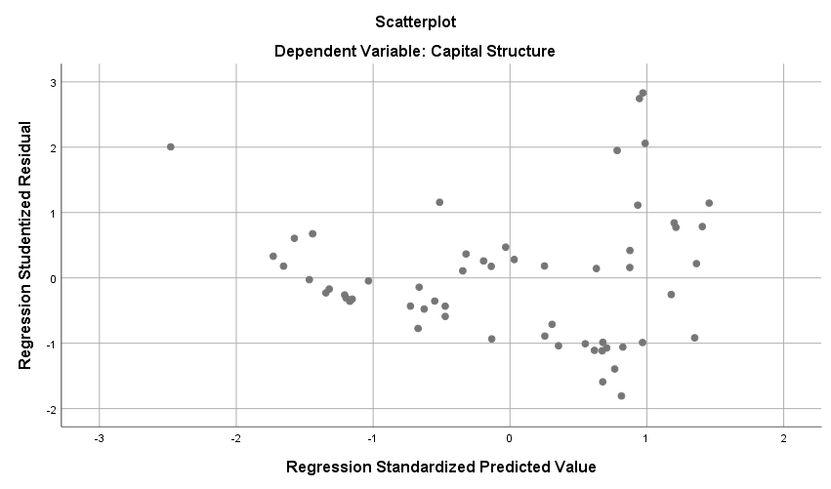
Table 5 Autocorrelation Test

Runs Test
 | Unstandardized Residual
Test Valueª | -,06849
Cases < Test Value | 28
Cases >= Test Value | 29
Total Cases | 57
Number of Runs | 23
Z | -1,736
Asymp. Sig. (2-tailed) | ,083
a. Median

Hypotesis Testing

Table 7 Test The Coefficient of Determination ($R^{2}$)

Model Summary^{b}
Model | R | R Square | Adjusted R Square | Std. Error of the Estimate
1 | ,767ª | ,588 | ,572 | ,49277
a. Predictors: (Constant), Liquidity, Company Size
b. Dependent Variable: Capital Structure

Table 8 Simultaneous Test (Test Statistic F)

ANOVAª
Model |  | Sum of Squares | df | Mean Square | F | Sig.
1 | Regression | 18,679 | 2 | 9,339 | 38,461 | ,000^{b}
1 | Residual | 13,113 | 54 | ,243
1 | Total | 31,791 | 56
a. Dependent Variable: Capital Structure
b. Predictors: (Constant), Liquidity, Company Size

Table 9 Partial Correlation Test (T Test)

Coefficientsª
Model |  | Unstandardized Coefficients |  | Standardized Coefficients | t | Sig.
 |  | B | Std. Error | Beta | t | Sig.
1 | (Constant) | 1,181 | ,284 |  | 4,152 | ,000
1 | Company Size | ,044 | ,013 | ,296 | 3,350 | ,001
1 | Liquidity | -,497 | ,058 | -,752 | -8,511 | ,000
a. Dependent Variable: Capital Structure

