Discovering Culture and English: My Learning Experience at Ahmad Dahlan University through UMT's Study Abroad Program
¹ Yudhie Indra Gunawan, ²Audia Triana, ³Dalpah, ⁴Rizka Salsabiila Syahan,
⁵Sita Ardelia
¹ Universitas Muhammadiyah Tangerang, 021–55793251
² Universitas Muhammadiyah Tangerang, 021–55793251
³ Universitas Muhammadiyah Tangerang, 021–55793251
⁴ Universitas Muhammadiyah Tangerang, 021–55793251
⁵ Universitas Muhammadiyah Tangerang, 021–55793251
1 yudhie.indra@umt.ac.id 2 audiatriana@gmail.com 3 ddalpah3@gmail.com 4 rizkasyahan15@gmail.com 5 sitardelia30@gmail.com
Abstrak
Tujuan dari penelitian ini adalah untuk membuka pintu bagi penulis untuk mengeksplorasi public speaking dalam budaya Indonesia, khususnya di lingkungan kampus UAD. Mereka merinci interaksi dengan pelajar lokal, partisipasi dalam kegiatan budaya, dan pembelajaran tentang tradisi dan nilai-nilai yang mendasari masyarakat Indonesia. Selain itu, penulis juga mencatat adanya pengaruh positif budaya Indonesia terhadap cara pandang dunianya. Metode yang digunakan adalah metode kualitatif. Hasil penelitian ini menunjukkan bahwa penulis berbagi tantangan dan pencapaian mereka dalam meningkatkan kemampuan bahasa Inggris mereka. Mereka mengevaluasi bagaimana pengalaman ini meningkatkan keterampilan bahasa Inggris dan berbicara di depan umum, yang akan berguna dalam konteks globalisasi saat ini dan memberikan wawasan tentang pengalaman pembelajaran lintas budaya dan linguistik yang berharga melalui program studi banding. Hal ini juga menggarisbawahi pentingnya pertukaran budaya dalam membuka pemahaman global dan mengembangkan keterampilan bahasa bagi siswa yang berpartisipasi dalam program tersebut.
Kata kunci: Pengalaman Belajar, Public Speaking, Study Abroad
Abstract
The aim of this research is to open the door for writers to explore their public speaking in Indonesian culture, especially in the UAD campus environment. They detailed interactions with local students, participation in cultural activities, and learning about the traditions and values that underlie Indonesian society. In addition, the author also notes the positive influence that Indonesian culture has on their world perspective. The method used is a qualitative method. The results of this research show that the authors share their challenges and achievements in improving their English language skills. They evaluated how this experience improved their English and public speaking skills, which would be useful in the current context of globalization and provided insight into valuable cross-cultural and linguistic learning experiences through comparative study programs. It also underscores the importance of cultural exchange in opening up global understanding and developing language skills for students participating in such programs.
Keywords: Learning Experience, Public Speaking, Study Abroad

INTRODUCTION
Language and culture are closely linked to shape our understanding of the world. According to Zelvia Liska Afriani (2019), the influence of culture on communication includes elements such as tradition, art, and language. The combination of culture and language cannot be separated so it has an impact on the thought processes of language users. This journal aims to explore my learning journey at Ahmad Dahlan University through the Study Abroad Program by Universitas Muhammadiyah Tangerang, highlighting the important relationship between culture and English language studies.
Cultural awareness, as stated by Frank (2013), plays an important role in understanding various values and attitudes. For Indonesian students studying English, understanding English culture is very important. Without a comprehensive understanding of the nuances of English culture, students may face challenges in expressing thoughts coherently in the language. This journal intends to investigate how cultural understanding significantly influences the acquisition and mastery of English language skills, especially for Indonesian language learners.
The in-depth experiences of students taking part in the UMT’s Study Abroad Program at Ahmad Dahlan University emphasize the intrinsic connection between language and culture. According to Afriani (2019), exposure to various cultural activities improves language skills and deepens appreciation of cultural nuances. Engaging in local customs, traditions and social etiquette will broaden perspectives, encouraging inclusive language use in English-speaking countries. This journal aims to explain how immersion in English culture fosters a deep respect for diversity and enriches the language learning experience.
According to Afriani (2019), language functions as a gateway to new knowledge, more than just communication. For students participating in the Study Abroad Program, understanding British culture is an integral part of their educational journey. Integrating cultural understanding with language proficiency provides a different understanding of the relationship between language and societal norms. This journal seeks to detail the transformative impact of cultural immersion on the acquisition of English and the broadening of cultural horizons for learners at Ahmad Dahlan University.
In summary, the next section of this journal aims to explore insights into the experiences, challenges and transformative learning moments faced by students during the UMT’s Study Abroad Program at Ahmad Dahlan University. By examining the combination of culture and language, this journal aims to illustrate the significant influence of cultural understanding on English language mastery, especially in the context of Indonesian language learners. The goal is to show how cultural awareness enhances language learning and fosters a deep respect for the richness and diversity that exists in the English-speaking world.
LITERATURE REVIEW
The definition of "learning experience" is an experience or process in which a person acquires new knowledge, skills, understanding, or insight through various types of interactions, activities, or situations that involve learning. Learning experiences can occur in various contexts, including at school, university, workplace, social environment, or even through independent learning. (Tarwiyah, 2009) suggests that learning from experience includes the relationship between acting and thinking. If students are actively involved in the learning process, then students will learn better. This is because in the learning process students actively think about what is learned and how to apply the results of the learning process in real situations.
Learning experiences can be formal experiences, such as attending classes or seminars, or informal experiences, such as discussing with friends, attending conferences, or even learning from mistakes made in everyday life. These learning experiences can include a variety of learning methods, from reading and writing to experiments, simulations, discussions, and more. According to Atherton (2008), in the context of learning, experience-based learning is described as a process in which students' experiences are reflected in depth and from this a new understanding or learning process emerges.
It is important to note that learning experiences can be positive or negative, and the learning process does not always go smoothly. However, in the context of education and self-development, learning experiences are often sought to be meaningful experiences and support individual development in achieving their learning goals.
Learning experience is a process in which a person gains knowledge, skills, insight and experience that can help in personal and professional development. The following are some of the benefits that can be gained from learning experiences; (a) Increased Knowledge: Through experiential learning, one can gain new knowledge about various topics and subjects, understand deeper concepts, and develop broader understanding. (b) Skills Development: Learning experiences often involve developing specific skills that can be useful in daily life and careers. For example, learning a foreign language, computer programming, communication skills, or leadership. (c) Improved Thinking Ability: Learning experiences help a person develop critical, analytical and creative thinking skills. It helps individuals solve problems, make decisions, and think more effectively. (d) Deeper Understanding: Learning experiences can help a person understand deeper concepts, ideas and issues. This can help in understanding the world around you and contribute to the understanding of complex issues. (e) Increased Self-Confidence: When a person successfully passes a particular learning experience, such as overcoming a difficult assignment or achieving an educational goal, this can increase self-confidence and personal satisfaction. (f) Increased Open-Mindedness: Diverse learning experiences and interacting with a variety of people can open an individual's mind to different world views, cultures, and perspectives. (g) Job and Career Enhancement: Increasing skills and knowledge through experiential learning can help in improving job prospects and advancing one's career. (h) Improved Social Skills: Learning often involves interaction with other people, which can help in the development of social skills, such as the ability to communicate, work in teams, and build human relationships. (i) Self-Understanding: Learning experiences can also help a person understand their interests, talents and goals in life. This can help in making decisions about career and personal life. (j) Developing a Work Ethic: Some learning experiences, such as an internship or part-time job, can help a person develop a strong work ethic and understand the importance of dedication and responsibility.
Learning experiences can be beneficial in various aspects of a person's life and play an important role in personal and professional development. This is an ongoing process, and each learning experience can provide new insights and opportunities for growth.
RESEARCH METHODOLOGY
This research was conducted using qualitative methods. According to Sugiyono (2018:213), qualitative research methods are research methods based on philosophy that are used to research scientific conditions (experiments) where the researcher is the instrument, data collection techniques and qualitative analysis emphasize meaning. Themes related to cultural understanding, language acquisition, and the impact of cultural awareness on language learning can be identified through analysis. The population of this study were students participating in the UMT Ahmad Dahlan University Overseas Study Program. The sample is part of the population, most likely students who have participated in a Study Abroad Program. The instrument used for data collection can be a survey. Specific questions in the instrument will inquire about students' experiences, challenges faced, and moments of transformative learning during the UMT Study Abroad Program, with a focus on cultural influences.
RESULT AND DISCUSSION
Comparative study experiences are a wonderful way to gain new insights, learn from the experiences of others, and expand our understanding of the world around us. During comparative studies at Ahmad Dahlan University, the thing that really stuck was because there we learned a lot. Starting from the MoU between Ahmad Dahlan University and Muhammadiyah Tangerang University as well as a seminar on public speaking, where we became speakers who were of course good and also had good speaker skills. Of course there we also learned a lot and exchanged stories about the learning system, especially in the English language education study at the two universities, where Ahmad Dahlan University already has its own course laboratory to support better learning and has innovative learning media and also supports lectures. Because the laboratory is one of the important strategic supporting facilities in the implementation of the education system, especially in the education system in higher education. In general, its role and function is to carry out educational, research, and community service activities. Effective education is education that is able to facilitate students optimally so that they are able to make a positive contribution to national development and development. One of the educational components that must be present in education is facilities and infrastructure. According to Barnawi and M. Arifin (2012) educational facilities include all equipment and supplies that directly support the educational process, while educational infrastructure includes all equipment and supplies that indirectly support the educational process. Therefore, educational facilities and infrastructure are factors that must be present because they are very important to use to optimize teaching and learning activities.
Apart from that, by taking part in a comparative study at Ahmad Dahlan University, I gained a lot in terms of student learning experiences there and from the seminar. Starting from our seminar on public speaking where we have to be good public speakers in delivering material, body gestures and also our character in front of the audience. Then we also learned how and what material should be conveyed so that the audience does not get bored in public speaking activities, and of course also in the seminar we were told how to become a good and correct public speaker which was delivered by 2 speakers from Muhammadiyah University lecturers Tangerang and also from lecturers at Ahmad Dahlan University. And also there we exchanged stories and learned a lot about the learning system there, especially in English Language Education, where Ahmad Dahlan University already has its own laboratory managed by several English Language Education students and has also supported better learning to support lectures. In this public speaking activity, it is very important to be confident, our gestures and character in front of the audience are assessed by those who attend our public speakers, where we must be confident in delivering the material so that the ideas and concepts in our material are conveyed well. . And it can also build togetherness with the audience. This is supported by Rice (2001).
Then when exploring the Muhammadiyah Museum which is located at UAD. The Muhammadiyah Museum is not only a historical place, but also a space full of stories about the movement and development of education in Indonesia. The buildings are classic but so stunning, they hold so many stories in each piece of architecture. In the museum, the museum rooms are spread out, filled with historical artifacts, pictures and writings. In the first room, the walls are filled with photos of educational heroes. Each photo is not just an image, but is a reflection of their enthusiasm in fighting for inclusive and quality education for all. Then there is written history. Every word on every information board provides a clear picture of the development of Muhammadiyah and its role in the transformation of education in Indonesia. Not only limited to writing, this museum displays historical artifacts that gave me a direct look into the past. I could see a collection of old books, ancient writing instruments, and items used in the educational process at that time. After exploring the museum, I saw more clearly how their struggle provided the foundation for our current education system. I left the museum with deep respect for their struggle and a new determination to continue to contribute to the world of education, in line with the spirit instilled by the educational heroes at the Muhammadiyah Museum.
Comparative study activities are carried out by interest groups to visit or meet certain objects that have been prepared and take place in a relatively short time. The point is to compare the conditions of the study object in other places with the conditions in your own place. The result is data and information collected as reference material in formulating the desired concept. The preparations made before conducting a comparative study are carrying out an internal review and evaluation regarding which areas will be developed and progress increased. After that, a structured draft list is created according to the specified schedule. The main aim of conducting a comparative study is to dig up as much information as possible that can be obtained using real technical and empirical means. To be used as a barometer and comparison which then goes into finding an applicable update, both for future plans in the short term and long term in a futuristic manner. So in other words, the purpose of this comparative study is: (1) to increase our knowledge about other places. (2) to gain new experiences in other places. (3) to compare our place with other places. (4) to increase our horizons of thinking.
CONCLUSSION AND SUGGESTION
The conclusion of this research is that comparative study experiences are a wonderful way to gain new insights, learn from other people's experiences, and broaden our understanding of the world around us. Comparative studies at Ahmad Dahlan University provide valuable experience in terms of learning, especially in the field of English Language Education, and also in public speaking skills. Apart from that, a visit to the Muhammadiyah Museum provides an understanding of the history of the educational movement in Indonesia and inspires people to contribute to the world of education.
Suggestions that can be taken from this research are: 1. Encourage more students to take part in comparative study activities, because they can provide valuable insight and experience. 2. Emphasize the importance of facilities and infrastructure in education, including laboratories, in increasing the effectiveness of learning. 3. Motivate students to develop public speaking skills, because this is a valuable communication skill. 4. View comparative studies as an opportunity to broaden your understanding of various aspects of life and education, as well as increase your horizons of thinking. By implementing these suggestions, we can further maximize the benefits of the comparative study experience and enrich our education and understanding.
REFERENCES

Abedi, J. (2010). Standardized achievement test and English language learners: psychometric issues. Educational Assessment, 8(3), 231-257.
Aninsi, Niken (2021). Benefits of Public Speaking and How to Learn It for Beginners.
Assemi, A., Saleh, S., Asayeshh, M. E., &Janfaza, E. (2012). Culture within Language. International ConferenceonLanguage, Medias and Culture, 33, 78–82.
Bailey, K. M. (2005). Practical English Language Teaching: Speaking. New York: McGraw-Hill.
Binus University. (28 Oktober 2014). Binus University Comparative Study. Accessed October 29, 2023. https://qmc.binus.ac.id/2014/10/28/pengertian-studi-banding/
Byram, M., & Wagner, M. (2018). Making a difference: Language teaching for intercultural and international dialogue. Foreign Language Annals, 51(1), 140–151.
Cakir, I. (2012). Developing Cultural Awareness in Foreign Language Teaching. Turkish Online Journal of Distance Education, 5(3), 154–161. https://doi.org/10.5539/elt.v5n3p95.
Celce-Murcia, M., Brinton, D. M., & Snow, M. A. (2014). Teaching English as a Second or Foreign Language. Cengage Learning.
Edukasia, J. E., & Anggoro, S. (2019). The Influence of the Experiential Learning Model on Curiosity. 2(2), 154– 163. http://jurnal.elementaria.edukasiana.ac.id
Getie,A. S. (2020). Factors affecting the attitudes of students towards learning English as a foreign language, Cogent Education.
Hirsch, E. D. (1984). Cultural Literacy. National Adult Literacy Project. https://doi.org/10.1158/1535-7163.mct-16- 0142
Ihsan, Kamil. (2022). Muhammadiyah Museum: Evidence of Important Traces of the Persyarikatan's Struggle.
Kumparan. (17 February 2022). Understanding and Importance of Comparative Studies for Students. Accessed October 29, 2023. https://kumparan.com/berita-update/pengertian-dan-pentingnya-studi-banding-bagi-pelajar-1xWVK859Tyn/2
Noer, Muhammad (2020). Understand the definition and meaning of public speaking.
Peterson, E., & Coltrance, B. (2003). Culture in Second Language Teaching. (December).
Ronny H. Mustamu. (2012). Becoming a Reliable Public Speaker: The Public Speaker Phenomenon, Between Needs and Trends.
Saleh, S. R. (n.d.). Comparative Study Preparation and How to Compile a Comparative Study Report. Retrieved October 29, 2023. From http://setiadisejati.blogspot.com/2014/12/persiapan-study-banding-dan-cara_13.html
Suparlan. (2013). Comparative Study is Not Just an Outing - Suparlan.org. https://suparlan.org/1399/
Universitas Ahmad Dahlan. (4 December 2008). History of Ahmad Dahlan University. Retrieved October 29, 2023. https://uad.ac.id/id/

APPENDIXES

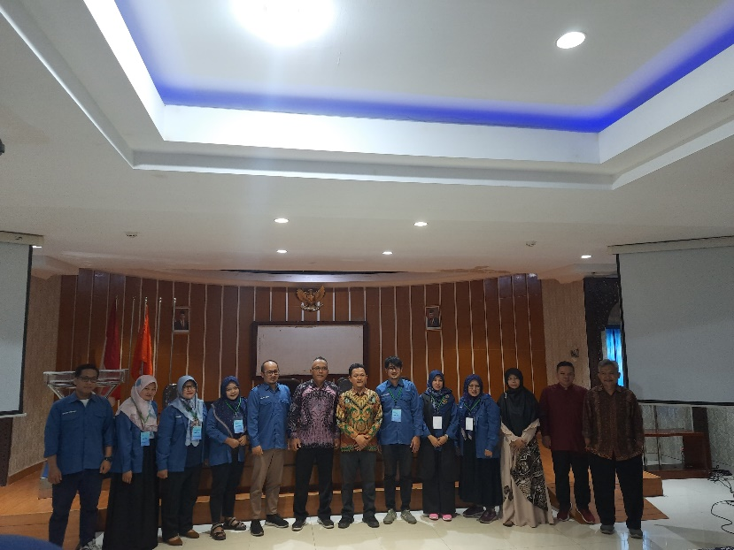V
Figure 1. lecturers of UAD and UMT

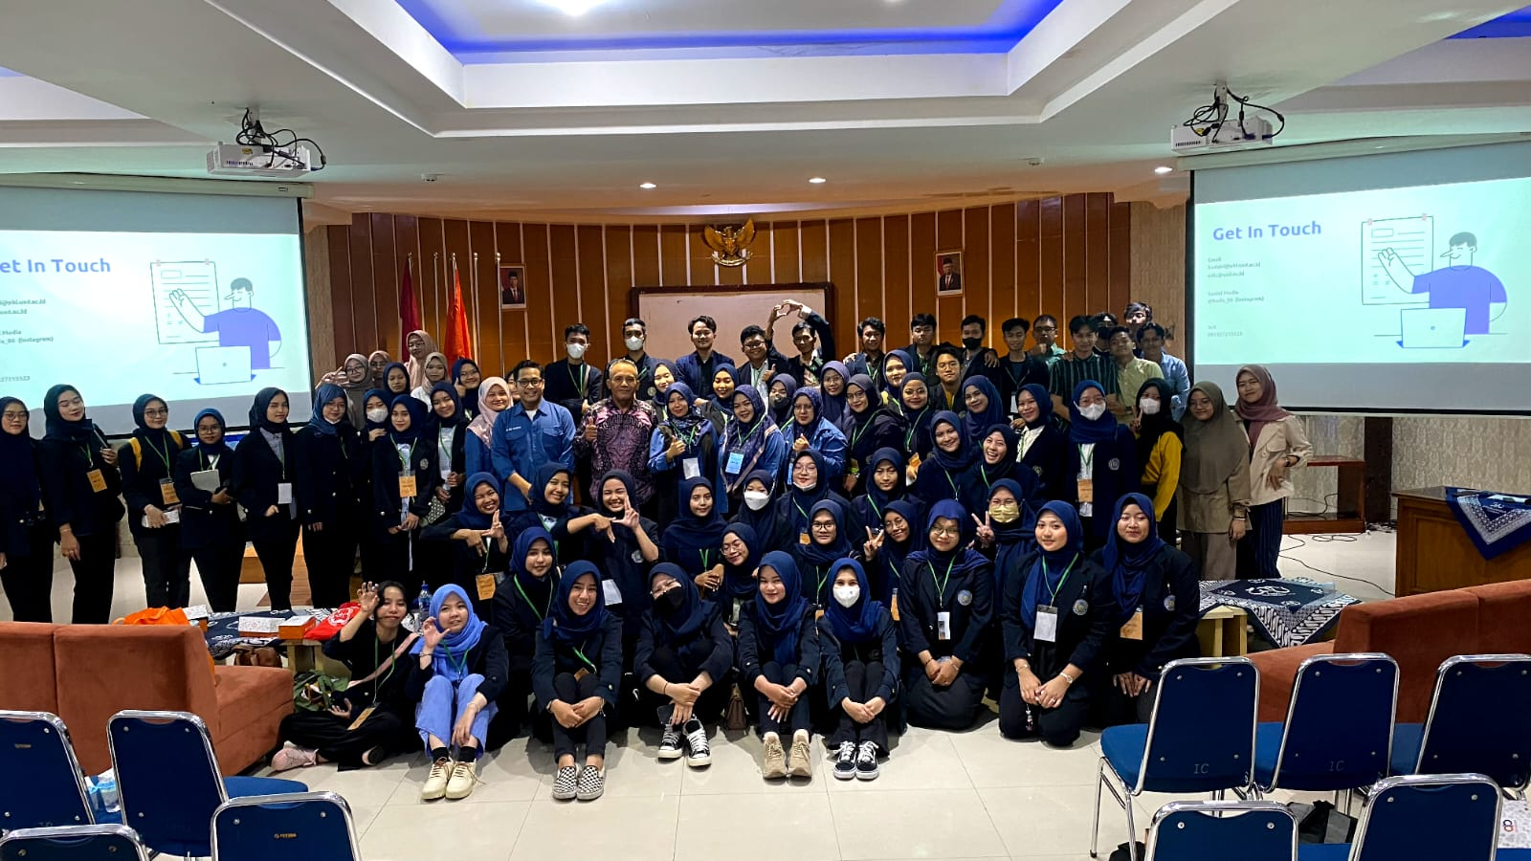
Figure 2. Group photo after workshop activities

