The local government through the Sorong City Cooperatives and SMEs Office held a business capital assistance program in the form of box containers for MSME business actors, especially for indigenous Papuans. Box container or Booth container is a temporary building used to store and sell products or goods, food, beverages and others to the general public which can usually be found in locations where there are groups of people gathering to spend their free time such as parks, cities, squares and others. The Sorong City Government hopes that with the assistance of this container box, small traders can develop their businesses so that they can make profits and be able to compete with other business actors. The urgency in this study is the need for a study conducted to determine the level of effectiveness of the implementation of this business facility distribution assistance program on the development of small and medium enterprises in the community, especially for indigenous Papuans in Sorong City.
- Impact of the Box Container Assistance Program
The existence of assistance in the procurement of box container business infrastructure for the indigenous Papuan community certainly has an impact on the community's economy, especially in small and medium enterprises. Based on the results of the research, as many as 40% of indigenous Papuans from the Biak tribe received box container assistance from the Sorong City government. Then the Papuan people from Serui as much as 20%, the Moi people and the Raja Ampat people each amounted to 13.33%, the rest were from the Kokoda, Innawatan and Imeko tribes which were 4.44% each. According to Suharsimi Arikunto, effectiveness is the level of achievement of a predetermined goal [1]. The local government of Sorong City through the 2022 budget special autonomy fund provides business capital assistance in the form of business facilities to the people of Sorong city, especially the indigenous Papuan people to develop their small and medium businesses. What has been planned or determined by the local government can be said to be effective because it is in accordance with the concept that to measure the effectiveness of an activity when a goal is achieved.

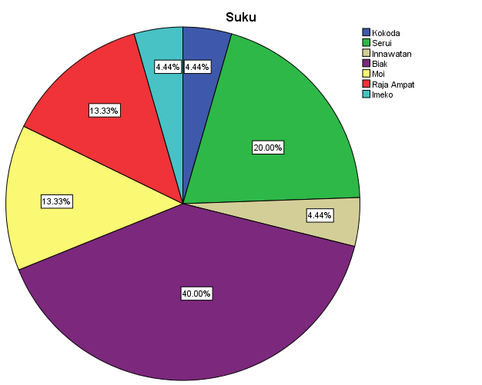
Source: Data, 2023

Based on the diagram above, the provision of box container assistance for indigenous Papuans is right according to the planned target where the allocation of this business infrastructure assistance is 80% allocated to indigenous Papuans. This is related to the special autonomy fund which is indeed intended for the indigenous Papuan community. Special autonomy funds are funds provided by the central government to certain regions to support community development and empowerment. Especially for indigenous Papuans, special autonomy funds are expected to help and support small and medium enterprises (SMEs) in the community with the aim of improving the economy and community welfare. Based on law number 2 of 2021 concerning the second amendment to law number 21 of 2001 concerning special autonomy of Papua Province, the economy in Papua Province that utilizes natural resources is carried out by respecting the rights of indigenous peoples, providing legal certainty guarantees for entrepreneurs, and the principles of environmental preservation and sustainable development regulated by Perdasus [2]. In carrying out these efforts, it is important to prioritize local human resources, namely indigenous Papuans. The impact of box container assistance to the community includes:
- Business capital that helps small and medium enterprises (SMEs) in the community. The Sorong City government's policy in providing box container business capital assistance for the community to develop small and medium enterprises (SMEs) is certainly very helpful for people who are going to start a new business or small business. SMEs are an alternative in answering the problem of high unemployment in Sorong City. During the Covid-19 pandemic, SMEs are a sector that is able to survive with little profit amid many who have lost their jobs [3]. To enable small and medium-sized businesses to become self-sufficient, this box container assistance program must be carried out gradually. Providing business actors with the resources, opportunities, knowledge and skills necessary to increase their capacity to determine their future.
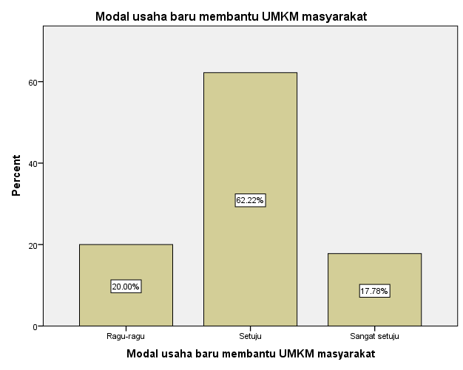
Source: Data, 2023

Based on the results of research on people who received box container assistance, as many as 62.22% of the community agreed that this infrastructure assistance could be a new business capital that helps SMEs for the community. The people who received this box container business capital assistance are new SMEs and also those who initially did have a business which was then supported by the government by providing capital assistance for SME infrastructure. In the structure of Indonesia's economy, SMEs are a productive people's economic activity, whose existence dominates in the national and local economic structure. Some types of businesses run by the community include the sale of areca nuts, vegetables and fruits, beverage processing (pop ice) and various kinds of snacks and drinks.

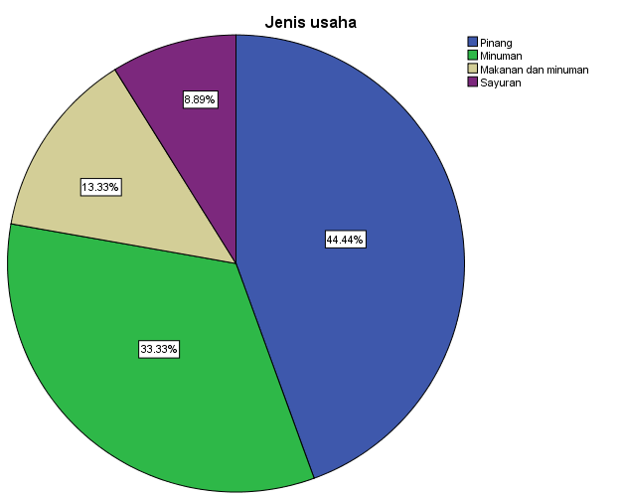
Source: Data, 2023
The diagram above shows the types of community businesses that use box container assistance from the Sorong City government. The most common type of business is the sale of areca nuts and drinks (pop ice) with the use of 2 x 1 meter type box containers. In the distribution of the box container assistance program, the Sorong City Cooperatives and SMEs Office distributed box container sizes of 2 x 1 meters, size 2 x 1.5 meters, and size 2 x 1.8 meters. Chapter VI Article 20 of Law No. 20 of 2008 concerning Micro, Small, and Medium Enterprises stipulates that local governments must support business growth by providing incentives to Micro, Small, and Medium Enterprises in terms of technology development, environmental sustainability, and development. With units and sections available and effective and experienced staff in their fields, the implementation of the program is getting closer to the goal. This box container assistance program has been implemented by the Sorong City Cooperatives and SMEs office well as conveyed by Mr. Thamrin Tajauddin, ST, MM (Assistant for Economic Administration and Development of the Sorong City SETDA) that, the staff in the Sorong City SME office make observations or visit the addresses where business proposals submitted by the community are submitted to get business capital facilities. There are several people from the community who include proposals as a basis for receiving assistance. But not necessarily then the proposal came in and was immediately given. The provision of business facility assistance is not necessarily directly distributed to the community, the Sorong City SME Office will check businesses owned by the community who submit business assistance proposals or who register to get the box container assistance program. According to the informant above, people who can receive this assistance are people who already have businesses such as areca nut sellers, processed beverages, daily necessities and others.
- Creating jobs for women. Based on the results of the study, the majority of small business actors who use box containers are women or housewives. In addition to their daily life as housewives, they also open a small business using a box container that is usually placed in front of their house. In the development of the local economy, women's empowerment is one of the aspects that needs to be done. According to Canzanelli, local economic development is a participatory process that encourages and provides a way for local stakeholders to increase local competitiveness with the aim of creating decent jobs and creating sustainable economic activities. Local economic development is a concrete step taken as an effort to create jobs and encourage economic activities at the local level with the aim of improving people's living standards [4]. This is in accordance with the concept of effectiveness, where a program is measured how far the target can be achieved, then it is called effective [5]. So if you look at the results of the research, which with the assistance of this business capital facility, it can be said to be effective because it creates jobs for indigenous Papuan women.
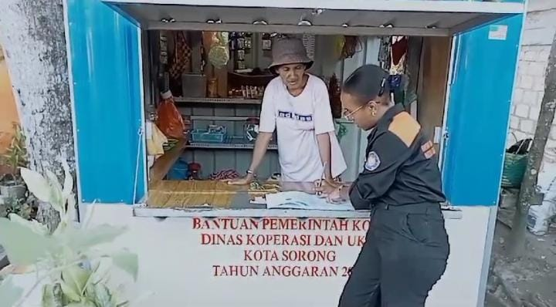
Figure 1. The Container used to sell by Mama Papua
The Sorong City Government through the Sorong City Cooperatives and SMEs Office has provided business capital infrastructure assistance, namely box containers for the community, especially the indigenous Papuan people with the aim of improving the standard of living and economy of the community. The participation of women in small and medium enterprises (SMEs) is a reality in the economic life of some indigenous Papuans. Women have the potential to carry out various productive activities that can be profitable and also add to the family economy. The role of women in the SME sector is related to the trade and processing industries such as klontong stalls, food and beverage processing, because this business can be run at home so that they do not leave their homework as housewives [6]. If viewed from the aspect of benefits, the impact of this box container assistance program on indigenous Papuan women is in line with Steers' statement which defines effectiveness as an effort to achieve a benefit in the organization by all means. He emphasized that the greater the profit obtained by the organization, the more effective the organization will be. Thus, an activity is said to be effective if the activity provides benefits to the organization and society according to its needs [7].
- Adjusting the location of selling. The use of box containers as a place of business by business actors or traders has become a popular trend in recent years. In addition to having an impact on traders, box containers also have an influence on the spatial layout of the city in their placement. The Sorong City Government hopes that with this assistance, SMEs from the indigenous Papuan community will get a decent selling location.
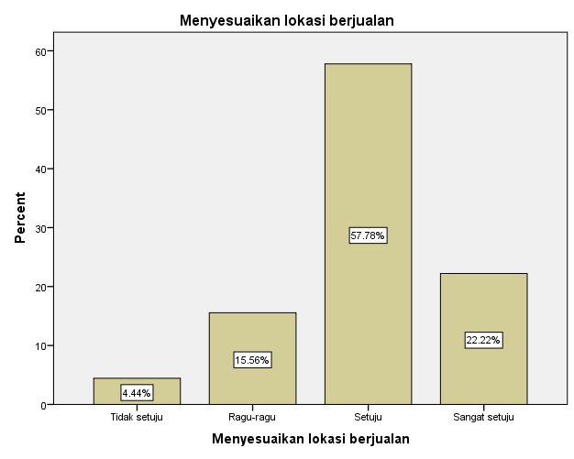
Source: Processed Data, 2023
Based on the diagram above, the use of box containers can adjust the selling location of SMEs, especially women. As discussed earlier, the majority of SMEs who use this box container are housewives, so that in the placement of this box can be placed in front of the house or yard of the community's house and can be placed according to the location of the sale. The existence of a poorly regulated place of sale can interfere with the spatial planning of the city and damage the visual beauty. With the existence of this box container, it can optimize the use of limited space, can be moved to adjust the location according to specific needs and events. This is in accordance with what was conveyed by the Assistant for Economic Administration and Development of the Sorong City SETDA in an interview on December 19, 2023.
"I think overall actually, the steps taken by this government are a necessity, especially since we in the city no longer allow the government to let business activities be sluggish. That's why with this box container, it is hoped that everything will be organized as a whole. Especially we have indigenous Papuans".

Based on the above statement, the government wants business actors, especially Papuan mothers (Papuan natives) to get a decent selling location. He added that;
"We actually educate them to or educate them that they sell moderately. They no longer sell in their customary ways of preparing tables and then later take them home again, later they will sell them again and bring them back, it's a pity then. We hope that later with this assistance, they will be really calm and safe where they sell. Do not bring his goods home again and bring them back so that he is also protected when he sells such as for example heat, rain and so on".
In addition to providing assistance for micro business actors, the purpose of the local government is also to provide knowledge to business actors to sell in today's times, where the use of box containers has become a trend in community SMEs and its use makes the urban spatial layout neatly arranged.
- Sustainable Model
The procurement of box containers for small and medium enterprises (SMEs) in Sorong City has been carried out by the Sorong City Cooperatives and SMEs Office, where this procurement is budgeted from special autonomy funds for the 2022 fiscal year. This form of business capital facility assistance can be held again with several proposals or inputs from the community who have used it.
- Container Size Design/Model. The community hopes that if later this business capital facility assistance program will be held again, comfort and safety in its use must be prioritized. For example, the size of this type of box container adjusts to the type of business to be managed. Based on the results of the research, business actors, especially women, want a place to sell that is considered comfortable and safe to trade.
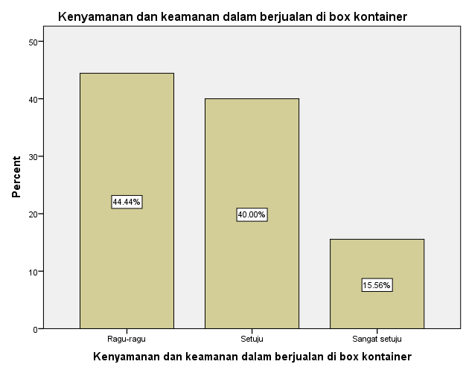
Source: Processed Data, 2023
From the results of the diagram above, it shows that the use of this box container is not considered comfortable and safe in selling for several reasons. For example, when the government provides box container assistance with a type size of 2 x 1 meter with the type of beverage processing business (for example, popice) or areca nut. So that in the future, when the local government budgets again, this business capital facility is expected to adjust to the type of business in the community. In addition, there needs to be a visual attraction to the business capital facility.
- Low Maintenance Costs. The cost of maintaining this box container is considered easy and cheap by the public. According to one of the business actors, since this business started, there has not been much damage to this box container as long as they maintain and maintain the facility.
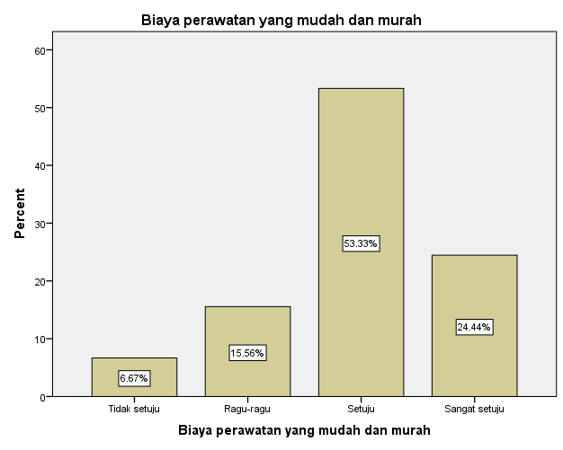
Source: Data, 2023
In addition to low maintenance costs, business actors also feel that this assistance program makes it easier for them to start a business. According to one of the business actors (RK, 25 years old) that he started selling after the existence of this business facility. They placed this box container on the side of the main road which was indeed provided for a selling location so that they could sell areca nuts to more consumers than if this box container was placed in front of the house, where the location of the house was in an alley. With the existence of this box container, it reduces the business capital that must be spent.
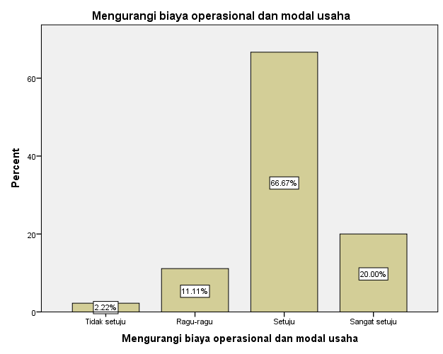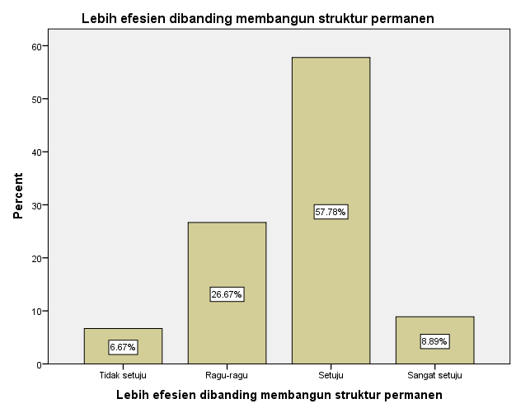
Source: Data, 2023
Based on the diagram above, what was conveyed by the informant was in accordance with the responses of other business actors. What was conveyed by the informant if it is studied based on the benefit aspect of effectiveness, then if an activity is useful or provides benefits to the community, it can be said that the program is effective. So that in the planning of the APBD budgeting, it is necessary to reallocate the budget for government activities to help business actors in providing business capital, especially the indigenous Papuan people.
- Selection of Aid Recipients. If this assistance program will later be held again or budgeted for the procurement of box containers, there needs to be a selection in providing business capital assistance to business actors. Determine clear criteria for selecting recipients of business capital assistance. Because based on the results of monitoring in the field, there are also many boxes that are not opened or people are not selling.

- Kiki Fitriani, The Effectiveness of BUMDes Business Capital Loans Increases the Economic Income of the Community of Sungai Meranti Village, Pinggir District, Bengkalis Regency in the Perspective of Sharia Economy. Thesis. Repository of Sultan Syarif Kasim State Islamic University. 2020
- Law Number 2 of 2021 concerning the Second Amendment to Law Number 21 of 2001
- Martinus Solo, "Indigenous Papuans Get Box Container Assistance for Trade". Media Indonesia, December 16, 2022. https://mediaindonesia.com/nusantara/545004/orang-asli-papua-dapat-bantuan-box-container-untuk-berdagang
- Rojaul Huda, "Local Economic Development Through the Tourism Sector in Serang Village, Karangreja District, Purbalingga Regency", Aspiration: Journal of Social Problems, Vol. 11, No. 2 December 2020.
- http://repository.uin-suska.ac.id/13183/7/7.%20BAB%20II_2018363ADN.pdf
- Ulya, N., & Wahyudi, A. (2022). The role of women in the revival of the local economy through micro, small and medium enterprises is reviewed from the perspective of Islamic economics. SERAMBI: Journal of Islamic Management and Business Economics, 4(3), 267 – 276.
- C. Punu, "The Effectiveness of Community Empowerment Programs for Small and Medium Enterprises (SMEs) in Manado City," Journal of Governance, vol. 1, no. 2, 2021.

