Digital Innovations in Southeast Asian: Research-Driven Mapping Local Governance for Efficiency and Participation

Submitted:  20 January xxxx  Revised:  13 March xxxx  Accepted:  27 April xxxx | Abstract  This study addresses issues of bureaucratic inefficiency and low public participation in governance by systematically mapping the scope of digital innovation in local governance throughout Southeast Asia. The research seeks to understand how technology aids governance outcomes, guided by the region’s disparities in digital infrastructure and institutional readiness. The study conducts a systematic literature review of 996 publications from Scopus, following the PRISMA protocol and employing bibliometric analysis via RStudio-Biblioshiny and CiteSpace to derive trends, themes, and gaps concerning Indonesia, Malaysia, Singapore, Thailand, and the Philippines. The results demonstrate and actively reinforce the three dominant innovation clusters: smart cities, e-government systems, and citizen participation platforms that foster greater democratic engagement alongside improved administrative efficiency. The analysis emphasizes the factors critical for successful digital transformation: institutional readiness, digital competency, and cross-organizational collaboration. By synthesizing regional best practices and thematic patterns, the research provides strategic recommendations for policymakers aiming to cultivate flexible, inclusive, and ethically responsible frameworks of implications focused on formulated digital governance. These findings emphasize the need to align technology with community needs and participatory processes, thereby directing further research on interoperability, AI ethics, and public trust in digital public administration.  Keywords: Digital Transformation, E-Government, Smart Cities, Local Governance, Public Participation.
Abstrak

Studi ini membahas masalah ketidak efisienan birokrasi dan rendahnya partisipasi publik dalam tata kelola pemerintahan dengan secara sistematis memetakan ruang lingkup inovasi digital dalam tata kelola pemerintahan di seluruh Asia Tenggara. Penelitian ini bertujuan untuk memahami bagaimana teknologi mendukung hasil tata kelola pemerintahan, dengan mempertimbangkan disparitas infrastruktur digital dan kesiapan institusional di wilayah tersebut. Studi ini melakukan tinjauan literatur sistematis terhadap 996 publikasi dari Scopus, mengikuti protokol PRISMA, dan menggunakan analisis bibliometrik melalui RStudio-Biblioshiny dan CiteSpace untuk mengidentifikasi tren, tema, dan celah terkait Indonesia, Malaysia, Singapura, Thailand, dan Filipina. Hasilnya menunjukkan dan secara aktif memperkuat tiga kluster inovasi dominan: kota pintar, sistem e-pemerintahan, dan platform partisipasi warga yang mendorong keterlibatan demokratis yang lebih besar bersamaan dengan efisiensi administratif yang lebih baik. Analisis ini menyoroti faktor-faktor kritis untuk transformasi digital yang sukses: kesiapan institusional, kompetensi digital, dan kolaborasi lintas organisasi. Dengan mensintesis praktik terbaik regional dan pola tematik, penelitian ini memberikan rekomendasi strategis bagi pembuat kebijakan yang bertujuan untuk mengembangkan kerangka kerja yang fleksibel, inklusif, dan etis dalam tata kelola digital. Temuan ini menekankan pentingnya menyelaraskan teknologi dengan kebutuhan komunitas dan proses partisipatif, sehingga mengarahkan penelitian lebih lanjut pada interoperabilitas, etika AI, dan kepercayaan publik dalam administrasi publik digital.

Kata Kunci: Transformasi Digital, E-Government, Smart Cities, Tata Kelola Pemerintahan Lokal, Partisipasi Publik.

INTRODUCTION
In Southeast Asia, digital transformation has become one of the more pressing triggers for reform within local governance systems. Within the context of the socio-economic and political landscape frameworks, digitalization creates new opportunities for improving the bureaucratic functions of an administration, including efficiency, transparency, and public participation participation participation (Greavu-Şerban et al., 2025). In response to changing governance issues, countries like Indonesia, Malaysia, and the Philippines have incorporated varying degrees of technology with e-government systems, smart cities, and online participatory governance (Llovido et al., 2024; Matitah et al., 2021; Zukarnain et al., 2020). There is still insufficient understanding regarding the gap-driven initiatives implemented concerning the adoption and localized implementation of practical digital innovations (David et al., 2023).
Smolinski, (2024) underscores the fragmentation of research across various literature streams as lacking in-depth thematic synthesis. In turn, such a synthesis makes it difficult for policymakers and practitioners to extract best practices and evaluate digitalization’s real impact on operational efficiency and public participation (Doran et al., 2023). In this regard, more holistic approaches are necessary to understand the landscape of digital innovation within the framework of regional governance, particularly in the Southeast Asian context, which is marked by cultural diversity coupled with uneven levels of development and challenges in digital infrastructure (Caplanova & Dimelis, 2025). Here, systemic and data-driven frameworks are more suited for comprehensive understanding of the region’s unique and complex characteristics.
Through this study, we seek to chart the digital innovations within local governance frameworks across Southeast Asia using a systematic literature review methodology. Specifically, we strive to analyze and identify the gaps and the implemented technologies to improve administrative efficiency and community engagement. Emphasis on a data-driven framework, alongside the PRISMA protocol, aims to advance theoretical and practical perspectives for building more inclusive and sustainable digital policies. An equally important objective addresses the role of technological innovations in enhancing citizen engagement in the public decision-making process.
In Indonesia, e-Musrenbang and social media platforms in the Philippines have engaged citizens in the policy design and assessment phases (Loeffler & Martin, 2023). As Hien et al., (2024) noted, such digital participation enhances transparency and reinforces the legitimacy of public policies. Technology can also advance efficiency in administration, which is exemplified by Indonesia’s Digital Land Administration and Singapore’s Smart Nation Initiative, both of which streamline bureaucratic functions, enhance data precision, and increase public service accessibility (Efthymiou, 2025; Nursyamsi et al., 2020).
From this study, policymakers are expected to gain strategic direction to formulate adaptive and evidence-based digital strategies. By mapping best practices from other Southeast Asian countries, the study contributes to understanding how cross-sector collaboration among governments, civil society, and businesses can foster sustainable and inclusive digital policy innovation (Klievink, 2015; Li et al., 2024). This research underlines the role of digital literacy alongside institutional preparedness within the framework of local governance as critical to effective technology implementation. Thus far, this research has advanced the systematic mapping of local governance to include the dimension of digital innovation.
Integrating bibliometric analysis, data visualization, and thematic synthesis substantially contributes to the digital governance and public participation literature. His results are significant, not solely for scholars, but also for practitioners and decision makers who aim to comprehend and facilitate digital transformation. Thus, this research is anticipated to be a primary strategic reference in designing regionally adaptive and inclusive governance frameworks underpinned by technology.

RESEARCH METHODS
This research performed a literature review analysis on the case of digital transformation in local governance, viewing it as a mapping of the administrative and public participation processes, efficiency, innovation, and technology using the Scopus database (Rodríguez-Bolívar et al., 2018). Scopus was chosen because of its multidisciplinary scope and reputation for rigor and relevance, as evidenced in peer-reviewed publications (Gusenbauer, 2022). This database assists in framing primary concepts related to governance and aids in synthesizing literature concerning policies and best practices about technology in public administration (Landum et al., 2020). This study analyzes literature to identify knowledge gaps and integrates conclusions to derive comprehensive reviews and describe innovations and outcomes mapping, and extensively highlights challenges, technology-algorithmic solutions to the performance and engagement enhancement for government and community collaboration (Sarafis et al., 2025).
Protocols and Frameworks
This study follows PRISMA guidelines for obtaining and analyzing literature dealing with efficiency, transparency, and public involvement in a bureaucracy for purposes of order and consistency (Page et al., 2022). Page et al., (2021) indicate that PRISMA is both a checklist and a flowchart describing stepwise reporting for all systematic mapping studies. It was deemed more beneficial to use systematic mapping in this study on the various approaches to bureaucratic efficiency, transparency, and public participation, as compared to traditional systematic reviews. (Rozanc, 2018). There is more focus on systematic reviews; however, systematic mapping targets finding gaps, classifying important research, and tracking the progress of themes over time related to bureaucratic efficiency, transparency, and public participation (Turk, 2021).
Inclusion and exclusion criteria
After the search stage, the identified studies are screened to eliminate irrelevant research. The collected studies were analyzed based on inclusion and exclusion criteria to ensure only articles that provided direct insights into digital transformation in local governance were included. The search was limited to studies published between 2014 and 2024, to capture the latest trends in government technology innovation. The selection of this time coverage aims to avoid historical bias and ensure the relevance of the data to the challenges and implementation of digital systems in public administration today. Inclusion criteria include:
- Language: Only English-language articles to ensure accessibility and compatibility with bibliometric analysis.
- Type of publication: Only scientific journals are included, while percentages, posters, and short reports are excluded.
- Relevance to the research statement: An article that directly discusses Digital Transformation in Local Governance: Mapping Technological Innovation to Improve Efficiency and Public Participation.
- Publication version: If a study is published in multiple journals, the most recent version with updated data is used.
The following studies were excluded from further review:
- Articles that are not in English, to maintain consistency in the analysis.
- Papers that only contain policy recommendations without empirical analysis or experiments related to digital transformation in local governance.
- Editorials, books, chapters, and summaries of workshops or symposiums that do not meet the standards of academic publications.
- Articles with inadequate methodologies, such as lack of data sources, analysis techniques, or validation methods.
- Studies with less than five pages, which were judged to have insufficient information for in-depth analysis.
- Documents whose full text are not available, so they do not allow for a thorough analysis.
Search and Data Processing Strategies
Search the literature using a query {TITLE-ABS-KEY {"Digital Transformation" OR "Local Government Governance" OR "Technological Innovation" OR "Public Participation" OR "E-Government" OR “smart Cities" OR "Public Sector Digitalization" OR "Government Efficiency" OR "Civic Engagement" OR "Digital Democracy" OR "ICT in Governance" OR "Open Government Data" OR "E-Participation" OR "Automated Public Services" OR "Citizen-Centric Technology" OR "AI in Public Administration" OR "Blockchain in Government" OR "Government Transparency"). produced 2,813 documents on the implementation of digitalization in local government administration. Selected publications are exported to MS Excel as many as 996 for processing, such as titles, abstracts, keywords, and year of publication. Based on PRISMA guidelines (Athikarisamy & Patole, 2021). and assisted by the flowchart tool PRISMA 2020 online (Kahale et al., 2022). The modified framework is used to describe the process of identifying, evaluating, and refining structured literature. This adjustment ensures alignment with the research objectives in mapping digital transformation strategies to improve bureaucratic efficiency and public participation in local government.

Figure 1. PRISMA research method
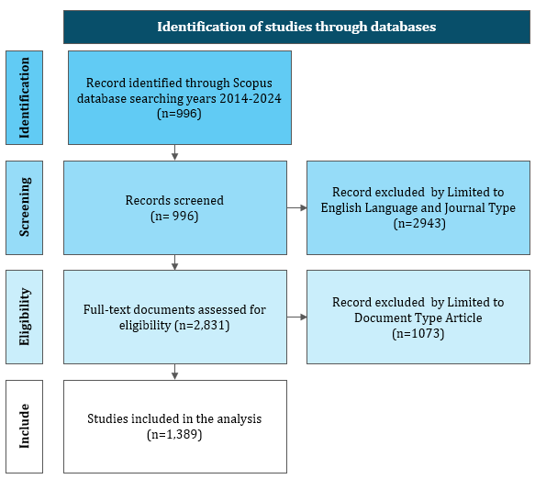
Source: Adapted from Page et al. (2021) generated thought Power Point
Data analysis and visualization
Using RStudio-Biblioshiny and CiteSpace, which help visualize literature networks and capture emerging trends, bibliometric maps were constructed utilizing 996 documents pertaining to the digital transformation of local government (Nurmandi et al., 2021; Syahputra et al., 2023). As part of this research, RStudio-Biblioshiny was also used to perform statistical analysis and create tree maps, trend and cluster visualizations, which aid in the mapping of not only technological innovations in public administration but also enhanced citizen engagement (Barbosa, 2021; Chanduví et al., 2015).

RESULTS, DISCUSSION, AND ANALYSIS
Trends in the emergence of research topics
Visualizing text data through words and their corresponding frequencies-WordCloud is an effective analysis tool for determining and tracking research trends. While text McNaught & Lam (2010), work provided a qualitative study of WordCloud’s advantages in visual representation, many contemporary scholars have opted to employ it within more quantitative frameworks. More advanced algorithms have made it possible for scholars to track the advancement of the research problem, determine essential ideas, and distinguish new trends, all based on an assortment of articles and databases. Retaining raw data in aesthetically pleasing visuals gives researchers an insightful perspective on the emphasized issues and disciplines.

Figure 2. Wordcloud Analytics
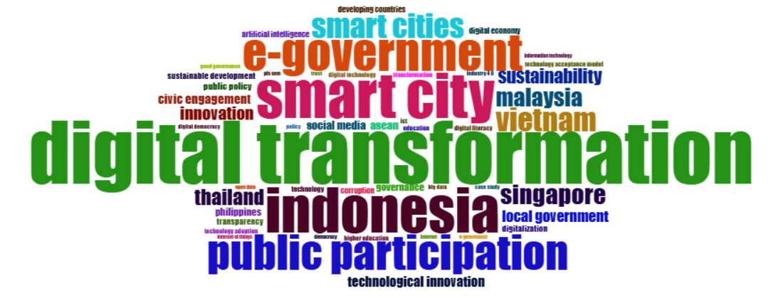
Source: Author generated through RStudio-Biblioshiny
Figure 2 shows that the significant concepts of digital transformation, smart cities, Indonesia, e-governance, and public participation emerged as the focal concepts that were interconnected and constructed the conceptual framework of this research. Digital transformation is a key factor because it denotes the local government’s adoption of technology meant for the modernization of bureaucracy, enhanced transparency, and improved public service delivery (Maulana et al., 2024). It is more than just systematizing the operation of government; it involves profound changes in the organizational culture and the interrelations between the governed and the governing bodies (Kamil et al., 2025). For Southeast Asia, the relevance of digital transformation is accentuated by the fast pace of socio-economic changes in the region and the need for agile governance (Anggono et al., 2025).
Moreover, smart cities can be viewed as the lower-level indicators of the digital transformation process at the regional scale. This approach incorporates information and communication technology (ICT) into sustainable development practices, thus fostering an agile, equitable, and effective urban ecosystem (Sucupira Furtado et al., 2023). The focus on Indonesia as the primary case study broadens the analysis as the country grapples with multifaceted issues concerning the digital development continuum, technology access divide, and organizational capability capacity (Kusmiarto et al., 2021). On the contrary, e-government is essential in realizing more open and participatory governance by enabling service delivery and public participation remotely (Boon et al., 2020).
Mapping Research Topics
Conceptual structure maps incorporate cluster analysis to conduct systematic reviews and visualize research topics (Reutterer & Dan, 2021). With this method, researchers can discern both homogeneous and heterogeneous conceptual patterns across various disciplines (J. Wang et al., 2023). Additionally, this approach focuses on efficient clustering techniques and scalable algorithms, which are essential for capturing the complete structure and dynamics of the research topics under investigation through cluster analysis (Gupta et al., 2023).

Figure 3. Conceptual Structure Map
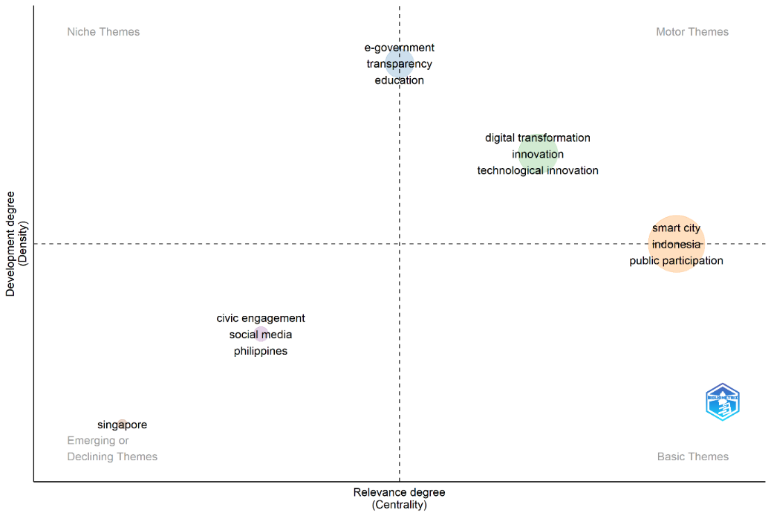
Source: Author generated through RStudio-Biblioshiny
Figure 3 shows the first cluster from the factorial analysis centers around the key terms “smart cities,” “Indonesia,” and “public participation.” This cluster illustrates the concept of smart cities in Indonesia while stressing the necessity of public participation. In this regard, the solutions for implementing smart cities in Indonesia are guided by collaboration between the governing bodies and the community willing to participate. As per Law No. 23 of 2014 stipulations, the regional innovation framework provides for community participation to solve socio-economic and environmental problems (Syah et al., 2024). The realization of smart cities hinges on active public engagement, a cornerstone in sustainable development driven by technology (Febriani et al., 2024).
The second cluster concentrates on the most recent trends of “digital transformation and technological innovation,” using the keywords “digital transformation,” “innovation,” and “technological innovation.” This cluster showcases the pivotal function of technological innovation as a primary motor for change in the digital governance system. Developments that enable smart cities to emerge systematically integrate innovative technologies into urban management (Dremlyuga & Korobeev, 2023). Moreover, managing the digital economy profoundly influences governance, particularly in modernizing systems and developing institutional capacities (Liu et al., 2024). Newer regional initiatives like the DSR (Digital Silk Road) and DEPA (Digital Economy Partnership Agreement) have sought to advance digital collaboration and policy integration amongst Southeast Asian nations (Corning, 2022).
This analysis’s third cluster revolves around e-government and its transparency and education dimensions. It highlights the relationship connecting the two sides with a clear emphasis on the education sector. This study determines that e-government has a significant and positive impact on enhancing transparency and accountability in the education sector through increasing accessibility to information. These solutions would help foster public trust and resolve many public implementation challenges if implemented. Thus, there is ample opportunity for e-government to revamp governance models in the education sector and transform the associated outcomes (Howard et al., 2020). Nevertheless, sustained work is needed to ensure the effective implementation of e-government services across all educational institutions (Zhang & Kaur, 2024).
Figure 4. Cluster of Co-Cited References
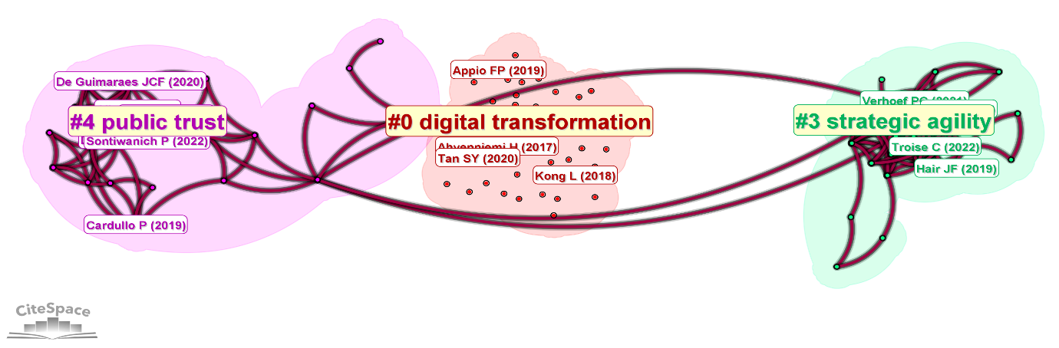
Source: Author generated through CiteSpace
Figure 4 shows that three clusters have been formed through shared citation analysis in Southeast Asia’s digital governance discourse, as depicted in figure 4. Cluster 0 is referred to as “smart City Strategy.” It focuses on the power of digital technology to catalyze change in contemporary urban planning and sustainable development (Ziehl et al., 2023). Global discourse on smart cities focuses on their proliferation; most developed urban centers serve as nadirs for smart city influx (Joss et al., 2019). This study aims to analyze the conceptual interrelations of innovative and sustainable cities. Articles after (Sontiwanich et al., 2022). offer their perspectives on citizen participatory engagement and the uneven planning silos in Thailand. Key topics are smart cities, digital transformation, and the “standardization” of innovative city development, describing a movement towards participatory and holistic digital urbanism.
This focus on the “strategic Renewal in Digital Transformation” (silhouette value: 0.993), which forms the third cluster, centers on adopting digital technology in enterprises, tiny and medium-sized businesses, and the logistics industry. This cluster is validated through seminal contributions like (Naushad & M. M, 2020). which provide frameworks for PLS-SEM reporting. (S. Wang et al., 2024). which develops a multidisciplinary research agenda for digital transformation. The cluster’s thematic focus includes strategic agility, technology-organization-environment frameworks, and digital capabilities. Contributions of this cluster include (Saeedikiya et al., 2025). which analyzes digital readiness in SMEs and logistics companies in Vietnam, suggesting a strategic regional shift in innovation during accelerated digital transformation.
In the same way, with the title “sustainable Development and Public Trust,” Cluster #4 focuses on sociotechnical aspects of digital urbanism, particularly inclusivity and public trust as well as legitimacy in innovative governance. This compilation works like (Przeybilovicz & Cunha, 2024) and (Jiang et al., 2020), which criticized the citizens” participation in Dublin’s brilliant city initiative. It discussed big data and the implications of AI in smart cities. Citing works like (Chang & Das, 2020). raises worries about the smart city and Singaporean governance model using AI. Terms like `public trust`, `citizen-centric smart cities`, and `digital legitimacy` highlight the need for the public to consider acceptance and engagement about the sustainability of smart cities in Southeast Asia.
Evolution of Research Topics
Utilizing Biblioshiny with RStudio, complemented by a Sankey diagram, provides a comprehensive perspective on the study. Such visual aids are beneficial for researchers in identifying intersections of interest among multiple themes, anticipating emerging trends, and uncovering significant relationships relevant to the investigative problems at hand (Ramasubbareddy et al., 2019). Therefore, this method sharpens the focus for thematic analysis and assists in meticulous multi-domain data evaluation.
Figure 5. Sankey Diagram of Thematic Evolutionary Sources
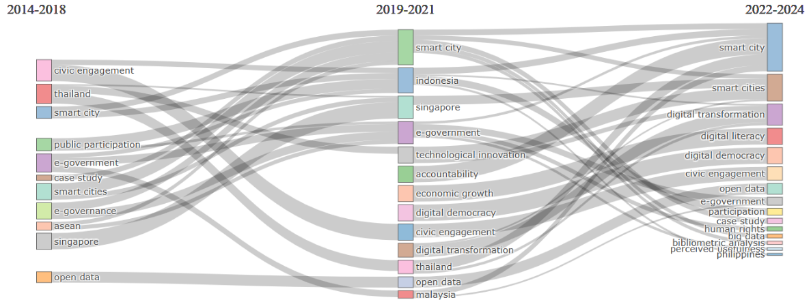
Source. Author generated through RStudio-Biblioshiny
Thematic evolution from 2014 to 2018 with regard to Southeast Asia’s local government digital innovation, emphasizing civic engagement and government transparency, is captured in Figure 5. During this period, governance digital transformation was associated with heightened civic engagement, improved collaboration, active empowerment, and a better quality of life (Rashdi, 2024). Moreover, the research explores how the community in the Southeast Asia region can alter the social ecosystem digitally, reinvigorate social life, and enable better governance (Lim, 2025). During this timeframe, it was noted that the e-government systems had achieved major gains in transparency; 70% of respondents reported enhanced access to informational and governmental services (Setyarto et al., 2025).
In addition, the attention given to the capacity of technological changes to ensure the accountability of government and enable citizens’ participation through digital democracy was sustained from 2019 to 2021. Retrieval and dissemination of information related to politics by governments, their affiliated agencies, civil society organizations, and citizen groups has been made easier due to innovations in the practice of digital democracy technology (Kusumasari, 2018). Moreover, technology integration into governmental functions has proven to increase civic engagement as well as participatory citizenship (Belkhamza, 2024). This particular shift shows that e-government initiatives have a strong and positive impact in regards to citizen engagement and trust, transparency, civic effectiveness and responsibility, public service accountability, and overall public service delivery.
It is observed that Hien et al., (2024). have reported these features as a composite of factors that facilitates systematic public engagement and trust in government institutions. A notable trend from 2022-2024 is the expansion in the scope of digital transformation that has a focus on empowerment and rights of the public. The efforts within this period of the research showcase how public services are increasingly transforming towards a citizen-centric approach with real-time engagement that is holistic and inclusive (Frach et al., 2016). An Illustrative example undergoing this transformational shift is the Republic of the Philippines, which is being propelled by a perfect storm of government policy, technological advancement, and changing consumer behaviors (Rey et al., 2024). Consequently, from a strategic perspective relating to public administration, there is a need to undertake service delivery improvement concerning governance through the automation of interfaces with citizens and the business community via integrated systems, online portals, and interoperable data frameworks (Di Martino et al., 2022).
Table 1. Top 10 Keywords with the Strongest Citation Bursts
Keywords | Strength | Begin | End | 2014 - 2024
developing country | 3.21 | 2014 | 2018 | ▃▃▃▃▃▂▂▂▂▂▂
e-government | 2.49 | 2014 | 2021 | ▃▃▃▃▃▃▃▃▂▂▂
public participation | 4.08 | 2015 | 2017 | ▂▃▃▃▂▂▂▂▂▂▂
civic engagement | 3.27 | 2015 | 2017 | ▂▃▃▃▂▂▂▂▂▂▂
local participation | 4.19 | 2016 | 2020 | ▂▂▃▃▃▃▃▂▂▂▂
public policy | 2.76 | 2017 | 2019 | ▂▂▂▃▃▃▂▂▂▂▂
smart cities | 2.74 | 2019 | 2020 | ▂▂▂▂▂▃▃▂▂▂▂
social media | 2.74 | 2020 | 2021 | ▂▂▂▂▂▂▃▃▂▂▂
governance approach | 2.16 | 2021 | 2022 | ▂▂▂▂▂▂▂▃▃▂▂
service quality | 2.28 | 2022 | 2024 | ▂▂▂▂▂▂▂▂▃▃▃
Source: Author generated through CiteSpace
Table 1 shows that the literature includes topics like local and public participation, showcasing the significance of community engagement within the digital governance framework. Reaching out to communities is a crucial step towards closing the digital divide. Moving forward, the development of policies must focus on creating manageable and user-friendly systems. Such systems should be centered on community participation, where system design considers the needs of various stakeholders and their suggestions are continuously integrated into the governance cycle. A community-centric model requires the inclusion of participatory policymaking, innovative technology, and continuous feedback systems (McKinley et al., 2021). Therefore, to mitigate the digital divide while fostering community engagement, local governments must establish frameworks that position citizens as key contributors in the governance process, transcending the role of mere service consumers to active participants in policymaking and evaluation (Freeman, 2016).
In the interim, these keywords, citizen engagement and developing countries, are informative regarding the issues and possibilities of digital transformation in the Southeast Asian region. The first one, “citizen engagement”, focuses on mobilizing the public in communal activity facilitated through technology, for example, online consultations, digital forums, and citizen reporting applications (Aboucaya et al., 2022). The other one, “developing countries”, describes the region’s unique underlying socioeconomic characteristics, such as the digital divide, which has a gap in technological infrastructure, sparse technology education, and limited accessibility (Prajaknate, 2017).
Timeline trends of keywords
The keyword network diagram produced by CiteSpace encapsulates the overview of the entire research topic. It reveals the relationships among “smart cities,” sustainability, and "digital transformation" over the period 2014-2024, enabling advanced thematic inquiry and interdisciplinary analysis.
Figure 6 Timeline View of Topics

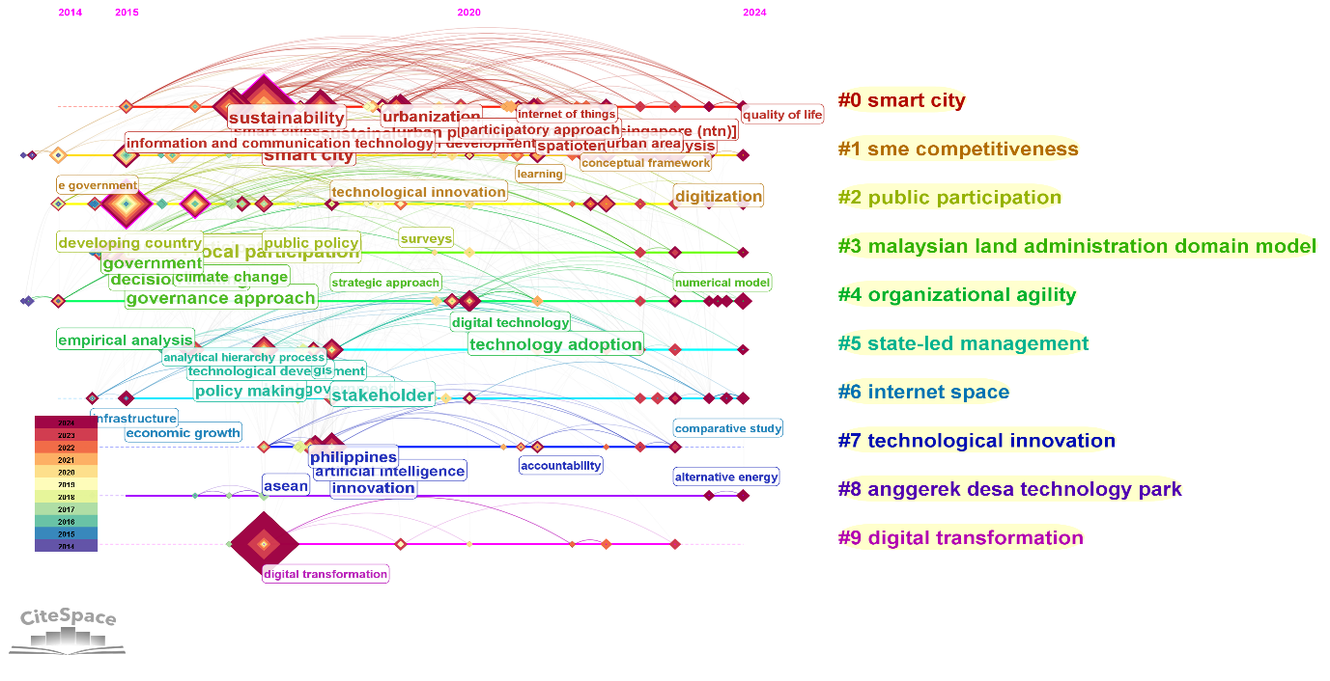
Source: Author generated through CiteSpace
Figure 5 shows that the digital transformation landscape in local governance for Southeast Asia has been organized into three primary clusters that share thematic overlap. The smart city innovation focus, represented as the first cluster with (Cluster #0) label, has a silhouette value of 0.766 and the highest number of documents within the dataset. This cluster is defined by the emphasis on participatory and sustainability strategies in innovative city development, which has been benchmarked against case studies from Helsinki, Singapore, and London (Shamsuzzoha et al., 2021). The terms smart city, sustainability, and sustainable development characterize the focus on managing the city’s environmentally oriented technologies. Singapore and Indonesia serve as the focal points in this body of literature.
The second cluster, which is labeled as (Cluster #1), focuses on the issues of digital transformation concerning the boost in productivity of small and medium enterprises in Southeast Asia, most notably in Malaysia and Indonesia. At a silhouette value of 0.73, this cluster displays a firm relation between the use of digital technology and innovation in business models. Businesses are digitally transforming, as illustrated in the study of digital business model innovation by Fang et al. (2024) and supplier loyalty in the digital transformation era by Mujianto et al. (2023). The keywords previously mentioned, like innovation in technology, digitization, and civic engagement, reveal that the effect of digital innovation transcends economic productivity to social relations and corporate governance changes.
Third Cluster (Cluster #2) Concentrates on Public Participation and Citizen Engagement in Public Policy and Resource Management. With Silhouette value the highest among the other three clusters (0.777), this theme illustrates the coherence of issues in the study of community participation. Concerning groundwater resources management in Thailand (Piyapong et al., 2019). and “The Failure of E-Government in Developing Countries” Gunawong & Gao (2017) illustrates the relationship between policy awareness, policy construction, and the achievement of digital innovation. Dominant keywords, including public participation, local participation, and public policy, demonstrate that the achievement of digital governance rests on local governments” participatory legitimacy and responsiveness.
Digital Innovations in Local Governance in Southeast Asia
Table 2. Digital Innovations in Local Governance in Southeast Asia
Country | Digital Innovation | Form of Efficiency | Form of Participation | Source
Indonesia | West Java Digital Service (JDS) | Improves efficiency and accuracy of community data policies | Joint decision-making with stakeholders | (Maulana et al., 2024)
Indonesia | e-Musrenbang | Enhances transparency and accountability in city planning | Digital public participation mechanism | (Anindito et al., 2022)
Indonesia | Digital Land Administration | Modernization of land registration and improving data accuracy | Ensure access to digital services for vulnerable communities | (Bennett et al., 2023)
Malaysia | Smart City Governance (Kuala Lumpur) | Enhances public service quality through ICT | Increases citizen participation via social media and government apps | (Mutiarin & Lawelai, 2023)
Singapore | Smart Nation Initiative | Connects, collects, and comprehends data for efficient public service strategies | Engages citizens, especially vulnerable groups, in policy co-creation | (Aigner et al., 2022; Ni, 2022)
Thailand | E-Government | Standardizes infrastructure and improves service level standards | Encourages public engagement through digital platforms | (Noymanee et al., 2017; Thamjaroenporn & Achalakul, 2020)
Thailand | Local Government Awards | Incentivizes local governments to improve service delivery | Enhances public access to local government services | (Nagai & Kagoya, 2011)
Philippines | E-Governance in South Cotabato | Prioritizes and amplifies digital public administration | Uses social media for public engagement and content creation | (Bajar & Porsche-Ludwig, 2023)
Table 2 shows that digital innovations transform Southeast Asia’s local governance by improving service delivery and participatory frameworks. In Indonesia, the West Java Digital Service (JDS) initiative exemplifies the effective advancement of community data management through collaborative policymaker hubs (Maulana et al., 2024). Further, Anindito et al., (2022), argue that e-Musrenbang boosted transparency in planning processes through a quasi-participation framework, while Bennett et al., (2023). report that initiatives under Digital Land Administration enhanced the precision and service accessibility of land registration, particularly aiding marginalized groups. Such undertakings express growing national resolve towards addressing the digital divide and consolidating the enhancement of accountability, inclusion, and decisional agility through digitized frameworks.
In Singapore, the Smart Countries Initiative is an archetype of integrated digital governance innovation as it employs the “3Cs” (connect, collect, comprehend) architecture for data-driven service delivery and citizen participation. Centrally, the program advocates for community representation in digitally framed policy processes and multi-stakeholder collaboration as key (Aigner et al., 2022; Ni, 2022). Singapore further offers global leadership in the ethical use of innovative technologies by providing inclusion benchmarks at the core of governance frameworks. Malaysia, Thailand, and the Philippines also fall within the Southeast Asian region and exhibit differing degrees of progress regarding digital governance.
Malaysia’s Smart City Governance uses ICT to optimize service delivery and promote civic engagement via social media and other digital platforms (Mutiarin & Lawelai, 2023). In Thailand, basic e-government services are complemented by Local Government Awards and other incentivized participation (Noymanee et al., 2017; Thamjaroenporn & Achalakul, 2020). The e-Governance project in South Cotabato, Philippines, highlights social media’s dual role as an administrative interface and participatory tool (Aigner et al., 2022; Ni, 2022). Collectively, these studies illustrate that sustainable digital governance stems from the collaboration of government, civil society, and the business sphere, as well as the need for steady political will and public trust to foster innovation. I can adapt these insights into a policy brief, slide deck, or infographic.

CONCLUSIONS
This study systematically synthesized 996 scientific publications to digitally transform local governance in Southeast Asia. The results of the bibliometric analysis, along with thematic clustering, demonstrate the technological innovations of smart cities, e-government, and digital participation. These innovations have evolved over time to construct a conceptual system of digital transformation. These results reaffirm that the operational efficacy of the bureaucracy, together with heightened public engagement, is strongly influenced by the level of institutional preparedness and the digital literacy of the constituents. The research also emphasizes how data-driven governance with advanced social policy instruments responds to the region’s complex social issues.
With the primary goal of sustainability in mind, this research provides an indirect strategic reference for policymakers focusing on adaptive, technology-centered governance models. The highlighted practices from Indonesia, Malaysia, Singapore, Thailand, the Philippines, and other ASEAN countries underscore the role of cross-sector collaboration in establishing a democratic digital ecosystem. This research serves as a springboard for exploring AI ethics, interoperability within public systems, and the strengthening of trust in digital governance and transformations. Ultimately, the resilience of digital innovation in local government will rely on system design driven by community engagement as well as synergy between policies, technology, and the people’s actual needs.

REFERENCES
Aboucaya, W., Angarita, R., & Issarny, V. (2022). Detecting Obstacles to Collaboration in an Online Participatory Democracy Platform: A Use-case Driven Analysis. Proceedings - International Workshop on Equitable Data and Technology, FairWare 2022, 25–33. https://doi.org/10.1145/3524491.3527307
Aigner, I., Garai-Fodor, M., & Szemere, T. P. (2022). Singapore’s Journey as a Digit-all-ized and Innovative Smart Nation Toward Sustainability. ICCC 2022 - IEEE 10th Jubilee International Conference on Computational Cybernetics and Cyber-Medical Systems, Proceedings, 259–264. https://doi.org/10.1109/ICCC202255925.2022.9922714
Anggono, B. D., Wahanisa, R., Aulia Oktarizka Vivi Puspita Sari, A. P., & Adiyatma, S. E. (2025). Interrogating the Legal Foundations of Digital Transformation: Balancing Economic Growth and Social Welfare in the Era of Disruption. Volksgeist: Jurnal Ilmu Hukum Dan Konstitusi, 8(1), 191–211. https://doi.org/10.24090/volksgeist.v8i1.12211
Anindito, D. B., Sagala, S. A. H., & Tarigan, A. K. M. (2022). E-musrenbang: A digital framework for local participatory planning at the community level. International Development Planning Review, 44(2), 191–216. https://doi.org/10.3828/IDPR.2021.5
Athikarisamy, S., & Patole, S. (2021). Reporting of meta-analysis (PRISMA). In Principles and Practice of Systematic Reviews and Meta-Analysis (pp. 111–123). Springer International Publishing. https://doi.org/10.1007/978-3-030-71921-0_11
Bajar, J. T. F., & Porsche-Ludwig, M. (2023). Digital Innovations during the COVID-19 Pandemic: Facebook Use for Local E-Governance in the Province of South Cotabato. Philippine Political Science Journal, 44(3), 242–273. https://doi.org/10.1163/2165025X-bja10051
Barbosa, M. W. (2021). Uncovering research streams on agri-food supply chain management: A bibliometric study. Global Food Security, 28, 100517. https://doi.org/10.1016/j.gfs.2021.100517
Belkhamza, Z. (2024). The Innovation’s Role in Boosting e-Government Engagement in Global Economies. 30th Americas Conference on Information Systems, AMCIS 2024.
Bennett, R. M., Hutabarat, I. R., Unger, E.-M., Ginting, C. P., van der Vegt, H., & Latif, A. (2023). Digital Transformation in Indonesian Land Administration. In Geospatial Science for Smart Land Management (pp. 43–67). CRC Press. https://doi.org/10.1201/9781003349518-7
Boon, L. S., Malek, J. A., Hussain, M. Y., & Tahir, Z. (2020). Participation in e-government services and smart city programs: A case study of Malaysian local authority. Planning Malaysia, 18(3), 300–312. https://doi.org/10.21837/PM.V18I13.794
Caplanova, A., & Dimelis, S. (2025). THE DIGITAL PERFORMANCE AND COMPETITIVENESS OF PUBLIC SECTOR INSTITUTIONS IN SOUTHEAST ASIA. Journal of Competitiveness, 17(1), 101–126. https://doi.org/10.7441/joc.2025.01.06
Chanduví, D. A. G., Lama, G. L. R., & Morey, N. D. (2015). Analysis of Research Literature of Professional Competency Models with a Cognitive-motivational Approach. Procedia - Social and Behavioral Sciences, 171, 1400–1409. https://doi.org/10.1016/j.sbspro.2015.01.260
Chang, F., & Das, D. (2020). Smart Nation Singapore: Developing Policies for a Citizen-Oriented Smart City Initiative. In Developing National Urban Policies (pp. 425–440). Springer Nature Singapore. https://doi.org/10.1007/978-981-15-3738-7_18
Corning, G. P. (2022). ASEAN and the Regime Complex for Digital Trade in the Asia-Pacific. Journal of World Trade, 56(6), 915–938. https://doi.org/10.54648/trad2022038
David, A., Yigitcanlar, T., Li, R. Y. M., Corchado, J. M., Cheong, P. H., Mossberger, K., & Mehmood, R. (2023). Understanding Local Government Digital Technology Adoption Strategies: A PRISMA Review. Sustainability (Switzerland), 15(12). https://doi.org/10.3390/su15129645
Di Martino, B., Graziano, M., Colucci Cante, L., Esposito, A., & Epifania, M. (2022). Application of Business Process Semantic Annotation Techniques to Perform Pattern Recognition Activities Applied to the Generalized Civic Access. In B. L. (Ed.), Lecture Notes in Networks and Systems: Vol. 497 LNNS (pp. 404–413). Springer Science and Business Media Deutschland GmbH. https://doi.org/10.1007/978-3-031-08812-4_39
Doran, N. M., Puiu, S., Bădîrcea, R. M., Pirtea, M. G., Doran, M. D., Ciobanu, G., & Mihit, L. D. (2023). E-Government Development—A Key Factor in Government Administration Effectiveness in the European Union. Electronics (Switzerland), 12(3). https://doi.org/10.3390/electronics12030641
Dremlyuga, R. I., & Korobeev, A. I. (2023). Regulation of Smart City Technologies in Asian Digital Economy Leaders. Journal of Siberian Federal University - Humanities and Social Sciences, 16(5), 819–832.
Efthymiou, I.-P. (2025). The role of e-government and e-governance in modern societies. In Public Governance Practices in the Age of AI (pp. 45–68). IGI Global. https://doi.org/10.4018/979-8-3693-9286-7.ch003
Fang, T. M., Ahmad, N. H., Halim, H. A., Iqbal, Q., & Ramayah, T. (2024). Pathway towards SME competitiveness: Digital capability and digital business model innovation. Technology in Society, 79, 102728. https://doi.org/10.1016/j.techsoc.2024.102728
Febriani, R., Luthfi, Z. F., & Waldi, A. (2024). Participation of Citizen as Social Capital in LAPOR! Application in Indonesia. International Journal on Informatics Visualization, 8(3), 1185–1191. https://doi.org/10.62527/joiv.8.3.2239
Frach, L., Fehrmann, T., & Pfannes, P. (2016). Measuring digital government: How to assess and compare digitalisation in public sector organisations. In Digital Government: Leveraging Innovation to Improve Public Sector Performance and Outcomes for Citizens (pp. 25–38). Springer International Publishing. https://doi.org/10.1007/978-3-319-38795-6_2
Freeman, J. (2016). Digital civic participation in Australian local governments: Everyday practices and opportunities for engagement. In Public Administration and Information Technology (Vol. 15, pp. 195–218). Springer. https://doi.org/10.1007/978-3-319-17722-9_11
Greavu-Şerban, V., Gheorghiu, A., & Ungureanu, C. (2025). A multidimensional perspective of digitization in Romanian public institutions. World Development, 191. https://doi.org/10.1016/j.worlddev.2025.106996
Gunawong, P., & Gao, P. (2017). Understanding e-government failure in the developing country context: a process-oriented study. Information Technology for Development, 23(1), 153–178. https://doi.org/10.1080/02681102.2016.1269713
Gupta, V. K., Gupta, A., Agrawal, M., Sardana, A., Shukla, S. K., & Joshi, K. (2023). An Effectual Method for Clustering of Bigdata on the Cloud using Fuzzy c-means Algorithm. 2023 Global Conference on Information Technologies and Communications, GCITC 2023. https://doi.org/10.1109/GCITC60406.2023.10426546
Gusenbauer, M. (2022). Search where you will find most: Comparing the disciplinary coverage of 56 bibliographic databases. Scientometrics, 127(5), 2683–2745. https://doi.org/10.1007/s11192-022-04289-7
Hien, B. N., Tuyen, N. T. K., Lan, N. T., Ngan, N. T. K., & Thanh, N. N. (2024). the Impact of Digital Government Initiatives on Public Value Creation: Evidence From Ho Chi Minh City - Vietnam. Revista de Gestao Social e Ambiental, 18(2), 1–23. https://doi.org/10.24857/RGSA.V18N2-092
Howard, T. O., Winkelmes, M. A., & Shegog, M. (2020). Transparency Teaching in the Virtual Classroom: Assessing the Opportunities and Challenges of Integrating Transparency Teaching Methods with Online Learning. Journal of Political Science Education, 16(2), 198–211. https://doi.org/10.1080/15512169.2018.1550420
Jiang, H., Geertman, S., & Witte, P. (2020). A Sociotechnical Framework for Smart Urban Governance. International Journal of E-Planning Research, 9(1), 1–19. https://doi.org/10.4018/IJEPR.2020010101
Joss, S., Sengers, F., Schraven, D., Caprotti, F., & Dayot, Y. (2019). The Smart City as Global Discourse: Storylines and Critical Junctures across 27 Cities. Journal of Urban Technology, 26(1), 3–34. https://doi.org/10.1080/10630732.2018.1558387
Kahale, L. A., Piechotta, V., McKenzie, J. E., Dorando, E., Iannizzi, C., Barker, J. M., Page, M. J., Skoetz, N., & Akl, E. A. (2022). Extension of the PRISMA 2020 statement for living systematic reviews (LSRs): protocol. F1000Research, 11, 109. https://doi.org/10.12688/f1000research.75449.2
Kamil, M., Muhammad, R., Roziqin, A., Sari, A. E., & Kismartini. (2025). Examining Practice Smart City in Local Government: A Smart Governance Perspective. International Journal of Sustainable Development and Planning, 20(2), 635–644. https://doi.org/10.18280/ijsdp.200214
Klievink, B. (2015). Understanding public-private collaboration configurations for international information infrastructures. In T. E., P. P., S. H.J., T. K., K. B., J. M., G. M., L. I., & W. M.A. (Eds.), Lecture Notes in Computer Science (including subseries Lecture Notes in Artificial Intelligence and Lecture Notes in Bioinformatics) (Vol. 9248, pp. 170–180). Springer Verlag. https://doi.org/10.1007/978-3-319-22479-4_13
Kusmiarto, K., Aditya, T., Djurdjani, D., & Subaryono, S. (2021). Digital Transformation of Land Services in Indonesia: A Readiness Assessment. Land, 10(2), 120. https://doi.org/10.3390/land10020120
Kusumasari, B. (2018). Digital democracy and public administration reform in Indonesia. International Journal of Electronic Governance, 10(3), 317–337. https://doi.org/10.1504/IJEG.2018.095937
Landum, M., Moura, M. M. M., & Reis, L. (2020). ICT Good Practices in alignment with Green IT. In R. A., P. B.E., P. F.G., del M. M. M., & G. R. (Eds.), Iberian Conference on Information Systems and Technologies, CISTI (Vols. 2020-June). IEEE Computer Society. https://doi.org/10.23919/CISTI49556.2020.9141166
Li, Y., Zou, H., Qin, H., Liu, B., & Ji, H. (2024). Research on Government Incentive and Enterprise Data Resource Sharing Strategies in Digital Innovation Ecosystems. IEEE Access, 12, 25278–25295. https://doi.org/10.1109/ACCESS.2024.3362238
Lim, J. B. Y. (2025). Digital Media Interventions in Southeast Asia: A Decolonial Perspective. In Digital Media Interventions in Southeast Asia: A Decolonial Perspective. Springer Nature. https://doi.org/10.1007/978-3-031-78211-4
Liu, H., Gao, F., & Ma, P. (2024). Theoretical Logic and Policy Practice of Digital Economy Driving the Improvement of Macroeconomic Governance System —An Analysis Based on Marx’s Theory of Social Reproduction. Modern Economic Science, 46(4), 1–13. https://doi.org/10.20069/j.cnki.DJKX.202404001
Llovido, J. L., Brogada, M. A. D., Relucio, F. S., Austero, L. D., MacEda, L. L., & Abisado, M. B. (2024). BOSESKO: Designing A Synoptic Multi-Platform Digital System for Citizen Participation. International Conference on Advanced Communication Technology, ICACT, 376–383. https://doi.org/10.23919/ICACT60172.2024.10472009
Loeffler, E., & Martin, S. (2023). Citizen engagement. In Public Management and Governance: Fourth Edition (pp. 284–298). Taylor and Francis. https://doi.org/10.4324/9781003282839-25
Matitah, M., Arifin, S., Sumarto, S., & Widiyanto, W. (2021). Confronting E-Government Adoption in Indonesian Local Government. Journal of Indonesian Legal Studies, 6(2), 279–306. https://doi.org/10.15294/jils.v6i2.47795
Maulana, R. Y., Durnik, M., & Decman, M. (2024). Collaborative Approach on Digital Government Transformation: In-Depth Analysis from Expert Interview. NISPAcee Journal of Public Administration and Policy, 17(1), 94–119. https://doi.org/10.2478/nispa-2024-0005
McKinley, E., Crowe, P. R., Stori, F., Ballinger, R., Brew, T. C., Blacklaw-Jones, L., Cameron-Smith, A., Crowley, S., Cocco, C., O’Mahony, C., McNally, B., Power, P., & Foley, K. (2021). ‘Going digital’ - Lessons for future coastal community engagement and climate change adaptation. Ocean and Coastal Management, 208. https://doi.org/10.1016/j.ocecoaman.2021.105629
McNaught, C., & Lam, P. (2010). Using wordle as a supplementary research tool. Qualitative Report, 15(3), 630–643. https://doi.org/10.46743/2160-3715/2010.1167
Mujianto, M., Hartoyo, H., Nurmalina, R., & Yusuf, E. Z. (2023). The Unraveling Loyalty Model of Traditional Retail to Suppliers for Business Sustainability in the Digital Transformation Era: Insight from MSMEs in Indonesia. Sustainability (Switzerland), 15(3), 2827. https://doi.org/10.3390/su15032827
Mutiarin, D., & Lawelai, H. (2023). Optimizing the Role of ICT and Citizen Participation: Analysis of Smart City Governance Implementation in Jakarta, Indonesia and Kuala Lumpur, Malaysia. E3S Web of Conferences, 440, 03027. https://doi.org/10.1051/e3sconf/202344003027
Nagai, F., & Kagoya, K. (2011). Decentralization as a local governance innovation in Thailand. In A. A.-V., V. P., T. University of Tampere, B. S.J., & G. C. U. Glasgow Caledonian University (Eds.), Innovation and the Public Sector (Vol. 16, pp. 137–150). https://doi.org/10.3233/978-1-60750-729-1-137
Naushad, M., & M. M, S. (2020). Prioritizing Technology Adoption Dynamics among SMEs. TEM Journal, 9(3), 983–991. https://doi.org/10.18421/TEM93-21
Ni, M. (2022). Digital Participation for Inclusive Growth: A Case Study of Singapore’s Collaborative Digital Governance Model. In Urban Book Series (pp. 323–337). Springer Science and Business Media Deutschland GmbH. https://doi.org/10.1007/978-3-030-96866-3_17
Noymanee, J., San-Um, W., & Theeramunkong, T. (2017). Perspectives and innovation roadmap for service ability enhancement of Thai E-government. 2016 Management and Innovation Technology International Conference, MITiCON 2016, MIT198–MIT203. https://doi.org/10.1109/MITICON.2016.8025214
Nurmandi, A., Kurniawan, D., Misran, & Salahudin. (2021). A Meta-analysis of Big Data Security: How the Government Formulates a Model of Public Information and Security Assurance into Big Data. In Communications in Computer and Information Science: Vol. 1499 CCIS (pp. 472–479). Springer. https://doi.org/10.1007/978-3-030-90179-0_60
Nursyamsi, D., Sulaeman, Y., & Noor, M. (2020). Management package of tri-kelola plus for increasing production and productivity in wetland development for agriculture. In S. Y., N. D., P. L., & M. B. (Eds.), Tropical Wetlands Innovation in Mapping and Management- Proceedings of the International Workshop on Tropical Wetlands: Innovation in Mapping and Management, 2018 (pp. 63–72). CRC Press/Balkema. https://doi.org/10.1201/9780429264467-11
Page, M. J., McKenzie, J. E., Bossuyt, P. M., Boutron, I., Hoffmann, T. C., Mulrow, C. D., Shamseer, L., Tetzlaff, J. M., Akl, E. A., Brennan, S. E., Chou, R., Glanville, J., Grimshaw, J. M., Hróbjartsson, A., Lalu, M. M., Li, T., Loder, E. W., Mayo-Wilson, E., McDonald, S., … Moher, D. (2022). The PRISMA 2020 statement: an updated guideline for reporting systematic reviews. Revista Panamericana de Salud Publica/Pan American Journal of Public Health, 46. https://doi.org/10.26633/RPSP.2022.112
Page, M. J., Moher, D., Bossuyt, P. M., Boutron, I., Hoffmann, T. C., Mulrow, C. D., Shamseer, L., Tetzlaff, J. M., Akl, E. A., Brennan, S. E., Chou, R., Glanville, J., Grimshaw, J. M., Hróbjartsson, A., Lalu, M. M., Li, T., Loder, E. W., Mayo-Wilson, E., Mcdonald, S., … Mckenzie, J. E. (2021). PRISMA 2020 explanation and elaboration: Updated guidance and exemplars for reporting systematic reviews. The BMJ, 372. https://doi.org/10.1136/bmj.n160
Piyapong, J., Thidarat, B., Jaruwan, C., Siriphan, N., & Passanan, A. (2019). Enhancing citizens’ sense of personal responsibility and risk perception for promoting public participation in sustainable groundwater resource management in Rayong Groundwater Basin, Thailand. Groundwater for Sustainable Development, 9, 100252. https://doi.org/10.1016/j.gsd.2019.100252
Prajaknate, P. (2017). Information Communication Technologies (ICT) for education projects in ASEAN: Can we close the digital divide? Communication, Culture and Change in Asia, 2, 107–133. https://doi.org/10.1007/978-981-10-2815-1_6
Przeybilovicz, E., & Cunha, M. A. (2024). Governing in the digital age: The emergence of dynamic smart urban governance modes. Government Information Quarterly, 41(1), 101907. https://doi.org/10.1016/j.giq.2023.101907
Ramasubbareddy, S., Walia, A. S., Luhach, A. K., Kannayaram, G., & Evakattu, S. (2019). Big Data Analysis on Job Trends Using R. Recent Advances in Computer Science and Communications, 14(1), 100–108. https://doi.org/10.2174/2213275912666190801113359
Rashdi, S. Al. (2024). Digital transformation for better innovation governance. In Perspectives on Digital Transformation in Contemporary Business (pp. 201–239). IGI Global. https://doi.org/10.4018/979-8-3693-5966-2.ch008
Reutterer, T., & Dan, D. (2021). Cluster Analysis in Marketing Research. In Handbook of Market Research (pp. 221–249). Springer International Publishing. https://doi.org/10.1007/978-3-319-57413-4_11
Rey, W. P., Villaluz, A. C., & Rey, K. W. J. D. (2024). The Impact of Digital Transformation in the Philippines: A Study of the Key Drivers and Barriers. ACM International Conference Proceeding Series, 107–113. https://doi.org/10.1145/3647782.3647799
Rodríguez-Bolívar, M. P., Alcaide-Muñoz, L., & Cobo, M. J. (2018). Analyzing the scientific evolution and impact of e-Participation research in JCR journals using science mapping. International Journal of Information Management, 40, 111–119. https://doi.org/10.1016/j.ijinfomgt.2017.12.011
Rozanc, I. (2018). Effective collection and selection of research articles for a systematic review. In V. B., T. E., G. T.G., S. V., C.-S. M., R. S., S. K., K. M., M. M., G. S., P. P., & J. M. (Eds.), 2018 41st International Convention on Information and Communication Technology, Electronics and Microelectronics, MIPRO 2018 - Proceedings (pp. 1394–1399). Institute of Electrical and Electronics Engineers Inc. https://doi.org/10.23919/MIPRO.2018.8400251
Saeedikiya, M., Salunke, S., & Kowalkiewicz, M. (2025). The nexus of digital transformation and innovation: A multilevel framework and research agenda. Journal of Innovation & Knowledge, 10(1), 100640. https://doi.org/10.1016/j.jik.2024.100640
Sarafis, D., Karamitsios, K., & Kravari, K. (2025). AI and Civic Engagement: A Brief Exploration of Applications and Opportunities. ICADEIS 2025 - 2025 International Conference on Advancement in Data Science, E-Learning and Information System: Integrating Data Science and Information System, Proceeding. https://doi.org/10.1109/ICADEIS65852.2025.10933183
Setyarto, D. B., Alimuddin, Mulyaningsih, & Judijanto, L. (2025). The role of e-government in increasing transparency and accountability of public administration in the digital era. Edelweiss Applied Science and Technology, 9(2), 1771–1783. https://doi.org/10.55214/25768484.v9i2.4908
Shamsuzzoha, A., Nieminen, J., Piya, S., & Rutledge, K. (2021). Smart city for sustainable environment: A comparison of participatory strategies from Helsinki, Singapore and London. Cities, 114, 103194. https://doi.org/10.1016/j.cities.2021.103194
Smolinski, J. (2024). Navigating the Digital Frontier: Emerging Trends in Digital Innovation Management for 2023 and Beyond. International Journal of Innovation and Technology Management, 21(4). https://doi.org/10.1142/S0219877024500329
Sontiwanich, P., Boonchai, C., & Beeton, R. J. S. (2022). An Unsustainable Smart City: Lessons from Uneven Citizen Education and Engagement in Thailand. Sustainability, 14(20), 13315. https://doi.org/10.3390/su142013315
Sucupira Furtado, L., da Silva, T. L. C., Ferreira, M. G. F., de Macedo, J. A. F., & de Melo Lima Cavalcanti Moreira, J. K. (2023). A framework for Digital Transformation towards Smart Governance: using big data tools to target SDGs in Ceará, Brazil. Journal of Urban Management, 12(1), 74–87. https://doi.org/10.1016/j.jum.2023.01.003
Syah, A. F., Sacipto, R., Yasin, A., Maemunah, S., Nuryadin, D., & Mutaqin, M. (2024). Smart City Implementation in Indonesian Regions: Juridical and Empirical Review. In M. D., A. M., C. D., S. J., S. M., R. A., S. P., & N. A. (Eds.), E3S Web of Conferences (Vol. 594). EDP Sciences. https://doi.org/10.1051/e3sconf/202459404004
Syahputra, D. I., Nurmandi, A., & Subekti, D. (2023). Bibliometric Analysis of Research Publication Trends on the ICT Use in Government Institutions from 2015–2022. In Lecture Notes in Networks and Systems: Vol. 624 LNNS (pp. 54–67). Springer. https://doi.org/10.1007/978-3-031-25344-7_6
Thamjaroenporn, P., & Achalakul, T. (2020). Big Data Analytics Framework for Digital Government. 2020 1st International Conference on Big Data Analytics and Practices, IBDAP 2020, 1–6. https://doi.org/10.1109/IBDAP50342.2020.9245461
Turk, N. (2021). Methodology of systematic reviews. Zdravniski Vestnik, 90(7–8), 432–442. https://doi.org/10.6016/ZdravVestn.3138
Wang, J., Sun, W., Zhang, X., & Yang, L. (2023). Interdisciplinarity Measurement Method of Scientific Research Papers based on Adaptive Feature Selection. Journal of Library and Information Science in Agriculture, 35(3), 52–70. https://doi.org/10.13998/j.cnki.issn1002-1248.23-0214
Wang, S., Cheah, J.-H., Wong, C. Y., & Ramayah, T. (2024). Progress in partial least squares structural equation modeling use in logistics and supply chain management in the last decade: a structured literature review. International Journal of Physical Distribution & Logistics Management, 54(7/8), 673–704. https://doi.org/10.1108/IJPDLM-06-2023-0200
Zhang, M., & Kaur, M. (2024). Toward a theory of e-government: Challenges and opportunities, a literature review. Journal of Infrastructure, Policy and Development, 8(10), 7707. https://doi.org/10.24294/jipd.v8i10.7707
Ziehl, M., Herzog, R., Degkwitz, T., Niggemann, M. H., Ziemer, G., & Thoneick, R. (2023). Transformative Research in Digital Twins for Integrated Urban Development. International Journal of E-Planning Research, 12(1), 1–18. https://doi.org/10.4018/IJEPR.333851
Zukarnain, Z. A., Sudin, R., Rahman, N. A., & Jamaludin, M. (2020). Exploring the potential of smart city in Kota Bharu. International Journal of Engineering Trends and Technology, 1, 114–119. https://doi.org/10.14445/22315381/CATI1P221

