No. | Axial clearance  (mm) | TYPE BEARING
1 | 0.03 | THREE-RACE ROLLER BEARING
Axial Clearence MRB

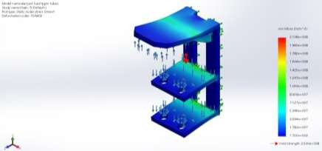
Gambar 5. Hasil Pengujian Tegangan
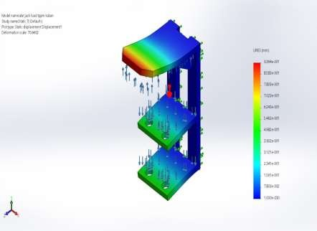

Gambar 6 Hasil Pengujian Displacement

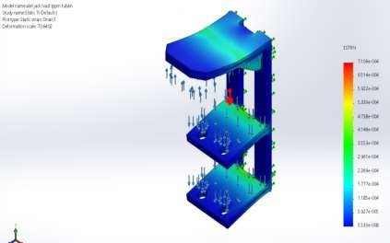

Gambar 7. Hasil Pengujian Regangan

Perbandingan Hasil Analisa
Tabel 2. Hasil analisa pengujian beban 3 ton dan 5 ton

Hasil Analisa | Beban 3 ton | Beban 5 ton
Stress (N/mm2) | 2.138 | ≥ 2.500
Displacement (mm) | 0.9364 | 1.565
Strain (mm) | 0.0007106 | 0.001188

