DEVELOPMENT OF SELECTED CAPITA BOOK OF MATHEMATICS BASED ON MEANINGFUL LEARNING FOR PROSPECTIVE MATHEMATICS TEACHER

Dwi Ivayana Sari¹, Moh. Zayyadi²
¹Mathematics Education Department, STKIP PGRI Bangkalan, Indonesia
²Mathematics Education Department, Universitas Madura, Indonesia
e-mail: dwiivayanasari@stkippgri-bkl.ac.id

Abstract
This study aimed to design, develop, and feasibility test of selected capita book of mathematics based on meaningful learning for prospective mathematics teachers. This research was a Research and Development (R&D). The development model in this study was Four-D model by Thiagarajan, Semmel and Semmel. The stages in this development were define, design, develop and disseminate. The subjects of this study were prospective 6th semester mathematics teacher at STKIP PGRI Bangkalan, East Java, Indonesia. This study used validity, practicality and effectiveness tests. The instruments in this study included validation sheets, lecturer and prospective mathematics teacher response questionnaires, observation sheets on lecturer' abilities in managing learning, observation sheets on prospective mathematics teacher activities, and test questions. The analysis technique in this study used descriptive statistics in the form of averages and percentages. The results of development of selected capita book of mathematics based on meaningful learning met valid, practical and effective categories. This book was a pedagogical tool that supports prospective mathematics teachers in building connections between mathematical concepts and their applications in learning contexts.
Keywords: Development, Selected Capita Book of Mathematics, Meaningful Learning, Prospective Mathematics Teacher

Abstrak
Penelitian ini bertujuan untuk merancang, mengembangkan, dan uji kelayakan buku kapita selekta matematika berbasis pembelajaran bermakna bagi calon guru matematika. Penelitian ini merupakan Penelitian dan Pengembangan (R&D). Model pengembangan dalam penelitian ini adalah model Four-D oleh Thiagarajan, Semmel dan Semmel. Tahapan dalam pengembangan ini adalah pendefinisian, perancangan, pengembangan dan penyebaran. Subjek penelitian ini adalah calon guru matematika semester 6 di STKIP PGRI Bangkalan, Jawa Timur, Indonesia. Penelitian ini menggunakan uji validitas, praktikalitas dan efektivitas. Instrumen dalam penelitian ini meliputi lembar validasi, angket respon dosen dan calon guru matematika, lembar observasi kemampuan dosen dalam mengelola pembelajaran, lembar observasi aktivitas calon guru matematika, dan soal tes. Teknik analisis dalam penelitian ini menggunakan statistik deskriptif berupa rata-rata dan persentase. Hasil pengembangan buku kapita selekta matematika berbasis pembelajaran bermakna memenuhi kategori valid, praktis dan efektif. Buku ini merupakan alat pedagogis yang mendukung calon guru matematika dalam membangun hubungan antara konsep matematika dan penerapannya dalam konteks pembelajaran.
Kata kunci: Pengembangan, Buku Kapita Selekta Matematika, Pembelajaran Bermakna, Calon Guru Matematika

INTRODUCTION
Mathematics education has an important role in shaping students' logical, critical, analytical and systematic thinking abilities (Makhmudah, 2018). Mathematics is not only a collection of formulas or calculation procedures, but a discipline that trains how to think and solve problems rationally (Hidayah & Hw, 2024). Mathematics education as an education that leads to an understanding of mathematics and other sciences, the needs in the future have a broader meaning, namely providing logical, systematic, critical and careful reasoning abilities as well as objective and open thinking which are very necessary in everyday life (Cresswell & Speelman, 2020). In mathematics education, prospective teachers in particular must have an understanding that is not only conceptual, but also contextual, so that they are able to help students become learners who think at a high level.
In mathematics education, especially in the formation of prospective teachers, the understanding developed is not only limited to conceptual aspects alone. Mastery of concepts about mathematical content is the main foundation, but in the context of the teaching profession, this must be complemented by contextual understanding, namely the ability to relate mathematical concepts to real situations (Siregar, 2024; Zayyadi et al., 2024). Conceptual understanding without contextual skills tends to make learning abstract, far from students' experiences, and difficult for students to understand (Lanya et al., 2020; Podschuweit & Bernholt, 2018).
Prospective mathematics teachers must be able to bridge theory and practice, between formal mathematical logic and the dynamics of real learning in the classroom.
In the mathematics education study program at universities, the selected capita course on mathematics has a strategic position in developing students' abilities (Gunawan & Retnaningrum, 2016). This course not only introduces selected topics in mathematics, but also serves as a forum for discussing current issues in mathematics education. In addition, this course integrates various learning approaches, and provides insight into the development of mathematics in the real world (Iliyah & Sari, 2025; Octaria et al., 2022; Widodo & Katminingsih, 2017). Selected capita course on mathematics become a reflective space for prospective teachers to expand students' thinking skills in complex mathematics learning.
However, implementation in field, selected capita course material on mathematics is often delivered descriptively and theoretically, without a pedagogical approach that is appropriate to the characteristics of students as prospective teachers. Textbooks used in lectures are generally general in nature and are not specifically designed to encourage active involvement, in-depth understanding, or relevance to learning experiences at school. This causes students to be less able to integrate the knowledge they have acquired with the practical context they will face as teachers.
One approach that can be used is the meaningful learning approach, which emphasizes the importance of the relationship between new information and the cognitive structures that students already have (Irmawan et al., 2021). This concept positions students not as passive recipients of information, but as individuals who actively build understanding based on previous learning experiences (Koskinen & Pitkäniemi, 2022; Polman et al., 2021). In addition, there is a need to develop teaching materials that not only present material informatively, but are also able to build students' knowledge structures meaningfully.
Meaningful learning will occur when new information is presented in a relevant context, has a logical connection to existing knowledge, and is presented in a way that can be understood conceptually (Mendoza & Mendoza, 2018; Taufikurrahman et al., 2021). In the context of teacher education, meaningful learning is essential to ensure that prospective teachers not only understand the content of the material, but also understand that the material can be taught effectively to students at the primary and secondary levels of education (Aarto-Pesonen & Piirainen, 2020; Kostiainen & Pöysä-Tarhonen, 2019). This approach also encourages long-term understanding, rather than short-term memorization that is easily forgotten. Meaningful learning theory emphasizes the importance of the relationship between new information and the knowledge structures that students already possess. With this approach, students are encouraged to relate new material to previous learning experiences so that the learning process becomes more relevant and meaningful (Bento Miguens et al., 2024).
Development of selected capita book of mathematics based on meaningful learning is an alternative teaching material that is more contextual, interactive, and oriented towards in-depth understanding. This book is not only a means of delivering material, but also a pedagogical tool that supports students in building connections between mathematical concepts and their application in the context of learning. The development of this book is important as part of efforts to improve the quality of prospective mathematics teachers who are not only academically capable, but also have high pedagogical awareness. So far, there has been no research that has studied in depth and specifically the development of selected capita book of mathematics based on meaningful learning for prospective mathematics teachers. Therefore, this research needs to be conducted to design, develop, and test the feasibility of selected capita book of mathematics based on meaningful learning for prospective mathematics teachers.

METHODS
This research was Research and Development (R&D). The development model in this research was Four-D model by Thiagarajan, Semmel and Semmel. The stages in this development were define, design, develop and disseminate. The subjects of this research were prospective 6th semester mathematics teachers at STKIP PGRI Bangkalan, Jawa Timur, Indonesia. This research used validity, practicality and effectiveness tests.
Define stage consisted of frontend analysis, student analysis, task analysis, concept analysis, learning objective analysis. Activities at the design stage was designing the selected capita book of mathematics which consists of 14 chapters and each chapter contained motivation, material exposure and practice questions.
The development stage consisted of three stages, namely the validation stage, small group trials, and field trials (large groups). Activities at the validation stage was validating the selected capita book of mathematics by two mathematics experts. The selected capita book of mathematics was valid if validators said that the book was suitable for use without revision.
Small group trials were conducted to test practicality. Practicality in this research was determined by lecturer and prospective mathematics teachers response questionnaires. A book was said to be practical if the response of lecturer and prospective mathematics teachers was at least good.
Field trials (large groups) were conducted to test effectiveness. Research instruments consisted of observation sheets on lecturers' abilities in managing learning, observation sheets on prospective mathematics teacher activities, and test questions. Field trials were said to be effective if lecturer's ability to manage learning was effective, activities of prospective mathematics teachers were effective, and classical learning completion was achieved. At the disseminate stage, the book was uploaded to an internet site for distribution.
The instruments in this research included validation sheets, teacher and student response questionnaires, observation sheets on lecturers' abilities in managing learning, observation sheets on prospective mathematics teacher activities, and test questions.
The analysis technique in this research used descriptive statistics in the form of averages and percentages.
- Analysis of Validation Results
The data was analyzed by considering comments and suggestions from validators. The results were used as guidelines for revising the book. The selected capita book of mathematics was valid if the average score given by validator was valid and very valid categories. The average score categories were as follows:
Table 1. Validity Criteria
Score | Criteria
$$3≤\overline{x}$$ | Very Valid
$$2,5≤\overline{x}<3$$ | Valid
$$2≤\overline{x}<2,5$$ | Less Valid
$$\overline{x}<2$$ | Invalid

- Analysis of Lecturer and Prospective Mathematics Teachers Responses
Data was analyzed using averages. lecturer and prospective mathematics teachers responses were said to be practical if the average score was practical or very practical categories. The average score categories were as follows:
Table 2. Practicality Criteria
Score | Criteria
$$3≤\overline{x}$$ | Very Practical
$$2,5≤\overline{x}<3$$ | Practical
$$2≤\overline{x}<2,5$$ | Less Practical
$$\overline{x}<2$$ | Impractical

- Analysis of Lecturer’ Ability to Manage Learning
Data was analyzed using averages. The lecturer' ability to manage learning was said to be effective if the average score was good or very good categories. The average score criteria were as follows:
Table 3. Average Score Criteria
Score | Criteria
$$3≤\overline{x}$$ | Very Good
$$2,5≤\overline{x}<3$$ | Good
$$2≤\overline{x}<2,5$$ | Enough
$$\overline{x}<2$$ | Less

- Analysis of Activities of Prospective Mathematics Teachers
Data was analyzed using averages. Prospective mathematics teacher activities in learning were said to be effective if the average score was good or very good critegories. The average score criteria were as follows:
Table 4. Average Score Criteria
Score | Criteria
$$3≤\overline{x}$$ | Very Good
$$2,5≤\overline{x}<3$$ | Good
$$2≤\overline{x}<2,5$$ | Enough
$$\overline{x}<2$$ | Less

- Analysis of Classical Learning Completion
The learning outcome test scores were used to determine the learning completion of prospective mathematics teachers. Every prospective mathematics teacher was said to be complete if their score was at least 70. And then, classical learning completion was achieved if the total number of prospective mathematics teachers who complete their studies was at least 80%.

RESULTS AND DISCUSSION
This research was development research using 4-D model from Thiagarajan. The 4-D model consisted of 4 stages, namely define, design, develop and disseminate. Activities in each of the 4 stages were explained as follows.
- Define
- Front End Analysis
The activity at this stage was an interview with lecturers and prospective mathematics teachers to analyze problems in selected capita course of mathematics. As a result, it was found that the books used were general junior high or high school books. There were no special selected capita books of mathematics used to study school mathematics material in depth during selected capita course. So that, prospective teachers' understanding of mathematics was not in-depth.
- Analysis of Prospective Mathematics Teachers
As a result, background of prospective mathematics teachers at STKIP PGRI Bangkalan mostly came from underdeveloped, outermost and remote areas. So this had an impact on their characteristics, especially their ability to explore information and learning resources, learning motivation and level of understanding of material. Their ability to explore information and learning resources was low. This was because the accommodation didn’t support. Their economic level was low and they lived in villages far from information. Thus, their motivation to learn was lacking. The source of knowledge they got from lecturers. Whereas, prospective mathematics teachers would be forefront of educating nation's children in order to achieve a golden Indonesia.
- Concept Analysis
The aim was to examine Graduate Learning Outcomes (GLO) on selected capita course of mathematics, Course Learning Outcomes (CLO) and sub-Course Learning Outcomes (sub-CLO). Table 5 below showed Graduate Learning Outcomes (GLO) on selected capita course of mathematics, while Table 6 showed Course Learning Outcomes (CLO) and sub-Course Learning Outcomes (sub-CLO).
Table 5. The GLO on Selected Capita Course of Mathematics
GLO Code | GLO elements
Attitude (A) | - A1: Have good morals, ethics and personality in completing his/her duties in the form of respecting and upholding the values ​​of humanity, individuality, freedom of choice and prioritizing the welfare of children with special needs in general.
Attitude (A) | - A8: Internalizing academic values, norms, and ethics
Attitude (A) | - A9: Demonstrate a responsible attitude towards work in his/her field of expertise independently
General Skills  (GS) | - GS1: Able to develop logical, critical, systematic, and creative thinking through scientific research, creation of designs or works of art in the field of science and technology that pay attention to and apply humanities values ​​in accordance with their field of expertise, compile scientific concepts and study results based on scientific rules, procedures, and ethics in the form of a thesis or other equivalent form, and uploaded on the university website, as well as papers that have been published in accredited scientific journals or accepted in international journals.
General Skills  (GS) | - GS2: Able to conduct academic validation or studies according to his/her field of expertise in solving problems in society or relevant industry through the development of his/her knowledge and expertise.
General Skills  (GS) | - GS3: Able to formulate ideas, thoughts, and scientific arguments responsibly and based on academic ethics, and communicate them through the media to the academic community and the wider community.
Knowledge (K) | - K2: Able to solve science and technology problems in the field of mathematics education through research with an inter or multidisciplinary approach to produce innovative, tested and novel work.
Knowledge (K) | - K4: Able to interpret scientific studies in the field of mathematics education and apply them in the professional field being pursued
Special Skills (SS) | - SS1: Able to develop logical, critical, systematic, holistic and innovative thinking in the context of developing science and/or technology in the field of mathematics education through research and application in learning.
Special Skills (SS) | - SS2: Able to conduct academic studies in solving problems in society related to the field of Mathematics education and skills possessed.
Special Skills (SS) | - SS4: Able to link the problems of mathematics education and learning as research objects and position them in a research roadmap developed through a multidisciplinary approach.

Table 6. CLO and sub-CLO on Selected Capita Course of Mathematics
CLO | Sub- CLO
Students are able to study materials from junior high school mathematics materials and materials related to olympiad materials at the junior high school level. | Analysis of whole numbers and fractional numbers
 | Analysis of set
 | Analysis of algebraic forms
 | Analysis of linear equations and inequalities of one and two variables
 | Analysis of comparison and social arithmetic
 | Analysis of lines and angles
 | Analysis of quadrilaterals, triangles and circles
 | Analysis of statistics and probability
 | Analysis of exponents
 | Analysis of Pythagorean theorem
 | Analysis of relations and functions
 | Analysis of equation of a straight line
 | Analysis of spatial shapes
 | Analysis of geometric transformations

- Task Analysis
At this stage, sub-CLO was broken down into indicators. The result was a description of tasks required in learning and their adjustment to CLO. This could be seen in Table 7.
Table 7. Sub-CLO and Indicators on Selected Capita Course of Mathematics
Sub- CLO | Indicators
Analysis of whole numbers and fractional numbers | Explaining concept, properties and operations of integers
Analysis of whole numbers and fractional numbers | Explaining concept, properties and operations of fractional numbers
Analysis of whole numbers and fractional numbers | Solve problems related to whole numbers and fractional numbers
Analysis of set | Explaining concept, types and operations of sets
Analysis of set | Solving problems related to sets
Analysis of algebraic forms | Explaining concept of algebraic forms
Analysis of algebraic forms | Solve problems related to algebraic forms
Analysis of linear equations and inequalities of one and two variables | Explaining concept of linear equations and inequalities in one and two variables
 | Solve problems related to linear equations and inequalities in one and two variables
Analysis of comparison and social arithmetic | Explaining concept of comparison and social arithmetic
Analysis of comparison and social arithmetic | Solve problems related to comparison and social arithmetic
Analysis of lines and angles | Explaining concept of lines and angles
Analysis of lines and angles | Solve problems related to lines and angles
Analysis of quadrilaterals, triangles and circles | Explaining concept of quadrilaterals, triangles and circles
Analysis of quadrilaterals, triangles and circles | Solve problems related to quadrilaterals, triangles and circles
Analysis of statistics and probability | Explaining concept of statistics and probability
Analysis of statistics and probability | Solve problems related to statistics and probability
Analysis of exponents | Explaining concept of exponents
Analysis of exponents | Solve problems related to exponents
Analysis of Pythagorean theorem | Explaining concept of Pythagorean theorem
Analysis of Pythagorean theorem | Solve problems related to Pythagorean theorem
Analysis of relations and functions | Explaining concept of relations and functions
Analysis of relations and functions | Solve problems related to relations and functions
Analysis of equation of a straight line | Explaining concept of a straight line
Analysis of equation of a straight line | Solve problems related to a straight line
Analysis of spatial shapes | Explaining concept and types of geometric shapes
Analysis of spatial shapes | Solve problems related to the area and volume of spatial shapes
Analysis of geometric transformations | Explaining concept of geometric transformations
Analysis of geometric transformations | Solve problems related to geometric transformations

- Analysis of Learning Objectives
At this stage, the aim was to summarize results of previous stages, namely concept analysis and task analysis stages. The indicators in Table 7 were related to learning objectives using selected capita book of mathematics.

- Design
- Initial Plan
This initial plan was design of a selected capita book of mathematics based on meaningful learning which consisted of (1) cover, (2) title page, (3) table of contents, (4) foreword, (5) presentations of fourteen materials which included an introduction (background to importance of material or connecting previous material with material to be studied, learning objectives), material content, example questions, practice questions, and (6) bibliography.
- Use of Learning Strategies
The development of selected capita book of mathematics was based on meaningful learning. Thus, researchers conducted learning by using meaningful learning model. Meaningful learning steps consisted of (1) conveying learning objectives, (2) identifying student characteristics, (3) organizing materials, (4) connecting new knowledge with old knowledge, (5) applying knowledge in real life, and (6) assessing process and results.

- Presentation of Teaching Materials
The steps for presenting the material were:
- Developing the selected capita book of mathematics based on the independent curriculum implemented at STKIP PGRI Bangkalan for prospective 6th semester mathematics teachers.
- Writing the selected capita book of mathematics used Microsoft Word 2019.
- Canva was used to design the selected capita book of mathematics.
- Making Assessment Tools
The assessment tools consisted of material and design validation sheets, lecturer and prospective mathematics teachers’ response questionnaires, observation sheets on lecturer' abilities in managing learning, observation sheets on prospective mathematics teacher activities, and test questions.

- Develop
Activities at this stage were as follows.
- Developing selected capita book of mathematics based on meaningful learning
The parts of book's contents were cover, title page, table of contents, foreword, presentation of fourteenth material and bibliography. Figure 1 below showed cover of the selected capita book of mathematics.
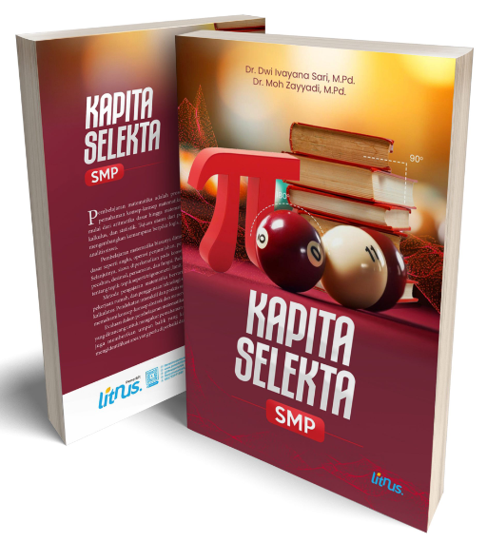
Figure 1. Cover of Selected Capita Book of Mathematics

Furthermore, each material consisted of an introduction, material content, relevant example questions, and practice questions. The introduction contains a description of background to importance of studying material or connecting previous material with material to be studied, learning objectives to be achieved in a material. Thus, prospective mathematics teachers were given motivation to learn the material. An example of an introduction contained in the selected capita book of mathematics can be seen in Figure 2.
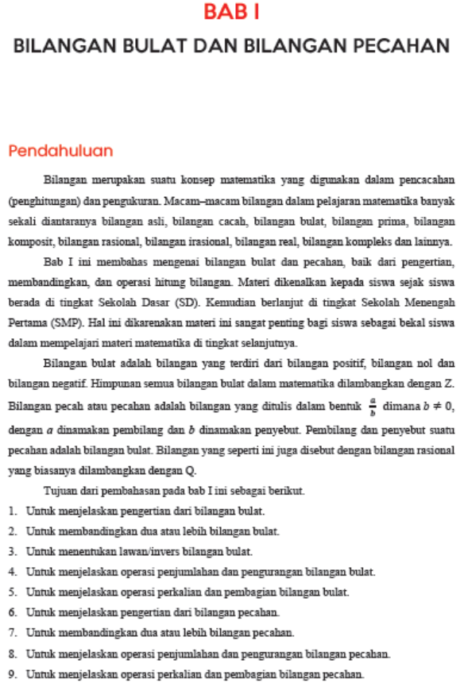
Figure 2. Example of Introduction in Presentation of Material

Furthermore, material was presented based on meaningful learning, presented in depth, step by step and using language that could be understood by both university and school students. One of contents of the material contained in the selected capita book of mathematics can be seen in Figure 3.
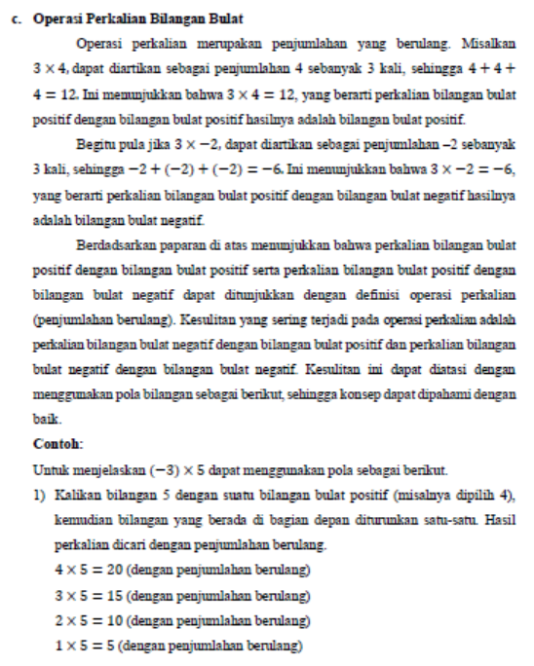
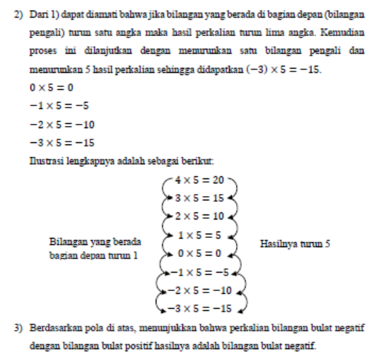
Figure 3. Example of Presentation of Material Based on Meaningful Learning

- Expert Validation Stage
- Material Validation Results
There were two validators to validate material of the selected capita book of mathematics. There were 18 aspects on the validation sheet. Table 9 below showed results of material validation analysis.
Table 9. Material Validation Analysis Results
Validators | Total Score | Score Value | Average
Validators  Validators | 69  70 | 3,83  3,89 | 3,86
Based on Table 9 above, the average score was 3.86 with very valid criteria, without any revisions.
- Design Validation Results
There were two validators to validate design of the selected capita book of mathematics. There are 22 aspects on the validation sheet. Table 10 below showed results of design validation analysis.
Table 10. Material Validation Analysis Results
Validators | Total Score | Score Value | Average
Validators  Validators | 75  73 | 3,41  3,32 | 3,37

Based on Table 10 above, the average score was 3.37 with very valid criteria.

Based on results of material and design validation above, the selected capita book of mathematics based on meaningful learning was valid. This was because based on results of material validation, an average of 3.86 was obtained with very valid criteria and results of design validation, an average of 3.37 was obtained with very valid criteria.
- Product Revision
There were several improvements based on criticism and suggestions from validators, namely:
- Changed in the content of geometric transformation material
- Changed in the examples of questions contained in the material on lines and angles, exponent numbers and straight lines equations

- Results of Small Group Trials
The next stage was a small group trial. This trial was conducted by providing a selected capita book of mathematics based on meaningful learning to respondents, namely 1 (one) mathematics lecturer and 2 (two) male math teacher candidate and 2 (two) female math teacher candidate with high and low mathematics abilities. Furthermore, respondents filled out a response questionnaire consisting of 20 assessment aspects. Table 11 shows results of questionnaire responses from lecturers and prospective mathematics teachers.
Table 11. Results of Responses from Lecturers and Prospective Mathematics Teachers
No | Subject | Total score | Score value | Average
1 | Lecture | 70 | 3,5 | 3,68
2 | Male math teacher candidate with high math ability | 75 | 3,75 | 3,68
3 | Male math teacher candidate with low math ability | 72 | 3,6 | 3,68
4 | Male math teacher candidate with high math ability | 78 | 3,9 | 3,68
5 | Male math teacher candidate with low math ability | 73 | 3,65

Based on results of questionnaire analysis in Table 11, an average score of 3.68 was obtained with a very practical category. Thus, the selected capita book of mathematics based on meaningful learning was said to be practical.
- Field Trial Results
Field trials aimed to determine level of effectiveness of product being developed. This trial was conducted over 2 meetings. The first meeting taught the first material, namely integers and fractions by using valid and practical selected capita book of mathematics based on results of previous analysis. The second meeting taught the eighth material, namely statistics, probability and sample selection by using valid and practical selected capita book of mathematics based on results of previous analysis. After that, at the third meeting, prospective mathematics teachers were tested to determine the completeness of classical learning outcomes. Results of analysis of lecturers' abilities in managing learning, results of analysis of prospective mathematics teacher activities, and results of analysis classical learning completion were presented below.
- Results of Analysis of Lecturers' Abilities in Managing Learning
The results of analysis of lecturers' abilities in managing learning using the selected capita book of mathematics based on meaningful learning can be seen in Table 12.
Table 12. Results of Analysis of Lecturers' Abilities in Managing Learning
No | Aspect | Score
No | Aspect | Meeting 1 | Meeting 2
1 | Carrying out apperception activities | 3 | 4
2 | Providing motivation for students in learning | 3 | 4
3 | Delivering learning objectives | 4 | 4
4 | Identifying student characteristics | 3 | 3
5 | Organizing material through discussion | 3 | 4
6 | Connecting new knowledge with old knowledge | 3 | 4
7 | Guiding students to apply knowledge in real life | 4 | 4
8 | Provide assessment questions | 3 | 4
9 | Guiding students in learning reflection | 4 | 4
Total Score |  | 30 | 35
Average Score Each Meeting |  | 3,3 | 3,89
Average Trial Score |  | 3,60
Category |  | Very good

Based on Table 12 above, it could be seen that the average score of lecturers' ability in managing learning using the selected capita book of mathematics based on meaningful learning was 3.60 with very good criteria. So, lecturers' ability in managing learning was effective.
- Results of Analysis of Prospective Mathematics Teacher Activities
The results of analysis of prospective mathematics teacher activities in learning during two meetings could be seen in Table 13 below.
Tabel 13. Results of Analysis of Activities of Prospective Mathematics Teachers
No | Aspect | Score
No | Aspect | Meeting 1 | Meeting 2
1 | Pay attention to the lecturer's explanation | 3 | 4
2 | Asking or answering questions from the lecturer | 3 | 4
3 | Note down material | 3 | 4
4 | Active in discussions | 3 | 3
5 | Working on assessment questions | 3 | 4
6 | Record the conclusions obtained | 4 | 4
Total Score |  | 19 | 23
Average Score Each Meeting |  | 3,17 | 3,83
Average Trial Score |  | 3,5
Category |  | Very good

Based on Table 13 above, it could be seen that the average score of prospective mathematics teacher activities in learning during two meetings using the selected capita book of mathematics based on meaningful learning was 3.5 with very good criteria. So that, prospective mathematics teacher activities were effective.
- Results of Analysis Classical Learning Completion
The test questions consisted of 20 questions, namely 15 multiple choice and 5 essays. The results of prospective mathematics teacher test could be seen in Table 14 below.
Table 14. The Results of Prospective Mathematics Teacher Test
No | Name | Score | Information
1 | LI | 70 | Complete
2 | MK | 78 | Complete
3 | NFP | 76 | Complete
4 | BR | 76 | Complete
5 | RHI | 75 | Complete
6 | RHA | 75 | Complete
7 | EM | 78 | Complete
8 | NU | 78 | Complete
9 | YY | 65 | Not complete
10 | KA | 75 | Complete
11 | MS | 75 | Complete
12 | NS | 74 | Complete
13 | AM | 65 | Not complete
14 | AL | 75 | Complete
15 | FAR | 78 | Complete
16 | AA | 74 | Complete
17 | KU | 74 | Complete
18 | DM | 76 | Complete
19 | ANF | 60 | Not complete
20 | JSD | 78 | Complete
21 | AMU | 75 | Complete
22 | LS | 75 | Complete
23 | MF | 75 | Complete
24 | NS | 76 | Complete
25 | NI | 76 | Complete
26 | SF | 73 | Complete
27 | WH | 67 | Not complete

Based on Table 14 above, it showed that highest score was 78 and t lowest score was 60. The average score was 74.

Table 15 below showed classical learning completion.
Table 15. Classical Learning Completion
Information | Number of Students | Percentage
Complete | 23 | 85,19%
Not complete | 4 | 14,81%

Based on Table 7 above, it could be seen that 23 prospective mathematics teachers completed their studies with a percentage of 85,19% and 4 prospective mathematics teachers did not complete their studies with a percentage of 14,81%. Thus, classical learning completion was achieved.
This showed that the selected capita book of mathematics was effective because lecturers' ability in managing learning was effective, prospective mathematics teacher activities were effective and classical learning completion was achieved.

- Disseminate
The distribution of this book was done by uploading it to a site or website, so that it could be easily downloaded by the public. The site was https://penerbitlitnus.co.id/portfolio/kapita-selekta-smp/

DISCUSSION
At the define stage based on interview results, it was found that the books used were general junior high or high school books. There were no special selected capita books of mathematics used to study school mathematics material in depth during the selected capita course. So, prospective teachers' understanding of mathematics was not in-depth (Purwaningrum & Purwoko, 2023). Based on the analysis of prospective mathematics teachers, background of prospective mathematics teachers at STKIP PGRI Bangkalan mostly came from underdeveloped, outermost and remote areas. So this had an impact on their characteristics, especially their ability to explore information and learning resources, learning motivation and level of understanding of material. Their ability to explore information and learning resources was low. This was because the accommodation didn’t support. Their economic level was low and they lived in villages far from information. Thus, their motivation to learn was lacking. The source of knowledge they got from lecturers (Djarwo et al., 2025).
At the task analysis, sub-CLO was broken down into indicators. The result was a description of tasks required in learning and their adjustment to CLO, namely analysis of set, analysis of algebraic form, analysis of linear equations and inequalities of one and two variables, analysis of comparison and social arithmetic, analysis of line and angle, analysis of quadrilateral, triangle and circle, analysis of statistical and probability, analysis of exponents, analysis of Pythagorean theorem, analysis of relation and function, analysis of equation of a straight line, analysis of spatial shapes, analysis of geometric transformation. This was adjusted to CLO that had been set and could help prospective mathematics teacher understand it. In the analysis of learning objectives stage summarized results of the previous stages, namely concept analysis and task analysis stages followed by determining the research object (Sawitri & Agustika, 2022).
Design stage. This initial plan was design of a selected capita book of mathematics based on meaningful learning. And then, researchers conducted learning by using meaningful learning models. Meaningful learning steps consisted of (1) conveying learning objectives, (2) identifying student characteristics, (3) organizing materials, (4) connecting new knowledge with old knowledge, (5) applying knowledge in real life, and (6) assessing process and results. Presentation of teaching materials, and assessment tools consisted of material and design validation sheets, lecturer and prospective mathematics teachers response questionnaires, observation sheets on lecturer' abilities in managing learning, observation sheets on prospective mathematics teacher activities, and test questions. In general, this design was to create an effective and relevant learning resource, to facilitate students in building a deep and meaningful understanding (Mulyono, 2018) of the material being studied.
In development, each material consisted of an introduction, material content, relevant sample questions, and practice questions. The material was presented based on meaningful learning, presented in depth, step by step and using language that can be understood by students and school students. Based on results of material and design validation above, the selected capita book of mathematics based on meaningful learning was valid. This was because based on results of material validation, an average of 3.86 was obtained with very valid criteria and results of design validation, an average of 3.37 was obtained with very valid criteria. This was also in accordance with other studies with valid criteria (Adirakasiwi et al., 2020). Based on results of questionnaire analysis, an average score of 3.68 was obtained with a very practical category. Thus, the selected capita book of mathematics based on meaningful learning was said to be practical. This was also in accordance with other studies with practical criteria (Agustyaningrum & Gusmania, 2017; Zayyadi et al., 2025). And then the average score of lecturers' ability in managing learning using the selected capita book of mathematics based on meaningful learning was 3.60 with very good criteria. So, lecturers' ability in managing learning was effective. The average score of prospective mathematics teacher activities in learning during two meetings using the selected capita book of mathematics based on meaningful learning was 3.5 with very good criteria. So that, prospective mathematics teacher activities were effective. Thus, 23 prospective mathematics teachers completed their studies with a percentage of 85,19% and 4 prospective mathematics teachers did not complete their studies with a percentage of 14,81%. It meant classical learning completion was achieved. This showed that the selected capita book of mathematics was effective because lecturers' ability in managing learning was effective, prospective mathematics teacher activities were effective and classical learning completion was achieved.
At the dissemination stage, the selected capita book of mathemtics can be accessed on the following site https://penerbitlitnus.co.id/portfolio/kapita-selekta-smp/, so that this book could provide wider benefits for prospective mathematics teacher who need learning resources. Digital textbooks could be used as learning resources by students and the public (Ermawasari et al., 2024; Masruroh & Sari, 2024). In general, results of development of the selected capita book of mathematics based on meaningful learning met valid, practical and effective categories.

CONCLUSION
The results of development of selected capita book of mathematics based on meaningful learning met valid, practical and effective categories. It was said to be valid because based on material validation result, average score of 3.86 was obtained with very good criteria, result of design validation obtained an average score of 3.37 with very good criteria. It was said to be practical because based on result of small group trial, average score of 3.68 was obtained with very practical criteria. It was said to be effective because average score of lecturers' ability in managing learning was 3.60 with very good criteria, average score of prospective mathematics teacher activities was 3.5 with very good criteria and classical learning completion was achieved with a percentage of 85.19%. This book was a pedagogical tool that supports prospective mathematics teachers in building connections between mathematical concepts and their applications in learning contexts.

REFERENCES
Aarto-Pesonen, L., & Piirainen, A. (2020). Teacher students’ meaningful learning in widening learning worlds. Teaching Education, 31(3), 323–342. https://doi.org/10.1080/10476210.2018.1561662
Adirakasiwi, A. G., Warmi, A., & Imami, A. I. (2020). Developing practical module of Capita Selecta in mathematics assisted by android. Math Didactic: Jurnal Pendidikan Matematika, 5(3), 237–247. https://doi.org/10.33654/math.v5i3.745
Agustyaningrum, N., & Gusmania, Y. (2017). Praktikalitas Dan Keefektifan Modul Geometri Analitik Ruang Berbasis Konstruktivisme Practicality And Effectiveness Of Geometry Analysis Module Based On Constructivity. DIMENSI, 6(3), 412–420.
Bento Miguens, A. L., Nunes Piedade, J. M., dos Santos, R. J. B., & Oliva, T. L. (2024). Meaningful learning in mathematics: a study on motivation for learning and development of computational thinking using educational robotics. Educational Media International, 61(1–2), 4–15. https://doi.org/10.1080/09523987.2024.2357472
Cresswell, C., & Speelman, C. P. (2020). Does mathematics training lead to better logical thinking and reasoning? A cross-sectional assessment from students to professors. PLoS ONE, 15(7 July). https://doi.org/10.1371/journal.pone.0236153
Djarwo, C., Inggamer, M., Rumbrapuk, A., & Astuti, N. (2025). Analisis Literasi Digital Berbasis Etnosains Dalam Pembelajaran Kimia Untuk Meningkatkan Pemahaman Konsep Dan Motivasi Belajar Mahasiswa. In Jurnal Pendidikan dan Pembelajaran IPA Indonesia (Vol. 15, Issue 1). https://Katadata.com
Ermawasari, Hidayati, A., & Helsa, Y. (2024). Pemanfaatan Sumber Belajar Digital Dalam Meningkatkan. Pendas : Jurnal Ilmiah Pendidikan Dasar, 9(4).
Gunawan, I., & Retnaningrum, E. (2016). Analisis Kesulitan Belajar Mahasiswa Yang Berlatarbelakang Siswa Smk Pada Mata Kuliah Kapita Selekta Matematika. Sosiohumanitas: Jurnal Ilmu-Ilmu Sosial Dan Humaniora, 18(1).
Hidayah, D. F., & Hw, S. (2024). Analyzing junior high school students’ mathematical reasoning in problem-solving: A focus on the Treffinger-oriented learning approach. Indonesian Journal of Science and Mathematics Education, 7, 281–296. https://doi.org/10.24042/ijsme.v5i1.22207
Iliyah, L., & Sari, D. I. (2025). Implementation of Contextual-Based Differentiational Learning On Problem-solving Ability of Grade 8^th Students. Prima: Jurnal Pendidikan Matematika, 9(2), 239–255. http://dx.doi.org/10.31000/prima.v9i2.13893

Irmawan, D., Efendi, D., Lestari, F., Matematika, P., PGRI Bandar Lampung, S., Pendidikan Matematika, P., & Muhammadiyah Lampung, U. (2021). MEANINGFUL LEARNING DALAM PEMBELAJARAN MATEMATIKA. In Hipotenusa Journal of Research Mathematics Education (Vol. 4, Issue 2).
Koskinen, R., & Pitkäniemi, H. (2022). Meaningful Learning in Mathematics: A Research Synthesis of Teaching Approaches. International Electronic Journal of Mathematics Education, 17(2), em0679. https://doi.org/10.29333/iejme/11715
Kostiainen, E., & Pöysä-Tarhonen, J. (2019). Meaningful Learning in Teacher Education, Characteristics of. In Encyclopedia of Teacher Education (pp. 1–6). Springer Singapore. https://doi.org/10.1007/978-981-13-1179-6_50-1
Lanya, H., Zayyadi, Moh., Aini, S. D., & Haris. (2020). Mathematic Communication Skills in Senior High School Based on Gender Differences. Pi: Mathematics Education Journal, 3(2), 15–21. https://doi.org/10.21067/pmej.v3i2.4718
Makhmudah, S. (2018). Analisis Literasi Matematika terhadap Kemampuan Berpikir Kritis Matematika dan Pendidikan Karakter Mandiri. PRISMA, Prosiding Seminar Nasional Matematika. https://journal.unnes.ac.id/sju/index.php/prisma/
Mendoza, D. J., & Mendoza, D. I. (2018). Information and Communication Technologies as a Didactic Tool for the Construction of Meaningful Learning in the Area of Mathematics. International Electronic Journal of Mathematics Education, 13(3). https://doi.org/10.12973/iejme/3907
Masruroh, M. & Sari, D. I. (2024). Comparison of Learning Outcomes of 11Th Grade Students After Being Taught Using The Teams Games Tournament (TGT) and Make A Match (MAM) Learning Models on The Topic of Limit Algebraic Functions. Prima: Jurnal Pendidikan Matematika, 8(2), 436–451. http://dx.doi.org/10.31000/prima.v8i2.11353
Mulyono, B. (2018). Pemahaman konsep dalam pembelajaran matematika. Jurnal Pendidikan Matematika, 3(2), 103–122.
Octaria, D., Kesumawati, N., & Retta, A. M. (2022). Selecta Capita of Mathematics E-Book for SHS on Contextual Teaching and Learning (CTL) Approach. http://journal.unnes.ac.id/nju/index.php/kreano
Podschuweit, S., & Bernholt, S. (2018). Composition-Effects of Context-based Learning Opportunities on Students’ Understanding of Energy. Research in Science Education, 48(4), 717–752. https://doi.org/10.1007/s11165-016-9585-z
Polman, J., Hornstra, L., & Volman, M. (2021). The meaning of meaningful learning in mathematics in upper-primary education. Learning Environments Research, 24(3), 469–486. https://doi.org/10.1007/s10984-020-09337-8
Purwaningrum, J. P., & Purwoko, R. Y. (2023). Mathematics Misconceptions Of Geometry Materials In Prospective Mathematics Teacher Students. Euclid, 10(4), 663–679.
Sawitri, L. A. D., & Agustika, G. N. S. (2022). Pengembangan Audio Visual Berbasis Kontekstual Learning Materi Volume Bangun Ruang Kubus dan Balok untuk Kelas V SD. Jurnal Pendidikan Dan Konseling, 4(3), 74–84.
Siregar, T. (2024). Filosofi pendidikan matematika: mengurai ideologi dan paradigma.
Taufikurrahman, T., Budiyono, & Slamet, I. (2021). Development of mathematics module based on meaningful learning. AIP Conference Proceedings, 2330. https://doi.org/10.1063/5.0043239
Widodo, S., & Katminingsih, Y. (2017). Kapita Selekta: Pembelajaran Matematika II. Universitas Nusantara PGRI Kediri.
Zayyadi, M., Lanya, H., Arifin, M. N., & Murtafiah, W. (2025). Ethnodigital microteaching model through virtual laboratory to improve TPACK of prospective mathematics teachers. Perspektivy Nauki i Obrazovania, 2, 637–650. https://doi.org/10.32744/pse.2025.1.41
Zayyadi, M., Lanya, H., Linarsih, Y., Nusantara, T., Danar Septiadi, D., & Dwi Windy Kusuma Ningtyas, Y. (2024). Prospective Teachers’ Commognitive: The Pedagogical Knowledge in Designing Mathematics Class for Proving Trigonometric Identity. Jurnal Pendidikan MIPA, 25(2), 946–960. https://doi.org/10.23960/jpmipa/v25i2.pp946-960

