ETHNOMATHEMATICS VALUES IN SUMEDANG TOFU AND BONGSANG (TOFU BASKET) FOR TEACHING GEOMETRY IN PRIMARY SCHOOL

Riana Irawati¹, Rahman², Retno Andriyani³, Ejen Jenal Mutaqin⁴, Nurdin Kamil⁵
^{1,2,3,4,5}Universitas Pendidikan Indonesia, Jl. Dr. Setiabudi No.229, Bandung City, West Java 40154, Indonesia
e-mail: rianairawati@upi.edu

Abstract
Ethnomathematics can be an option for teaching a more contextual mathematics which contributes to a successful mathematics learning. The present study highlighted ethnomathematics concepts that could be found in Sumedang’s local food, namely Sumedang Tofu, and the bamboo basket used as its container (bongsang). Mathematical concepts in Sumedang Tofu and its bongsang are related to geometry. Geometry allows students to develop their abilities in presenting or describing the order in the world or their immediate environment. Geometry learning affects students’ ability to connect mathematical ideas, both in the discipline and to other disciplines as well as the real world. The results of this study show that Primary School students still had difficulties in learning and understanding geometry. Therefore, it was necessary to develop a method that would improve students’ understanding of geometrical concepts, which were important because they were highly relevant to students’ daily life. The present study aimed to explore geometrical concepts found in Sumedang tofu and bongsang. Descriptive qualitative approach was implemented, in which the data was gathered through observation, literature study, and interviews. The findings indicated that geometrical concepts could be found in Sumedang tofu and bongsang. Those concepts could be used in mathematics lessons in primary school to provide meaningful learning for students. The results of this study could be used as a foundation to develop an ethnomathematics learning in primary school level.
Keywords: ethnomathematics, geometry, Sumedang tofu, bongsang

Abstrak
Etnomatematika dapat dijadikan alternatif untuk mengajarkan matematika lebih kontekstual sehingga berdampak pada keberhasilan pembelajaran matematika. Etnomatematika yang diangkat di dalam penelitian ini adalah etnomatematika yang termuat dalam makanan khas kabupaten Sumedang yaitu tahu Sumedang dan bongsang atau keranjang bambu pembungkus tahu Sumedang. Konsep-konsep matematis dalam tahu Sumedang dan bongsang tahu Sumedang berkaitan dengan konsep geometris. Melalui konsep geometri kemampuan siswa dalam mempresentasikan atau menggambarkan keteraturan dunia atau lingkungan sekitarnya dapat berkembang. Pembelajaran geometri memberikan pengaruh terhadap kemampuan siswa dalam mengoneksikan ide-ide matematis baik antar matematika itu sendiri maupun dengan disiplin ilmu lain dan dunia nyata. Berdasarkan hasil penelitian, siswa Sekolah Dasar masih mengalami kesulitan dalam mempelajari geometri. Oleh karena itu perlu adanya suatu upaya untuk meningkatkan kemampuan siswa terhadap materi geometri, mengingat materi tersebut sangat penting bagi siswa karena memiliki banyak keterkaitan dengan kehidupan sehari-hari. Penelitian ini bertujuan untuk mengeksplorasi konsep-konsep geometris yang terdapat dalam tahu Sumedang dan bongsang. Jenis penelitian yang dilakukan adalah penelitian deskriptif kualitatif, data dikumpulkan melalui observasi, studi litelatur dan wawancara. Hasil penelitian menunjukkan adanya konsep-konsep geometris dalam tahu Sumedang dan bongsang tahu. Konsep-konsep geometris yang ditemukan dapat dikaitkan dengan pembelajaran matematika Sekolah Dasar sehingga pembelajaran dapat bermakna bagi siswa. Hasil penelitian dapat dijadikan pengembangan terhadap pembelajaran etnomatematika di Sekolah Dasar.
Kata kunci: etnomatematika, geometri, tahu Sumedang, bongsang

INTRODUCTION
Indonesia is a culturally rich nation whose people have strong characters. Local cultures are the root of Indonesia’s national cultural diversity and contain positive values. Hence, it is important that local cultures are maintained and conserved. Moreover, the rapid spread of information technology and globalization has negatively affected the values of Indonesian culture. Massive influx of foreign cultures to Indonesia is threatening local cultures deeply embedded in daily life of Indonesian people, as evident in the trend that young people adores other countries’ culture more than they do their own culture.
At the same time, in the result of the 2018 Programme for international Student Assesment (PISA), Indonesia ranked 74th or in the bottom six. Specifically for Mathematics, Indonesian students scored 379, placing them in the 73rd position. There are many factors contributing to the low performance in mathematics, including the implementation of mathematics learning that focuses more on transmission of knowledge. In other words, teachers did not provide enough practice (doing math) in lessons and students only passively received the material or lecture (Yuniawatika, 2011).
Mathematics is inseparable from human activities. It plays a great role in human advancement. Hence, it is taught in every level of education, including in primary schools. It is closely related to cultural development. Mathematics as a human activity is shaped and affected by local culture and values. As a discipline, mathematics can be used as a means to conserve and preserve culture in both local and national levels.
Considering that local cultures are dwindling and that mathematics and culture are correlated, it is necessary to teach mathematics in integration with cultural elements. One of the ways teachers can integrate cultural elements to lessons is by using ethnomathematics approach. Ethnomathematics is the study about the implementation of mathematical ideas, procedures, values, and practices developed by and related to certain cultural group in the context of the current time (Rosa & Gavarrete, 2017). Indonesian culture is so diverse, compared to other cultures. The diversity of cultures, languages, and ethnicities in Indonesia presents a promising potential to be studied in ethnomathematics framework. Ethnomathematics study will keep growing in Indonesia and will reveal how unique Indonesian culture is compared to foreign cultures (Lidinillah et al., 2022). In addition to being a means to preserve culture, ethnomathematics can also be implemented as an alternative to teach mathematics in a more contextual way, which will contribute to a successful mathematics learning.
Successful teaching of ethnomathematics has been proven by Japan and China in their mathematics lessons (Supriadi et al., 2016). Hence, ethnomathematics can be used as a means to develop students’ love and pride for their own culture. It is in line with Ruseffendi (1992) who stated that mathematics should be taught not only by focusing on delivering material (lecture) but also by helping students develop their thinking and attitude.
Geometry is a topic in mathematics taught to students on every level of education. Teaching geometry to students is important because it will develop students’ reasoning, visual skills, verbal skills, logics, and practical implementation of mathematical concepts (Mursalin, 2016). In addition, geometrical concepts are found and used in daily life of the students. According to Kahfi (1996), geometry contributed to students’ ability to analyze and prove their environment in terms of congruency, uniformity, and consistency. The importance of geometry was also stressed by Allendoerfer (Kahfi, 1996) that through geometry, students would be able to connect mathematical concepts to the physical form of the world. Geometry developed students’ ability to describe abstract mathematical ideas and to provide examples for mathematical systems. In other words, geometry would affect students’ capability in relating or connecting ideas within mathematics discipline, between mathematics and other disciplines, and between mathematics and the real world. In addition, geometry would improve students’ capability in presenting or describing the order in the world or in their environment.
However, Primary School students still have difficulties in learning geometry, particularly in terms of implementing geometrical concepts and principles and problem solving (Fauzi & Arisetyawan, 2020). Many factors contributed to students’ low performance in geometry, including the teacher-centred learning process. Therefore, it is necessary to find a way to improve students’ achievement in geometry because that basic topic of mathematics is important for students due to its close relation to daily life.
A study concerning ethnomathematics showed that ethno-pedagogy is an important element in learning in primary school level (Rahayu et al., 2021). Another study on Panjalin traditional house concluded that Panjalin houses were closely related to geometrical concepts that they could be used as an alternative media in teaching prymary mathematics (Kurino & Rahman, 2022). Similarly, Rumah Gadang (the traditional house of Minangkabau, West Sumatera) was found to be rich in ethnomathematics contents (Rahmawati Z & Muchlian, 2019). However, there has not been many studies focusing on ethnomathematics in Sumedang culture.
One of the aspects of Sumedang culture is its local food, i.e. Sumedang tofu. Sumedang tofu is fried tofu sold in bamboo basket called bongsang. Everyone in Sumedang, from children to adults, is very familiar with Sumedang tofu and its bongsang because it is sold in almost every shop, store, or food stalls. Both Sumedang tofu and bongsang contain geometrical concepts. The tofu are cube- or cuboid-shaped. In the weaving process, the bottom of the bongsang formed a rectangle. The weaving patterns also formed geometric shapes such as parallelograms, hexagons, and transversal lines. Geometrical concepts of Sumedang tofu and bongsang could be used in teaching geometry to primary school students, in which they would connect geometrical concepts to Sumedang traditional food. The present study explored geometrical concepts found in Sumedang tofu and bongsang (Sumedang tofu basket).

METHODS
Qualitative research method was implemented to obtained in-depth data, i.e. meaningful data from the actual field. A qualitative study focused more on meaning than generalization.
The present study was conducted in three stages. On the first stage, data description, various data were gathered. On the second stage, data reduction/focus, the researchers focused the data found in data description into a particular topic. On the third stage, data selection, the researchers analyzed the topic in detail.
Data was obtained through observation and literature study and was supported by interviews with a primary school teachers representative and some Sumedang residents who worked in production and selling of bongsang.

RESULTS AND DISCUSSION

Sumedang is a regency in West Java Province, famous for its local food, the Sumedang tofu. The food is everyone’s favorite due to its delicious taste, its nutritional value, and its affordable price. The history of Sumedang tofu began when an immigrant from China, called Ong Ki No, wanted to make tofu for his wife. Ong Ki No searched for raw ingredients in Sumedang and found a soy bean plantation. Ong Ki No processed the beans into tofu and prepared it for his family consumption. He later shared his tofu with other Chinese people and the locals in his area. Since it was very popular, Ong Ki No decided to sell his tofu. At the time, Ong Ki No only sold the white unfried tofu but his business was not growing, which made him decided to go back to China. His business was taken over by his son, Ong Bung Keng, who made an innovation by frying the tofu before selling it. When tofu was deep fried in oil, it emitted a delicious smell which attracted customers. It was believed that the water used in processing the tofu also played a role in producing the unique characteristics of Sumedang Tofu. To produce crispier and tastier tofu, the water had to come from rivers or wells in Sumedang (A. Khair & Fathy, 2021).
The process to produce Sumedang tofu involved five steps, each with its own philosophy.
- Washing stage
Soy beans selected as the raw ingredient for Sumedang tofu should be high quality beans. They were washed clean. This process represented a philosophy that human being had to have clear and pure heart with good intention.
- Grounding stage
Clean soy beans were soaked for five hours in clean water from rivers, wells, or springs in Sumedang area. Water in Sumedang had higher concentration of calcium, which made the tofu more spongy and durable. Then, the beans were taken out of water, cleaned again, and grounded into powder in a machine. This stage represented a philosophy that human changed spiritually, mentally, and physically to be better men.
- Cooking stage
Soy bean powder was cooked in water and stirred until boiling. The philosophy of this stage was that men needed to keep learning, working hard, being open, and gained knowledge from their struggle.
- Straining stage
The cooked soy bean porridge underwent precipitation process by separating the soy bean juice from its dregs using straining cloth and laid on the bamboo sieve. This stage represented the philosophy that human would be chosen based on their good character.
- Cutting stage
The clean deposit of tofu was put into a cloth-lined mold. The mold was closed and pressed using a machine to cut the tofu into small blocks. Once the blocks of tofu became dense and solid, they were stored before being soaked in flavored water for frying. The philosophy of this stage was that human should be molded and shaped into an excellent individual to create a just and prosperous society (A. Khair & Fathy, 2021)(Filosofi Pembuatan Tahu, 2016).
Sumedang tofu was inseparable from its bamboo-woven basket, called bongsang. The basket was made by weaving bamboo strips to form a container. Bongsang was part of the identity of Sumedang tofu. Sumedang tofu without bongsang container would not taste different, but the image would be different (Sutawikara, 2017). Practically, bongsang could be used as a container for other objects beside Sumedang tofu. Since the demand for Sumedang tofu had increased, the demand for bongsang also increased, which improved the prosperity of bongsang weavers; especially since the government launched the campaign reducing the use of plastic bags.
To make bongsang, a special type of bamboo was used. Since bamboo grows the whole year, it is always available. Bongsang weavers in Sumedang Regency were generally housewives. The bamboo for bongsang weaving was procured mostly from Cirebon. Bongsang was sold not only in Sumedang but also in other areas around it.
Bongsang weaving began with cutting the bamboo in. The bamboo poles were cleaned, washed, and soaked in water to make them more durable. The clean poles were sliced (meulah) into thin strips of 2 cm X 30 cm. The strips were air-dried so they would be more pliable (ngahua). After that, they were dried under the sun (moe) before being woven (nganyam). The first step of weaving formed the base of the basket in a tight and locked (ngabengker) four-sided weave which would not come undone. The base was further woven (naekeun) to form the basket shape until it became a finished bongsang. Finished bongsang (baskets) were stored in stacks (ngantet) of a hundred bongsang.
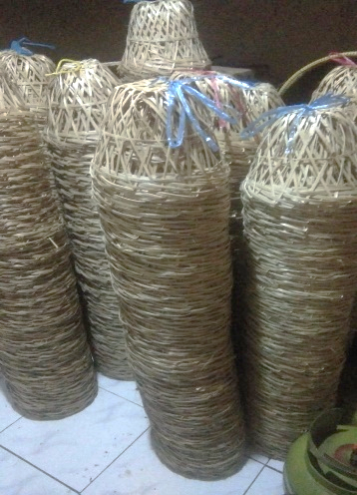
Figure 1. Stacks of unused bongsang.

Exploration of Ethnomathematics Concepts in Sumedang Tofu and Bongsang
Sumedang tofu are in the shape of a cube or a cuboid, and they are smaller than normal tofu. Before being fried, Sumedang tofu are arranged on a bamboo sieve called ancak and cut into small blocks of tofu. The blocks of Sumedang tofu on an ancak could be cut into 11 $×$ 11 or 13 $×$13 pieces. The 11 $×$11 cut would result in cuboid-shaped tofu while the 13 $×$ 13 cut would result in cube-shaped tofu. The area of an ancak (bamboo sieve) was 48 cm $×$ 48 cm.
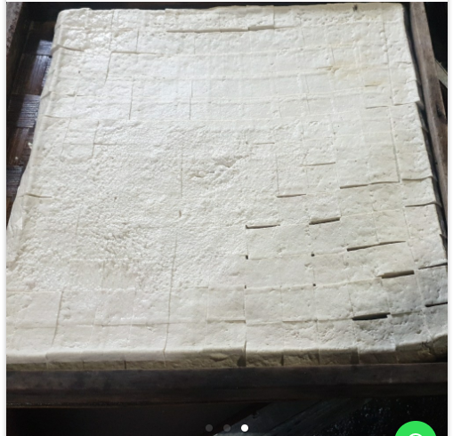
Figure 2. An ancak (block) of Sumedang tofu cut into 13 $×$ 13 pieces would form cubes
.
Source lummoshop.com
Ethnomathematics concepts in Sumedang tofu could be seen in the shape of the tofu, i.e. a cuboid or a cube. In teaching the topic of three-dimensional shapes, Sumedang tofu could be used as a demonstration media to explain about the volumes of a cube and a cuboid. It could also be used to demonstrate how to identify the properties of a cuboid and a cube, including identification of diagonals in a cube and a cuboid. The placement of tofu on the bamboo sieve could be related to the concept of calculating the volume of a cuboid using non-standard units of measurement. Students could calculate the volume of the bamboo sieve by counting the number of tofu that could be placed on the sieve.

Figure 3. Identification of diagonals in a cube
Mathematical concepts, particularly geometry, could be found in the weaving pattern of Sumedang tofu container (bongsang). Bongsang could be used as a teaching media on the topics of circles, squares, and angles. Table 1 listed mathematical concepts found in bongsang.
Table 1. Exploration of mathematical aspects in Sumedang tofu bongsang
Figure | Mathematical Aspects
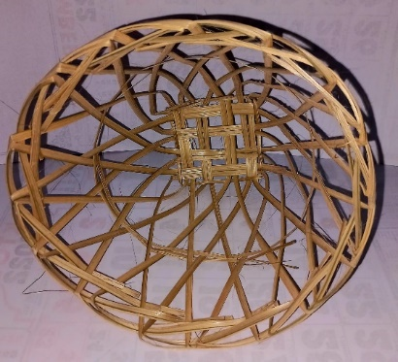  Figure 4. Bongsang weaving pattern | In bongsang (the bamboo basket used as Sumedang tofu container) we could see that its opening formed a circle.
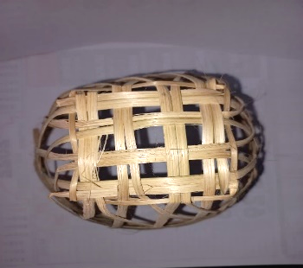  Figure 5. Weaving pattern of the bottom of bongsang | The four-sided weaving pattern on the bottom of bonsang formed a rectangle.
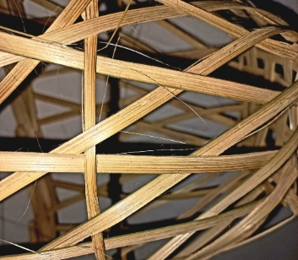  Figure 6. Bongsang weaving forms parallelograms | The weaving pattern of bongsang formed a geometric shape of parallelogram. A parallelogram is a two-dimensional shape whose opposite or facing sides are parallel and of the same length.
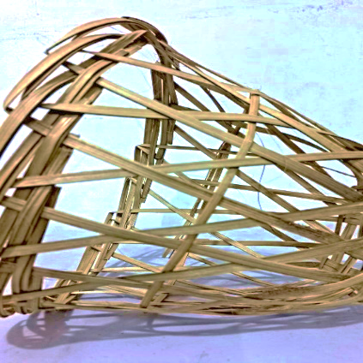  Figure 7. Transversal lines on bongsang weaving pattern | The concept of transversal lines could be found in the weaving of bongsang. A transversal line is a line that passes through two parallel lines. Transversal lines form corresponding angles. Students could analyze the angles formed by transversal lines.

Interview with a primary school teacher in North Sumedang Sub-district revealed that she had applied mathematical concepts of Sumedang tofu in teaching about three-dimensional shapes to the sixth graders. However, it only touched on identification of the properties of three-dimensional shapes. She chose high quality tofu to bring to the class, so that it would not crumble easily when used in teaching. She observed that students’ learning result improved when they studied the properties of three-dimensional shapes using Sumedang tofu. However, the teacher had not fully realized that ethnomathematics concepts could also be found in Sumedang tofu container (bongsang) and had not used it in teaching. Her colleagues also had not realized the geometrical concepts found in bongsang.
Ethnomathematics shows how mathematics is related to the rich, diverse, and historically different tradition. Since everyone is unique and brought up in different environment, our mathematical thinking is shaped and affected by our diversity in language, religion, moral values, economic situation, and social and political activities (Rosa & Gavarrete, 2017). In line with Rahayu (Rahayu et al., 2021), using ethno-pedagogy based teaching, particularly ethnomathematics, this study showed how integration of culture and mathematics could be implemented in teaching.

CONCLUSION
The exploration of Sumedang Regency’s traditional food, i.e. Sumedang tofu, and its container (bongsang) found the following geometrical concepts:
- Two-dimensional shapes, namely square, rectangle, parallelogram, and circle
- Three-dimensional shapes, namely cube and cuboid
- Transversal lines.
Geometrical concepts found in Sumedang tofu and bongsang can be connected with mathematics teaching in primary school level to provide a meaningful learning for students. The results of this study can be used as a foundation and reference for developing ethnomathematics learning in primary schools.

REFERENCES
A. Khair, M. L., & Fathy, R. (2021). Tahu Sejarah Tahu Sumedang. LIPI Press. https://www.ptonline.com/articles/how-to-get-better-mfi-results
Fauzi, I., & Arisetyawan, A. (2020). Analisis Kesulitan Belajar Siswa pada Materi Geometri Di Sekolah Dasar. Kreano, Jurnal Matematika Kreatif-Inovatif, 11(1), 27–35. https://doi.org/10.15294/kreano.v11i1.20726
Kahfi, M. S. (1996). Geometri Sekolah Dasar dan Pengajarannya: Suatu Pola Penyajian Berdasarkan Teori Piaget dan Teori van Hiele. In Jurnal Ilmu Pendidikan (Vol. 3, Issue 4, pp. 262–278).
Kurino, Y. D., & Rahman. (2022). Eksplorasi Etnomatematika Rumah Adat Panjalin pada Materi Konsep Dasar Geometri di Sekolah Dasar. Jurnal Cakrawala Pendas, 8(1), 268–275.
Lidinillah, D., Rahman, Wahyudin, & Aryanto, S. (2022). Into Mathematics Curriculum and Teaching : a. 11(1), 33–54. htpps://doi.org/10.22460/infinity.v1lil.p33-54
Mursalin. (2016). Pembelajaran Geometri Bidang Datar di Sekolah Dasar Berorientasi Teori Belajar Piaget. Jurnal Dikma, 4(2), 250–258. http://repository.unimal.ac.id/2482/1/Artikel Mursalin Pada Dikma Vol 4 No 2 Oktober 2016.pdf
Rahayu, G. D. S., Rahman, Karlina, D. A., Anggraini, G. F., & Ratumanan, S. D. (2021). Etnopedagogi: Persepsi Dan Implementasinya Di Sekolah Dasar. Jurnal Ilmiah P2M STKIP Siliwangi P2M STKIP Siliwangi, 5(2), 1–6.
Rahmawati Z, Y., & Muchlian, M. (2019). Eksplorasi etnomatematika rumah gadang Minangkabau Sumatera Barat. Jurnal Analisa, 5(2), 123–136. https://doi.org/10.15575/ja.v5i2.5942
Rosa, M., & Gavarrete, M. E. (2017). An Ethnomathematics Overview: An Introduction. 3–19. https://doi.org/10.1007/978-3-319-59220-6_1
Supriadi, Arisetyawan, A., & Tiurlina. (2016). Mengintegrasikan Pembelajaran Matematika Berbasis Budaya Banten Pada Pendirian Sd Laboratorium Upi Kampus Serang. Mimbar Sekolah Dasar, 3(1), 1–18. https://doi.org/10.17509/mimbar-sd.v3i1.2510
Sutawikara, E. S. (2017). Nilai Fungsional Dan Estetik Kemasan/ Wadah Berbahan Bambu Pada Makanan Tradisional Indonesia Dan Jepang. Desain Komunikasi Visual, Manajemen Desain Dan Periklanan (Demandia), 2(02), 148–160. https://doi.org/10.25124/demandia.v2i02.932
Yuniawatika. (2011). Penerapan Pembelajaran Matematika Dengan Strategi REACT Untuk Meningkatkan Kemampuan Koneksi dan Representasi Matematik Siswa Sekolah Dasar. Thesis, 2, 107–120.
- (2016). Filosofi Pembuatan Tahu. Diakses pada tanggal, November 1, 2022. FIP: Filosofi pembuatan tahu (samrofarnita2.blogspot.com).

