ETHNOMATEMATICS EXPLORATION TEMPLE PADANG LAWAS REGENCY IN THE CONCEPT OF BUILDING

Intan Sari Daulay¹, Yahfizam²
Program Study Education Mathematics , University Islam Negeri North Sumatra, Indonesia
*Correspondence: intandaulay87@gmail.com

Abstract

Indonesia is a country rich in culture and historical heritage, one of which is the sipamutung temple located in Padang old regency. This temple not only holds cultural and spiritual values but also contains mathematical concepts that are interested to study in mathematics education. This study aims to explore and describe the mathematical concepts embedded in the architectural structure of sipamutung temple from the perspective of ethnomathematics , particularly focusing on solid geometry. This research employee a qualitative method with an ethnographic approach. Data were collected through direct observation, interviews with temple managers, and photographic document of the research objects. The data were analyzed through data reduction, data presentation, and conclusion drawing. The results indicate that the architectural structure of Sipamutung Temple Applies Various Geometric Shapes such as Cubes, Rectangular Prisms, Pyramids, Spheres, and Cylinders. These Geometric Elements are found in the main building, Stairs, Perwara, Inner Chambers, and Temple Ornaments. This study contributes to the development of mathematics learning based on local culture and raises awareness of the importance of cultural heritage preserving. Through an ethnomathematical approach, mathematics learning can be become more contextual, engaging, and meaningful for students.
Keywords : sipamutung temple, ethnomathematics , solid geometry

INTRODUCTION
Indonesia is known as a country that has diversity, marked by the diversity of ethnic groups, culture, religion, language, and customs. In everyday life, culture and education are two inseparable aspects. Both have a very close relationship, one of which is seen in the relationship between culture and mathematical concepts. (Safitri, 2023) Mathematics is one of the subjects learned by students from elementary school to high school. Even in college. This proves that mathematics is one of the subjects that plays an important role in everyday life. (Yosi & Yahfizham, 2023) . Mathematics is one field of study that requires high mentality in the learning process because mathematics is an abstract concept that has been arranged systematically in a structure based on logical reasoning.
However, in its implementation, mathematics is often considered a subject that is full of abstract concepts and is difficult to learn by most students. This assumption often causes a lack of enthusiasm and interest in learning among them. (Tio et al., 2025) Learning mathematics is very important, but there are some students who say that learning mathematics is difficult. (Siregar & Yahfizham, 2023) Mathematics learning is an activity that involves teachers and students in interactions that aim to recognize and understand the concepts of mathematics together. (R. Sari, 2021) Students experience experience using mathematics as a tool to understand or convey information, such as using equations or tables in the mathematical model, which is a simplification of story problems or other mathematical descriptions. (Arif & Nim, 2023) .
Student success depends on how the teacher manages the learning mechanism. Both the material provided, mastery of the material by the class, as well as how to use the method. All that depends on teacher planning. Every student spends more time outside of school than at school. They also gain knowledge outside of formal education, and it happens every day and becomes a habit. The ethnomatematics method connects culture with mathematics a and can be a solution to increasing students' understanding. (Aulia & Afri, 2023)
Mathematics is actually an important part that cannot be separated from the daily lives of society, although most people do not realize that they often apply mathematical concepts and principles in their various daily activities. (Basmara & Yahfizham, 2024) Mathematics learning associated with cultural elements will make students more interested and able to connect the material learned with their daily experiences. This approach not only helps in strengthening the understanding of concepts, but also plays a role in increasing student motivation and interest in learning. (Kambani, 2025) Mathematics related to culture is commonly called ethnomatematics. Ethnomatematics see how mathematics is used in activities or people's lives. This bridges mathematics with culture. (Jayanti & Puspasari, 2020). In line with that, students or teachers must also be familiar with ethnomatemtika, the need for an ethnomatematics approach as an approach in learning mathematics. Because it is realized that ethnomatematics originated and developed from culture, but it is often not realized that mathematics has been used, so that from culture in the form of human activities or vice versa, the application of mathematics in real life is seen. . (Harahap & Rakhmawati, 2022)
The ethnomatematics approach pays attention to traditional and cultural ways in helping students learn mathematics, which are often ignored in learning conventional mathematics. Understanding and integrating the mathematical methods of various cultures can help students solve mathematical problems better. This approach not only enriching students' mathematical knowledge but also building relationships with their cultural context. This can increase the relevance of mathematics learning in daily life and enable the development of more innovative and contextual problem solving methods.(Suriani et al., 2024)
The main factor why cultural -based learning - or an ethnomatematics approach - is very important is the difficulties faced by students in linking mathematics with the real world. According to Wahyuni in Andriono, ethnomatematics is a field that investigates how culture and mathematics are related. By using it, students are expected to better understand their mathematics and culture. Thus, educators will more easily instill cultural values in students, so that cultural values become part of the nation's character. (Kristial et al., 2021) In line with Yusnizar's research concluded that ethnomatematics is the study of how traditional people use mathematics in many ways, such as in their arts and culture. (Yusnizar & Yahfizham, 2024).
Cultural objects that contain mathematical concepts in a particular society are called ethnomatematical objects. According to Bishop in Hanif, ethnomatematics objects are used for various mathematical activities, including calculating, measuring, designing, playing, explaining, and finding locations. Traditional games, traditional crafts, artifacts, and activities (actions) in the form of culture are some examples of these ethnomatematics objects. (Siparau, 2025) Mathematics and culture are something that cannot be separated in everyday life. Ethnomatematics helps connect mathematics and culture, especially in learning mathematics. (Amirah & Budiarto, 2022)
The purpose of cultural-based learning is to give students information, manage, and find ways of mathematical concepts can be applied in everyday life. (Sinaga & Yahfizham, 2023) Same is the same as Sulaiman that the review of ethnomatematics itself, namely to learn how students can understand, manage, and use cultural ideas in solving mathematical problems and practicing them in their own environment. (Sulaiman & Nasir, 2020) Culture in Indonesia is very diverse because Indonesia is an archipelago, among the thousands of islands, the five largest islands are Java, Sumatra, Kalimantan, Sulawesi and Papua. Each province has a unique culture. Traditional clothing, traditional houses, and regional specialties and so on. One of the cultural objects that has great potential to be used as material for ethnomatematics studies is temples. The temple as historical relics has architectural, spiritual, and mathematical values in its construction
On the island of Sumatra, especially North Sumatra there are many cultures that are often visited by people or visitors from outside, both traditional houses and other historic places. On this island there are many temple buildings, such as Bahal Portibi Temple, Sipamutung Temple, Tandihat Temple and there are still many temples that are often visited or become tourist attractions by the community. Temple is a building that has high historical value. The temple is a clear proof of the technology of the community at that time which was very extraordinary because of the limited facilities and infrastructure. The function of the temple as a place of worship and a place of burial of the ash of the body, so it can be said that the function of the temple depends on the king who has the ruling at that time. (Arifin, 2015).
D Arah Padang Lawas Regency many temple buildings such as; Sipamutung Temple, Tandihat Temple, Temple Bako Sangkilon. (Mayanti, 2021). The bath walls have various decorations other than as an aesthetic elements also have spiritual values and symbolic meanings that add to the attractiveness of the existence of the temple. Sipamutung Temple, which is located in Siparau Village in Padang Lawas Regency, has high historical and architecture value. This temple functions as a place of worship and cultural symbols of the local community. In this context, it is important to understand how the past people use mathematical concepts in the design and construction of the building. Sipamutung Temple, with various architectural elements, stores many interesting concepts of building space to be examined. For example, the use of symmetry, proportions, and geometric shapes in the temple structure can be analyzed to understand how people at that time apply their mathematical knowledge. Research shows that many ancient buildings in Indonesia, including temples, are designed by considering complex geometric principles.
Sipamutung Temple displays various geometric forms such as cubes, beams, cylinders, and pyramids in their architectural structure. The element of symmetry, proportion, and pattern of engraving in this temple reflects the application of mathematical principles by the people of the past. However, a study that raises the potential of mathematics in Sipamutung Temple architecture is still very limited. However, although Sipamutung Temple has great potential to be the object of ethnomatematics study, in -depth research on this matter is still very limited. Many aspects of building space contained in the temple, such as the use of cube, cylindrical, and pyramid forms, which have not been fully explored. This is important because it gets a deep understanding of the mathematical concepts contained in the Sipamutung temple can provide new insights on how the past people apply mathematical knowledge in creating a magnificent and functional structure.
In addition, this ethnomatematics research can increase public awareness of the importance of maintaining cultural heritage and contextual mathematical education. The results of Titi's research show that students' interests and understanding of mathematics can be improved by linking mathematical concepts with their local culture. It can also improve students' ability to solve mathematical problems and encourage them to better appreciate the cultural heritage that is around them. Exploration of mathematical elements in Sipamutung Temple is important not only to enrich the cultural-based mathematical learning approach, but also as an effort to preserve local cultural values. It is hoped that this research can bridge knowledge with cultural heritage and provide students with contextual and meaningful learning experiences.
From the explanation above, attracting the attention of the author to make the culture a form that culture and mathematics have a strong relationship, so that people can understand the culture that is around the temple, as well as mathematical and ethnomatematics aspects contained therein. In addition to Sipamutung Temple becomes a tourist spot and often a place to visit the surrounding community, it needs to be introduced that Sipamutung Temple is not only a tourist attraction, but as a way to connect mathematics with culture and make mathematics learning more contextual and attractive to students. In addition, the architectural structure of Sipamutung Temple contains geometric forms of building space such as cubes and blocks. This allows research to examine the application of mathematical concepts by past communities, in accordance with the purpose of the ethnomatematics approach. The purpose of this study is to explore and describe the mathematical concepts contained in the architectural structure of the Sipamutung temple through an ethnomatematical approach.

Methode
This research is a qualitative research with an ethnographic approach. Qualitative research aims to understand in depth the application of mathematical concepts in the cultural life of society, while the ethnographic approach is used to describe, describe, and analyze cultural elements related to the architecture of Sipamutung Temple. This research focuses on identifying the concept of the geometry of the space found in the structure and ornament of temples. Researchers use data collection techniques through direct observation, interviews with temple managers, as well as photo documentation. Data were analyzed by data reduction techniques, data presentation, and drawing conclusions. This study uses a human instrument, where researchers play a direct role in collecting data in the field.
RESULTS AND DISCUSSION
Padang Lawas Regency holds many historical relics. Archaeological discoveries such as temples, inscriptions, reliefs, and statues come from the Hindu-Buddhist era in Indonesia. Padang Lawas residents call cultural heritage as "BUAO". The word "monastery", mentioned in the Sitopayan inscription, is the source of the name of the local community. Not much different from the material used to build several temples in Java, bricks are used to build a monastery in the Padang Lawas area. Sipamutung Temple is one of the relics of Hindu -Buddhist civilizations in Padang Lawas, Central Barumun District which functions as a religious center in the 11th to 13th century. (Tanjung & Ali, 2024) Administratively, this temple is located in Síparau Village, Barumun Tengah District, Padanglawas Regency, North Sumatra. Located about forty kilometers from Sibuhuan, the capital of Padanglawas Regency, or around seventy kilometers from Padangsidimpuan, and about four hundred kilometers from Medan, the capital of North Sumatra Province.
In the Padang Lawas bathing complex, Sipamutung Temple is the largest. With an area of 6000 square meters, Sipamutung Temple has a brick wall around it, with an area of 74 x 74 meters. The Sipamutung Temple complex consists of one main structure, 2 sculptures of the sculpture of rays with his hands worshiping, 6 Perwara Temple and 16 stupas. (Daulay & Maulidiah, 2024) This iconographic art can show the background of a sacred building, components that are directly related to the completeness of this temple building are Kala, Makara, and Relief. Makara is a temple decoration that is usually at the entrance, niche, gate and the end of the stairs. In Sipamutung Makara Temple is located at the end of the stairs. Stupa is a symbol of Buddhism that has important religious values. The physical forms of Sipamutung Temple are inseparable from the concept of mathematical, not only as a culture that is a tourist attraction but the temple can also be used as a means in the introduction of the basic concepts of mathematics in real problems.
Based on the results of observations, documentation, and interviews that researchers conducted at Sipamutung Temple in Siparau Village, Barumun Tengah District, Padang Lawas Regency, it can be concluded that in the architecture of the Sipamutung Temple there is the application of mathematical aspects, especially in the concept of space geometry. This can be seen in the shape, size, and layout of the temple parts in accordance with the principles of geometry . Data obtained through direct observation at the location, interviews with the temple manager, as well as visual documentation in the form of photos and field notes. . In an effort to obtain an ethnomatematics description contained in Sipamutung Temple, researchers conduct an analysis of the concept of building space that appears in the structure of the temple building. This analysis process is carried out by processing data that has been collected through interviews, observations, and documentation during the research activities. This analysis process is carried out by processing data that has been collected through interviews, observations, and documentation during the research activities.
- The results of the analysis of interview data conducted researchers with the temple management, Mr. Burhanuddin Nasution around the Sipamutung Temple site.
History of Sipamutung Temple
Researcher : What is the history of the establishment of Sipamutung Temple?
Resource person : Sipamutung Temple was built around the 11th century. This temple was a place for Hindu-Buddhist worship and the center of community religious activities at that time.
Researcher : When was Sipamutung Temple inaugurated as a cultural heritage?
Resource person : Sipamutung Temple was inaugurated as a cultural heritage in 1997 based on the Decree of the Minister of Education and Culture.
Researcher : How long have you been Sipamutung Temple Standing?
Resource person : Sipamutung Temple is estimated to have been established for more than 900 years, namely since around the 11th century, and still established today.
Sipamutung Temple Building Structure
Research : What is the area of land used for Sipamutung Temple ?
Resource person : Sipamutung Temple Land Area reaches ± 6,000 m²
Researcher : What is the size of the Sipamutung Temple building?
Resource persons : Sipamutung Temple Parent Building is around 11 m × 11 m, and the height reaches 13 m.
Researcher : What are the structures contained in Sipamutung Temple?
Resource persons : Parent temple, 6 Perwara (small temples around it), statues, makara, and stupa, rising stairs, batur, and multilevel roofs
The role of Sipamutung Temple as a tourist spot
Researcher : Is there a ticket rate to enter Sipamutung Temple?
Resource persons : Until now, no ticket rates are charged. Visitors can enter the Sipamutung Temple area for free.
Researcher : How many managers of Sipamutung Temple?
Resource persons : The manager of Sipamutung Temple consists of 5 people, namely the caretaker and officers from the Padang Lawas Regency Culture and Tourism Office.
Researcher : Are there anyday limits entering Sipamutung Temple?
Resource persons : There are no restrictions. Sipamutung Temple is open every day at 08.00-17.00 WIB, and can be visited by the general public according to the applicable rules.
- Observation and Documentation Data Analysis
Observation and Documentation Tables
NO | Name | Element of building space | Picture
1 | Main Building Temple (Parent) | Cube | 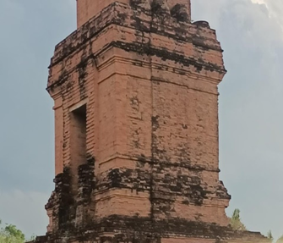
2 | The ladder of BUAO Perwara | Beam | 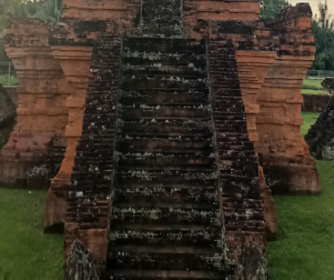
3 | Perwara | Beam | 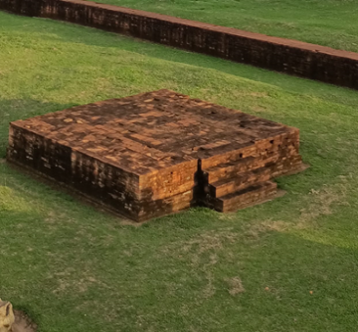
4 | Inner room | Rectangular pyramid | 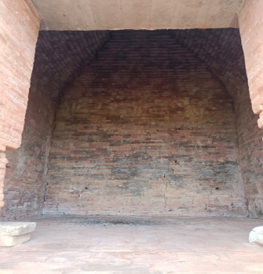
5 | Kepa1a statue and | Ball | 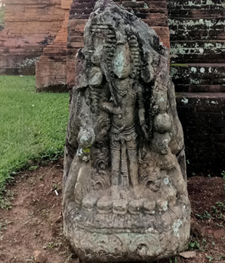
6 | Parent building decoration | Tube | 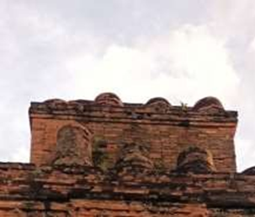

Based on the results of the study, it can be concluded that Sipamutung Temple is not only a place of worship and cultural heritage, but is also a creative form of human civilization at that time, namely Hindu-Buddhist society. In its design, people in ancient times used the principles of geometry and mathematical measures that were mature in order to achieve beauty, precision, and harmony. This is in accordance with the ethnomatematics approach to learning mathematics based on cultural aspects.
The forms of geometry applied to Sipamutung Temple can also be utilized at this time as a constextual and relevant mathematical learning medium. By understanding the size, shape, and layout of Sipamutung Temple, students can learn about prisms, tubes, pyramids, and balls directly, not only from textbooks. This is in accordance with the statements of D'Ambrosio (1985) and Barton (1996) that ethnomatematics can be a bridge to understand mathematics creatively, applicatively, and according to the context of the local culture . The role of Sipamutung Temple in learning mathematics in the concept of building space. Based on the results of observations made by researchers, found the concept of building space found in Sipamutung Temple including:

- Cube
Cube is a square -shaped building with a height, width, and length of three dimensions. The cube has the same side, there are 12 ribs, 8 vertices, 4 diagonal sides, 4 diagonal spaces, and 6 diagonal plane in the form of rectangles, cube surface area with rib length or "s" as a unit length, then l = $6 x s^{2}$ unit area and volume/contents in the cube with the length of the ribs or the "s" side of the length, then v = $s x s x s= s^{3}$
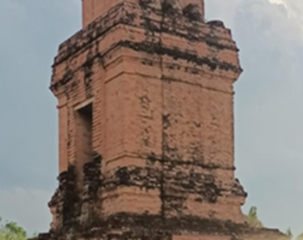
The concept of building space contained in Sipamutung Temple can be seen there is a part of the main building of the temple there is a cube -shaped building. The cube is a three-dimensional space building whose all sides are square and the size of each side is the same. The Sipamutung Temple that can be seen in the form of a cube is the main building of the temple

Figure 1. The main building of the temple
- Beam
Beams are three -dimensional buildings consisting of three rectangular or square parts, with at least one part of different sizes. This beam has six sides, twelve ribs, and eight vertices. Beams have properties, elements, and formulas such as volume, surface area, diagonal plane, and diagonal space. The surface area of the beam is the result of the area of the area of all sides that form the beam. If the length of the beam is symbolized by P, width with L, and height with T, then the surface area of the beam (L) can be calculated by the formula: L = 2 (PL + PT + LT). And the beam volume Suppose "V" states the volume/contents on the beam with a length (p), width (l) and height (t), then: v = p x l x t unit volume
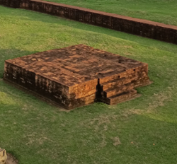
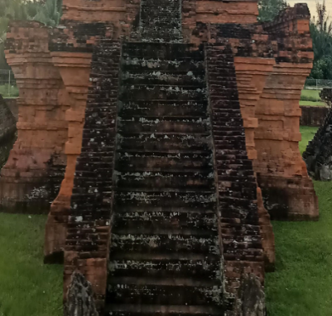
The concept of building space is found in Sipamutung Temple on the stairs of the Sipamutung temple in the form of a beam, which is a rectangular prism. This can be seen in the form of ladder steps consisting of several beams arranged in a packed manner. Perwara Temple is a small temple around the main temple. The building is also in the form of a beam, which is a rectangular prism, but the size of the officer is smaller. So the concept of beams can be seen from the stairs and temples of the temple.

Figure 2. The stairs of the temple and the officer
- Ball
The ball only has one side and consists of building three-dimensional space with an infinite circle with the same length and centered at one point. The ball is made from a semicircular wake that is rotated one full rotation or 360 degrees in the center line. The ball does not have any ribs or angle.
The center point, radius, diameter, volume, and surface area of the ball are the components. Surface area of the ball = $4πr^{2}$ and volume = $\frac{4}{3}πr^{2}$ . Where: $π=3, 14 atau \frac{22}{7}$, $r=jari -jari bola$
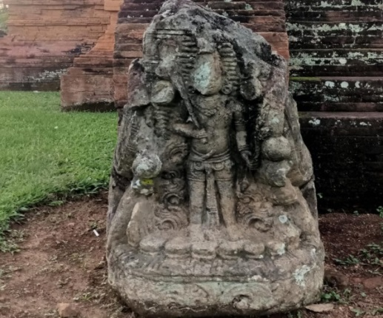
The concept of the ball can be seen in the Sipamutung temple on the statue, the head of the statue of the gods in the form of a ball and the support of the statue is also shaped like a ball

Figure 3. Statue Statue

- Pyramid
Building a pyramid space is a three-dimensional shape that has a base in the form of n-upright sides in the form of a triangle, where all sides meet at one point. There are several types of pyramids, such as pyramids with a triangular base, rectangular, segraphy, rectangles, to a segile. Each type of pyramid has different elements according to the basic shape or base. The surface area of the pyramid is the total area of the entire surface/ side that forms the pyramid. For example "L" states the surface area (side) of the pyramid, then: l = 1 x base area + x x area Side upright. And the volume of the pyramid, for example "V", states that the volume/side of the pyramid is "T" t "t", the area of the "la" prism, then: v = $\frac{1}{3}$ la x t.
The concept of building space can be seen in Sipamutung Temple at the top or the top of the Sipamutung Temple monastery room is formed resembling a pyramid. This is evident from the roof of the monastery that leads to one peak point, resulting in a meeting of triangle fields at its peak.
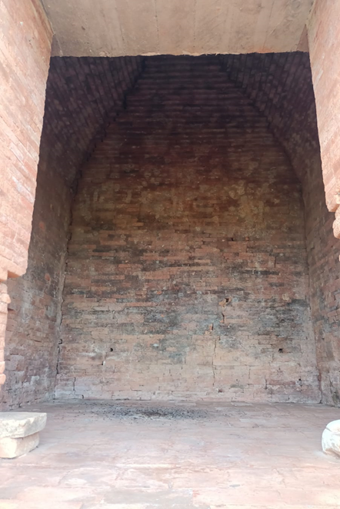

Figure 4. The main building room/ soo
- Tube
$2πr ( r+t )π=3,14 atau \frac{22}{7}πr^{2}tπ=3,14 atau \frac{22}{7}$One type of curved side space is a tube, which is a regular erect prism with a circle -shaped lid and base. The surface area of the tube is formulated l tube = where :, r = fingers of the base (lid), t = height of the tube (distance from base to lid). And the volume of the tube = where :: r = fingers of base (lid) t = tube height (distance from base to lid)
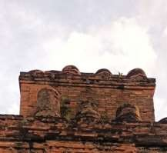
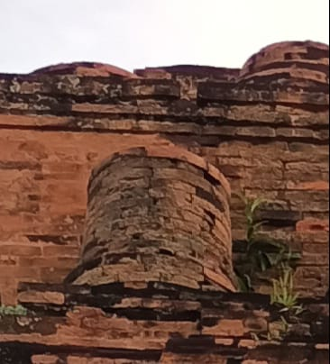
The top of the Sipamutung temple, which is at the peak or roof, is tube -shaped. This can be seen from the size of the circle on the base and roof, then given a height size

Figure 5. Temple decoration fence
In this study it can be seen that in the architecture of the Sipamutung Temple building there is ethnomatematics. One of them is the concept of building space, there are five elements of building space that can be seen in the shape of the Sipamutung temple. Like the element of the cube in the main building, beams on the stairs and temple officers, the ball on the head of the god in the statue of the statue, the pyramid of the Padang room and the tube on the main building decoration fence.
CONCLUSION
From the results of the research conducted regarding ethnomatematics exploration in Sipamutung Temple Padang Lawas Regency in the concept of building space, it can be concluded that Sipamutung Temple has various forms of building space that reflects mathematical concepts, such as cubes in the main buildings of the temple, beams on the stairs, and temples, pyramids on the roof in the monastery. These forms are a real representation of Geometry Concepts of Building Space commonly learned in Mathematics .

ACKNOWLEDGMENTS
Thank you to the parents who have given their prayers and full support to the researcher, to the supervising lecturer who has guided the research process and thank you to the friends who have given encouragement.

REFERENCES
Amirah, A., & Budiarto, M. T. (2022). Etnomatematika : Konsep Matematika pada Budaya Sidoarjo. MATHEdunesa, 11(1), 311–319. https://doi.org/10.26740/mathedunesa.v11n1.p311-319
Arif, S., & Nim, A. (2023). Eksplorasi etnomatematika pada bangunan masjid agung brebes untuk meningkatkan literasi matematika. 106.
Arifin, F. (2015). Representasi Simbol Candi Hindu Dalam Kehidupan Manusia: Kajian Linguistik Antropologis. Jurnal Penelitian Humaniora, 16(2), 12–20.
Aulia, L., & Afri, L. D. (2023). Eksplorasi Etnomatematika Tedhak Siten Adat Jawa. Euclid, 10(3), 512–526. https://doi.org/10.33603/e.v10i3.8642
Basmara, A., & Yahfizham. (2024). Eksplorasi Etnomatematik Pada Kain Ragidup Ulos Pada Konsep Bangunan Datar. Euclid, 11(3), 152–161. https://doi.org/10.33603/e.v11i3.8991
Daulay, M. P., & Maulidiah, S. (2024). Pengelolaan Objek Wisata Candi Sipamutung Oleh Dinas Kebudayaan Dan Pariwisata Kabupaten Padang Lawas Provinsi Sumatera Utara. 8(November), 1631–1636.
Deby, Y. S., & Yahfizham, Y. (2023). Ethnomathematics-Based Mathematics Learning Activities in Labuhan Batu Pesisir Beach Malay Communities. Jurnal Cendekia : Jurnal Pendidikan Matematika, 7(1), 580–589. https://doi.org/10.31004/cendekia.v7i1.2085
Harahap, S. A., & Rakhmawati, F. (2022). Etnomatematika dalam Proses Pembuatan Tempe. Jurnal Cendekia : Jurnal Pendidikan Matematika, 6(2), 1291–1300. https://doi.org/10.31004/cendekia.v6i2.1354
Jayanti, T. D., & Puspasari, R. (2020). Eksplorasi etnomatematika pada Candi Sanggrahan Tulungagung. JP2M (Jurnal Pendidikan dan Pembelajaran Matematika), 6(2), 53. https://doi.org/10.29100/jp2m.v6i2.1748
Kambani, D. P. (2025). Pengaruh Pembelajaran Etnomatematika Melalui Permainan Dakon Terhadap Kemampuan Pemahaman Matematis Materi Perkalian Siswa Kelas III Sekolah Dasar. 09(38), 249–261.
Kristial, D., Soebagjoyo, J., & Ipaenin, H. (2021). Analisis biblometrik dari istilah “Etnomatematika.” Kognitif: Jurnal Riset HOTS Pendidikan Matematika, 1(2), 178–190. https://doi.org/10.51574/kognitif.v1i2.62
Mayanti, V. (2021). Strategi Komunikasi Dinas Kebudayaan dan Pariwisata Pemerintah Kabupaten Padang Lawas Utara dalam Publikasi Wisata Candi Bahal.
Safitri, A. W. (2023). Eksplorasi Etnomatematika Budaya Lokal Indonesia Pada Rumah Adat Joglo Di Desa Dasri Kabupaten Banyuwangi. Sigma: Jurnal Pendidikan Matematika, 15(2), 169–183. https://doi.org/10.26618/sigma.v15i2.11769
Sari, R. (2021). Pembelajaran Matematika Berbasis Etnomatematika Dengan Konteks Rumah Adat Lubuklinggau. 1.
Sinaga, Q. A., & Yahfizham. (2023). Eksplorasi Etnomatematika pada Makam Papan Tinggi. Jurnal Cendekia : Jurnal Pendidikan Matematika, 7(2), 1867–1876. https://doi.org/10.31004/cendekia.v7i2.2245
Siparau, D. (2025). Jurnal Ilmiah Widya Pustaka Pendidikan. 13(1), 21–35.
Siregar, S., & Yahfizham, Y. (2023). Etnomatematika pada Transaksi Jual Beli Masyarakat Pesisir di Sibolga. Jurnal Cendekia : Jurnal Pendidikan Matematika, 7(2), 1877–1889. https://doi.org/10.31004/cendekia.v7i2.2251
Sulaiman, H., & Nasir, F. (2020). Ethnomathematics: Mathematical Aspects of Panjalin Traditional House and Its Relation to Learning in Schools. Al-Jabar : Jurnal Pendidikan Matematika, 11(2), 247–260. https://doi.org/10.24042/ajpm.v11i2.7081
Suriani, T. P., Siregar, B., & Isrina. (2024). IMPLEMENTASI APLIKASI RUANG GURU DI SMA ISLAM AL- FALAH KOTA JAMBI TAHUN AJARAN 2023-2024. 3(3), 76–85. https://doi.org/10.22437/krinok.v3i3.29108
Tindaon, T. M., Nadeak, S. L., Sarma, L., & Pakpahan, U. (2025). Pengaruh Pengimplementasian Etnomatematika Terhadap Minat Belajar Matematika Pada Siswa Sekolah Dasar. 2, 1–8.
Yusnizar, Y., & Yahfizham, Y. (2024). Ethnomathematics Identification in West Sumatra Rantak Dance Performances. Unnes Journal of Mathematics Education, 13(1), 28–35. https://doi.org/10.15294/5j8zky90

