DEVELOPMENT OF SNAKES AND LADDERS EDUCATIONAL GAME AND STUDENTS’ LEARNING OUTCOMES ON THE PROBABILITY MATERIAL IN GRADE VIII OF SMP

Windi Veber Yanty Sembiring¹, Fibri Rakhmawati²
First Author¹, Second Author², Third Author³ ← Center, Bold, Calibri 12pt
Pendidikan Matematika, Fakultas Ilmu Tarbiyah dan Keguruan, Universitas Islam Negeri Sumatera Utara
Jl. Williem Iskandar Psr V Medan Estate
e-mail: ¹windi0305213133@uinsu.ac.id ; ²fibri_rakhmawati@uinsu.ac.id

Abstract
This study aims to develop and test the feasibility of the snakes and ladders educational game media on probability material for grade VIII junior high school. The background of this study departs from the results of interviews with teachers who showed that students still have difficulty understanding the concept of probability because learning tends to be conventional and less interactive. This study uses a 4D development model (Define, Design, Develop, and Disseminate). Data collection techniques include interviews, expert validation questionnaires, teacher and student response questionnaires, and learning outcome tests (pretest and posttest). The results showed that the snakes and ladders educational game media is valid for use in learning, with validation scores from media experts of 87.5% and material experts of 95.83%, both of which are in the very valid category. From the practical aspect, the media is considered very practical, with an average student response of 87% and a teacher response of 93.37%. The effectiveness of the media is shown through an increase in student learning outcomes with an average N-Gain score of 76.52% in the high category. Thus, the snakes and ladders educational game has proven valid, practical, and effective in enhancing understanding of the concept of probability and creating a fun, interactive, and meaningful learning environment. This medium is suitable for use as an innovative alternative in mathematics learning at the junior high school level.
Keywords: game media; snakes and ladders; learning; mathematics

.Abstrak
Penelitian ini bertujuan untuk mengembangkan dan menguji kelayakan media game edukasi ular tangga pada materi peluang kelas VIII SMP. Latar belakang penelitian ini berangkat dari hasil wawancara dengan guru yang menunjukkan bahwa siswa masih mengalami kesulitan memahami konsep peluang karena pembelajaran cenderung bersifat konvensional dan kurang interaktif. Penelitian ini menggunakan model pengembangan 4D (Define, Design, Develop, dan Disseminate). Teknik pengumpulan data meliputi wawancara, angket validasi ahli, angket respon guru dan siswa, serta tes hasil belajar (pretest dan posttest). Hasil penelitian menunjukkan bahwa media game edukasi ular tangga valid digunakan dalam pembelajaran, dengan skor validasi dari ahli media sebesar 87,5% dan ahli materi sebesar 95,83%, keduanya termasuk kategori sangat valid. Dari aspek kepraktisan, media dinilai sangat praktis, dengan rata-rata respon siswa 87% dan respon guru 93,37%. Keefektifan media ditunjukkan melalui peningkatan hasil belajar siswa dengan skor N-Gain rata-rata 76,52% dalam kategori tinggi. Dengan demikian, media game edukasi ular tangga terbukti valid, praktis, dan efektif dalam meningkatkan pemahaman konsep peluang serta mampu menciptakan suasana belajar yang menyenangkan, interaktif, dan bermakna. Media ini layak digunakan sebagai alternatif inovatif dalam pembelajaran matematika di tingkat SMP.
Kata Kunci: media game; ular tangga; pembelajaran; matematika

INTRODUCTION
Education is a learning process that enables individuals to optimally develop their potential, including intellectual, emotional, social, and spiritual aspects (Umatin, 2021). According to Law Number 20 of 2003 concerning the National Education System, education is a conscious and planned effort to create a learning atmosphere and learning process so that students actively develop their potential to possess spiritual strength, intelligence, self-control, noble character, and the skills necessary for themselves, society, and the nation.
In the context of this research, the development of the Snakes and Ladders educational game is one effort to improve the quality of learning and help students acquire knowledge in a fun and meaningful way. Through interactive learning media, it is hoped that students will be more motivated to learn and better understand the concept of probability. This aligns with the message of the verse that increasing one's standing with Allah can be achieved through faith and beneficial knowledge.
In the context of formal education, mathematics is the science of logic concerning shapes, structures, quantities, and interconnected concepts. Meanwhile, in the educational context, mathematics serves not only to teach calculation but also to train critical and analytical thinking, and enhance problem-solving skills.
Mathematics plays a vital role in everyday life and various other fields of study (Komarullah, 2017). One of the branches of mathematics taught at the junior high school level is probability. Probability is an abstract topic in mathematics that requires logical thinking skills and an understanding of basic concepts. Students often struggle to grasp the concept of probability due to a lack of engaging and contextual learning media (Liana et al. 2015).
Based on interviews with eighth-grade mathematics teachers at SMP 17 Agustus Tiga Juhar, it was discovered that most students had difficulty understanding the concept of probability. Many students were unable to connect the concept to real-world examples, so they simply memorized formulas without truly understanding their meaning. Furthermore, teachers reported that learning still focused on textbooks, worksheets, and whiteboard explanations, which quickly led to students becoming bored and lacking motivation to actively participate.
Based on pre-research conducted through interviews and observations at SMP 17 Agustus Tiga Juhar, it was found that teachers rarely utilized instructional media in mathematics learning. They tended to deliver material conventionally without using instructional media. This aligns with the opinion of Mulia et al. (2022) that one of the factors contributing to students' limited understanding is the teaching methods employed by teachers. Hamalik, as cited in Isran and Rohani, stated that "the use of instructional media in the teaching and learning process can foster new desires and interests, stimulate motivation and stimulate learning activities, and even have psychological effects on students" (Isran Rasyid Karo-Karo, 2018). However, currently, teachers still frequently use conventional learning media, such as teaching scripts and non-dynamic visuals, which do not help students visualize fraction concepts dynamically.
Learning media is anything that can be used to convey learning messages and stimulate students' attention, interest, motivation, and curiosity. According to (Astami et al. 2025), learning media is a tool used to convey information to students to support the learning process, making it more effective and efficient. The use of appropriate media can make learning more enjoyable, interactive, and improve students' understanding of the subject matter.
To address this issue, the use of more effective and interactive technology-based learning media is necessary. Technology allows for a more engaging and interactive presentation of material. Previous research has attempted to develop innovative learning media. For example, Liana et al. (2015) wrote in a study titled "Development of comic learning media for probability in grade VIII," and Nur Fauzia's (2024) study titled "Development of Canva-assisted mathematics learning media for probability."
Based on the explanation above, it can be concluded that developing mathematics media for probability using these learning media is effective. Unlike previous research that used Canva and comics, this study offers a novelty through the use of the educational game Snakes and Ladders as an interactive learning medium. This medium was developed manually, allowing users to automatically design game boards, question cards, and visual illustrations in an engaging, efficient manner.
Snakes and Ladders is a game already well-known to students and has the potential to be modified into an educational learning medium. In this context, the educational game Snakes and Ladders can be used to help students understand probability through a fun and challenging game. Through this game, students can practice the concept of probability directly in an interactive and engaging setting (Rizki et al. 2023). This medium was chosen because of its many advantages, including ease of use, flexibility, interactivity, and the ability to present probability problems in a fun and engaging format. Furthermore, this game can stimulate students' thinking skills through hands-on problem-solving during the game (Setiani et al. 2022).
Therefore, to ensure the developed media is suitable for use in learning, a feasibility test is required, covering three main aspects: (1) validity, which indicates the extent to which the media's content and appearance align with the material's concepts and learning needs; (2) practicality, which describes the ease of use and student and teacher responses to the media; and (3) effectiveness, which indicates the extent to which the media is able to improve student learning outcomes. Therefore, the development of this snakes and ladders educational game on the topic of probability is expected to be not only valid in content, but also practical for use in learning, and effective in improving student understanding.
Based on this, researchers are interested in developing a snakes and ladders educational game as a learning medium to assess student learning outcomes on the topic of probability in class VIII of SMP 17 Agustus Tiga Juhar. Researchers hope that this media can help improve student understanding, motivate them in learning, and provide an alternative for teachers in delivering material more innovatively.

METHODS
This research is a research and development (R&D) study aimed at developing and testing the feasibility of the Snakes and Ladders educational game as a learning medium for probability in eighth-grade junior high school (Sugiyono, 2021). The model used in this study is the 4D development model developed by Thiagarajan, Semmel, and Semmel (1974). The 4D model consists of four main stages: 1. Define, 2. Design, 3. Develop, and 4. Disseminate.
The stages in the 4D development model used in this study are explained as follows:
- Define
This stage aims to determine and define learning needs. Activities include:
- Analysis of student and teacher needs through interviews.
- Curriculum analysis, namely analyzing core competencies and indicators in the opportunity material.
- Analysis of student characteristics to determine student readiness and learning styles.
- Concept analysis, namely identifying relevant topics and subtopics.
- Design
At this stage, the initial design of learning media products is carried out. Activities carried out include:
  - Determine the game design (snakes and ladders board, pieces, question cards, dice).
  - Design probability question content according to learning indicators.
  - Develop user instructions and game rules.
  - Develop assessment instruments for expert validation and pilot testing (questionnaires and evaluation sheets for student learning outcomes).
- Develop
This stage aims to produce a real product and conduct feasibility tests. Activities include:
  - Initial production of the Snakes and Ladders educational game media based on the design results.
  - Validation by material experts and media experts to assess the appropriateness of the content and presentation.
  - Product revision based on expert suggestions.
  - Limited trial with eighth-grade students in the form of group games.
  - Evaluation of learning outcomes using pretests and posttests to assess student learning outcomes.
During the trial, students were instructed to play the educational game Snakes and Ladders according to the provided instructions. The game was played in groups (2-3 students per group), with steps such as rolling dice, moving pawns, answering probability questions on cards when stopping in certain squares, and following the rules when stopping at the snake's head or under the ladder. The teacher acted as both facilitator and observer throughout the game. This trial aimed to assess the extent to which the media could enhance students' understanding of probability and to evaluate the media's appeal and effectiveness within the classroom learning context.
- Disseminate (Penyebaran)
The dissemination stage is the final stage in the 4D development model (Define, Design, Develop, and Disseminate), which aims to disseminate and test the feasibility of the developed learning media in other school environments. At this stage, activities focus on reviewing the level of practicality and effectiveness of the media when used by teachers and students different from the initial trial location. Thus, the dissemination stage is carried out to ensure that the Snakes and Ladders Educational Game media can be applied more widely, not just limited to the school where the initial development was carried out.
This research was conducted at SMP 17 Agustus Tiga Juhar and Pesantren Tahfiz Al-Habibi, with the subjects being eighth-grade students in the 2024/2025 academic year. The instrument used for this evaluation was a Likert scale, which is generally used for quantitative analysis purposes and assigns a value to each response.
Table 1. Likert Scale
Criteria | Scoring
Ecellent | 4
Good | 3
Fair | 2
Poor | 1

Data collection was carried out through four techniques, namely interviews to identify the needs of teachers and students, expert validation questionnaires to assess the validity of the media by material and media experts, student and teacher response questionnaires to determine the practicality of the media through user responses, and learning outcome tests in the form of pretests and posttests to measure the effectiveness of the media in improving students' understanding of the material on opportunities.

RESULTS AND DISCUSSION
In this study, a learning product was developed in the form of a Snakes and Ladders Educational Game on the subject of probability by referring to the 4-D development model (Define, Design, Develop, and Disseminate).
Results
  - Define
The definition phase is the stage of determining the criteria for the media to be developed according to the students' needs. This phase includes:
Based on interviews with teachers, it was discovered that eighth-grade students still experience difficulty understanding the concept of probability because learning is still teacher-centered, using lecture methods, worksheets, and textbooks. This tends to make students passive and easily bored. Therefore, learning media that are engaging, interactive, and appropriate to the students' characteristics are needed. Eighth-grade junior high school students are in the adolescent development stage, active, cooperative, and enjoy game-based learning activities. They also find it easier to understand abstract material when presented visually and interactively. The material selected for this media development is probability, with subtopics on sample space, events, the probability of an event, relative frequency, and the application of the concept of probability in everyday life, which aligns with the basic competencies of the eighth-grade junior high school mathematics curriculum. The learning objectives to be achieved through the use of this media are for students to be able to determine the sample space of a simple experiment, identify simple events as part of the sample space, calculate the probability of a simple event, determine the relative frequency of an event, and apply the concept of probability in everyday life contexts.
  - Desain
At this stage, the initial design of the media to be developed is carried out. The activities carried out include:
- Selection of media form
The media chosen was the snakes and ladders board game because it is easy to play, familiar to students, and can be modified into a means of learning mathematics.
- Game board design
The game board is rectangular with 25 squares numbered 1 through 25. The first square is marked "START" and the last square "FINISH." Some squares feature images of ladders and snakes to represent the game's rules. The board is large enough to accommodate group play on the classroom floor.
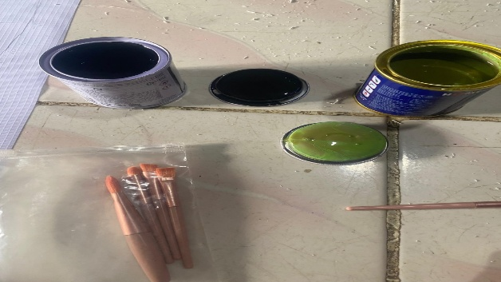
Figure 1. Tools for Making Game Boards

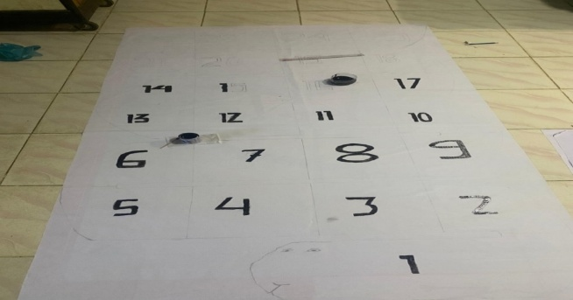
Figure 2. Game Board Making Process
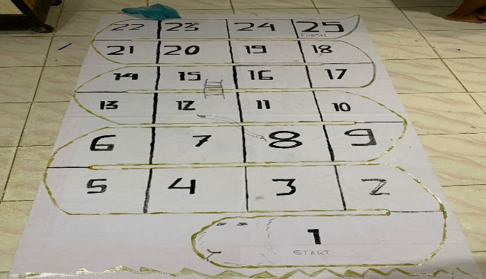
Figure 3. Game Board
Figure 3 shows the finished Snakes and Ladders game board. The board design is neat, with clearer snakes and ladders paths and a golden border for an attractive appearance. The board is ready to be used in the probability learning process.
- Making pawns and dice
Pawns are used to mark player positions, while cube-shaped dice are used to determine moves. The dice are made from readily available cardboard. The following image shows the design of the dice used in the game of Snakes and Ladders. The dice are made from cardboard in a cube shape, large enough for students to use. Each side is decorated with colorful dots representing the numbers 1 through 6. This colorful design is intended to add interest and prevent students from getting bored while playing.

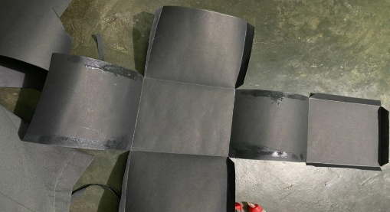
Figure 4. Dice Making Process
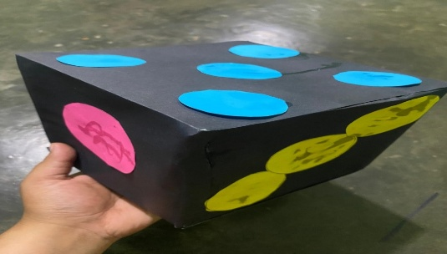
Figure 5. Dice
Figure 5 shows dice initially made from black cardboard without any numbered dots attached. After this process is complete, colored dots are attached to complete the sides of the dice. This manual manufacturing process demonstrates that dice can be made from simple and affordable materials.
- Designing question cards
Question cards are a crucial component of this snakes and ladders game. They are designed in different colors to enhance visual appeal and differentiate the difficulty levels. Each card contains a question related to probability, ranging from determining sample spaces, simple events, the probability of an event, to its application in everyday life. The use of varied colors not only creates a fun atmosphere but also helps students become more enthusiastic about answering the questions. Furthermore, the cards are designed to be small in size for practical use and easy distribution during the game.

Figure 6. Question Card Design
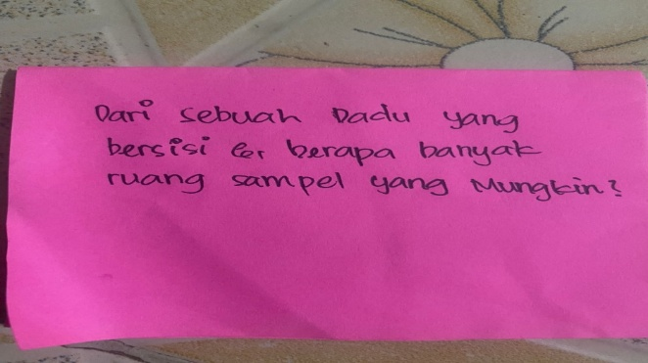
Figure 7. Question Card

  - Develop
This stage aims to produce learning media and conduct feasibility tests. The activities carried out are:
- Media production
The game board, consisting of snakes and ladders, pawns, dice, and question cards, was successfully created. The game board was designed in color to attract students' attention.
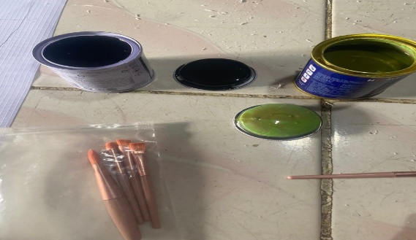
Figure 8. Tools for Making Game Boards
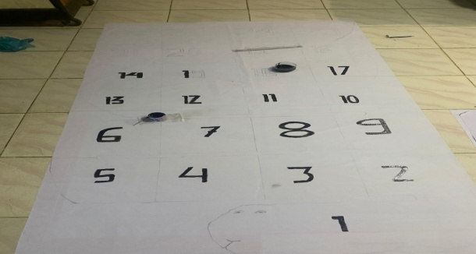
Figure 9. Game Board Making Process
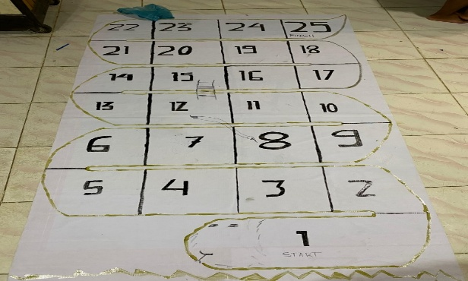
Figure 10. Game Board
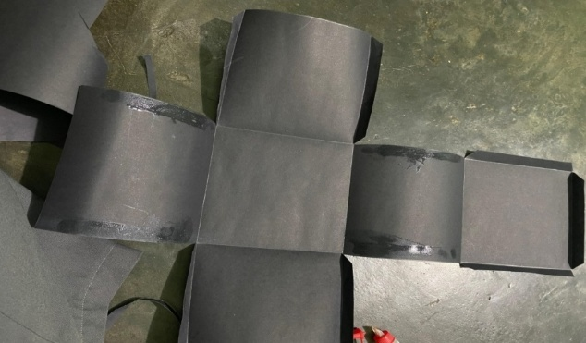
Figure 11. Dice Making Process
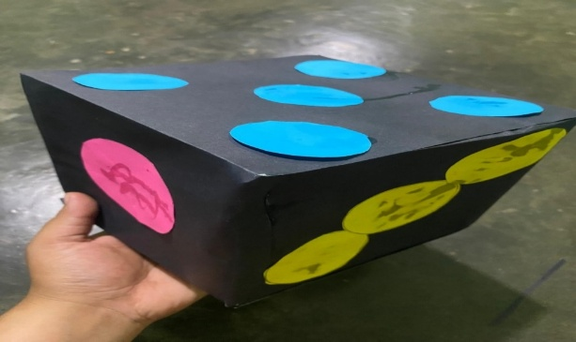
Figure 12. Dice

Figure 13. Question Card Design
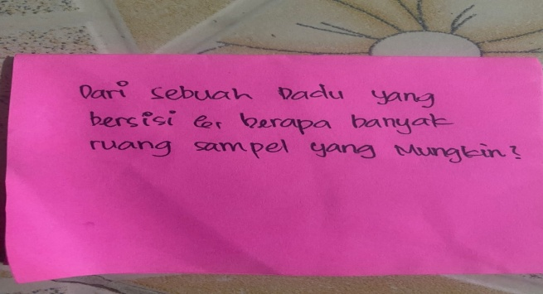
Figure 14. Question Card
The validity analysis of educational game learning media is carried out by processing validation data, including assessments from media experts and validation of materials by material experts, as explained below:
    - Media validity analysis
The media validation results were provided by Mrs. Suci Dahlya Narpila, M.Pd. Below is a table of media expert validation scores.
Table 2. Media Validation Results
No. | Assessment Aspects | Alternative Options
No. | Assessment Aspects | 4 | 3 | 2 | 1
1. | The media has an attractive and student-friendly design. | $$√$$
2. | The layout is neat and uncluttered. | $$√$$
3. | The media facilitates student active participation in playing while learning. |  | $$√$$
4. | Game instructions are easy for students to understand. | $$√$$
5. | Game components (board, dice, question cards, and pieces) mutually support learning objectives. |  | $$√$$
6. | The media can be used practically in classroom learning. |  | $$√$$
Total |  | 87,5%

Validity percentage (%) = $\frac{observed scores}{expected score}$ × 100%
Validity percentage (%) = $\frac{21}{24}$ × 100% = 87,5%
    - Media Validity Analysis by Material Experts
The material validation process was carried out by Ms. Indiyani Br Sembiring, S.Pd Gr as the validator. Below is a table of validation scores from material experts.
Table 3. Material Validation Results
No. | Assessment Aspects | Alternative Options
No. | Assessment Aspects | 4 | 3 | 2 | 1
1. | M Materi yang disajikan sesuai dengan Kompetensi Dasar pada kurikulum SMP | $$√$$
2. | Indikator pembelajaran sesuai dengan tujuan pembelajaran matematika | $$√$$
3. | Soal yang digunakan mencakup berbagai level kognitif siswa | $$√$$
4. | Media menyajikan konsep peluang secara bertahap dan sistematis | $$√$$
5. | Konsep matematika pada isi atau soal seusia dengan media | $$√$$
6. | Penulisan dan simbol matematika sesuai dengan kaidah yang benar |  | $$√$$
Total |  | 95,83%

Validity percentage (%) = $\frac{observed scores}{expected score}$ × 100%
Validity percentage (%) = $\frac{23}{24}$ × 100% = 95,83%

- Media Effectiveness Results
After all validations have been carried out with appropriate results, the snakes and ladders educational game media can be tested on students. Before the snakes and ladders educational game is given to students, the activity carried out is a pre-test to measure students' knowledge of the material of probability. After the pre-test activity, a discussion of questions is carried out to deepen students' knowledge and an explanation and game of the snakes and ladders educational game is carried out. After that, the snakes and ladders educational game is carried out with a duration of approximately 30 minutes. After the material delivery activity, a post-test is given as a learning evaluation. After the post-test is completed, an effectiveness test is carried out. The effectiveness test is carried out to determine whether the snakes and ladders educational game media that has been developed is able to improve student learning outcomes. Effectiveness is tested by comparing students' pre-test and post-test scores before and after using the media. Data analysis is carried out using the N-Gain test through the help of SPSS software, namely:
Table 4. N-Gain Test Results
Descriptive Statistics
 | N | Minimum | Maximum | Mean | Std. Deviation
NGain_Score | 30 | ,25 | ,96 | ,7652 | ,17080
NGain_Persen | 30 | 25,00 | 96,49 | 76,5238 | 17,07964
Valid N (listwise) | 30

Based on the results of data analysis using the N-Gain test, information was obtained regarding the improvement in student learning outcomes after learning using the snakes and ladders media. The number of subjects analyzed was 30 students. The calculation results showed that the minimum N-Gain value was 25, while the maximum value reached 96. The average student N-Gain score was 76.52 with a standard deviation of 11.08. If converted into percentage form, the average increase in student learning outcomes was 76.52% which is included in the high category. Thus, it can be concluded that the snakes and ladders learning media developed is effective in improving student learning outcomes on the material of probability.
  - Disseminate
The dissemination stage is the final stage of the 4D development model (Define, Design, Develop, and Disseminate). It aims to disseminate the developed learning media to determine its practicality and effectiveness in other schools. Dissemination was conducted on a limited basis at the Thafiz Al-Habibi Islamic Boarding School, involving 23 eighth-grade students and one mathematics teacher. This stage was carried out after the media was declared valid and feasible based on expert testing and a trial at the first school, SMP 17 Agustus Tiga Juhar.
In this stage, learning activities were carried out using the Snakes and Ladders educational game on probability. Prior to the lesson, the researcher explained to the teacher and students how to play, the rules, and the purpose of using the media. The learning process was conducted in groups of 3–4 students. Students took turns rolling the dice, moving their pawns on the game board, and answering questions on the game cards according to the numbers they received. The teacher acted as a facilitator throughout the learning process. The average percentage of responses from all media trials was 86.25%, categorized as very practical.
After the learning process was completed, researchers distributed practicality questionnaires to teachers and students. Based on the data recapitulation, students responded to the media at an average of 86.25%, categorized as very practical, while teachers responded at 87.5%, categorized as very practical. These results indicate that the Snakes and Ladders Educational Game learning media is easy to use, engaging, and able to increase student active participation in learning activities.
Students responded positively to the media because the Snakes and Ladders game made the learning environment more enjoyable and less monotonous. They felt challenged by answering the probability questions on the game cards and found it easier to understand the concepts of sample spaces and events because they were directly practiced through the game. Teachers also positively commented that the media was easy to use in the classroom, time-efficient, and able to foster positive interactions among students. These results reinforce the results of the previous practicality test at the first school, which indicated a "very practical" category. Therefore, this media is considered suitable for widespread use in other schools without requiring significant adjustments.
An effectiveness test was conducted to determine whether the developed snakes and ladders educational game media could improve student learning outcomes. Effectiveness was assessed by comparing students' pre-test and post-test scores before and after using the media. Data analysis was performed using the N-Gain test using SPSS software, as follows:
Table 5. N – Gain Test Results
Descriptive Statistics
 | N | Minimum | Maximum | Mean | Std. Deviation
NGain_Score | 23 | ,22 | ,89 | ,6542 | ,15060
NGain_Persen | 23 | 22,00 | 89,41 | 65,4238 | 15,06964
Valid N (listwise) | 23
Based on the results of data analysis using the N-Gain test, information was obtained regarding the improvement in student learning outcomes after learning using the snakes and ladders media. The number of subjects analyzed was 23 students. The calculation results showed that the minimum N-Gain value was 22, while the maximum value reached 89. The average student N-Gain score was 65.42 with a standard deviation of 15.06. If converted into percentage form, the average increase in student learning outcomes was 65.42% which is included in the moderate category. Thus, it can be concluded that the snakes and ladders learning media developed is effective in improving student learning outcomes in the material of probability.
Discussion
Based on the research conducted, the development of a Snakes and Ladders educational game for probability in eighth-grade junior high school resulted in a valid, practical, and effective learning medium for use in the learning process. Validation by media experts showed a score of 87.5%, categorized as very valid, while validation by material experts reached 95.83%, categorized as very valid. This demonstrates that the Snakes and Ladders educational game met the eligibility criteria in terms of content, appearance, and suitability to learning objectives. This medium was deemed visually appealing, easy to use, and relevant to the characteristics of junior high school students who enjoy game-based learning activities. These findings also align with Heinich's opinion in Arsyad (2017), which states that learning media serves to clarify message presentation and encourage student engagement in learning. With its colorful design, neat layout, and easy-to-understand instructions, the Snakes and Ladders educational game creates a fun learning environment and encourages students to be more active in understanding the concept of probability, which has previously been considered abstract.
The results of the practicality test indicate that the developed media is very easy to use for both teachers and students. Based on the results of a questionnaire administered to 30 students and one mathematics teacher, an average practicality rating of 87% was obtained from students and 93.37% from teachers, which falls into the very practical category. This figure indicates that the Snakes and Ladders educational game is easy to understand, does not require much additional equipment, and can be directly implemented in classroom learning. Furthermore, learning activities using this game can also increase student motivation and engagement during the learning process.
This aligns with Hamalik's opinion in Isran and Rohani (2018) that the use of learning media can stimulate interest, motivation, and stimulate student learning activities. This media also successfully fosters a collaborative atmosphere, where students work together and interact positively in groups, resulting in a more lively and meaningful learning environment. The results of a follow-up trial at the dissemination stage at the Tahfiz Al-Habibi Islamic Boarding School also supported these findings, as the media continued to demonstrate a high level of practicality even when implemented in a different school environment.
Furthermore, the results of the effectiveness test showed that the use of the Snakes and Ladders educational game had a positive impact on improving student learning outcomes. Based on the N-Gain test results, the average learning outcome increase was 76.52%, which is considered high. This means that students experienced a significant increase in understanding after learning using this media compared to before using the media. This improvement was due to students actively thinking, discussing, and practicing solving probability problems on the playing cards during play.
This play-while-learning activity aligns with Piaget's constructivism theory, which emphasizes that knowledge is built through direct experience and active student involvement in the learning process. Through this game, students not only memorize concepts but also experience the process of understanding probability in a concrete and enjoyable context. The results of this study also align with the findings of Rizki Fadil (2023), who showed that the use of the Snakes and Ladders educational game was effective in improving students' mathematical comprehension, with an effectiveness rate above 80%. This reinforces the notion that game-based media can be an innovative alternative in mathematics learning.
Besides being proven valid, practical, and effective, the Snakes and Ladders educational game is also relevant to mathematics learning objectives, which emphasize conceptual mastery, logical thinking skills, and the development of social attitudes such as cooperation and sportsmanship. Through this game, students learn to respect turns, accept outcomes with fair play, and work collaboratively in groups. These activities not only foster cognitive skills but also foster positive character and a strong enthusiasm for learning. This aligns with Islamic values, which place knowledge and honesty as part of worship, as stated in Surah Al-Mujadilah, verse 11, that Allah will exalt those who believe and are knowledgeable. Therefore, the development of this learning media not only supports academic aspects but also strengthens students' spiritual values ​​and character.
Overall, the results of this study demonstrate that game-based learning media, such as the Snakes and Ladders educational game, can be an effective innovation in mathematics learning, particularly for abstract topics like probability. This media can transform initially monotonous learning into something more interactive, enjoyable, and meaningful. In addition to helping students understand the concept of probability, this media also fosters logical thinking, communication, and teamwork skills. With these results, it can be concluded that the snakes and ladders educational game is suitable for use as an alternative learning media in schools and can be an inspiration for teachers to develop similar media for other mathematics materials.

CONCLUSION
The snakes and ladders educational game media on probability material has been proven valid, practical, and effective for use in learning. The validation results showed that the media obtained a score of 87.5% from media experts and 95.83% from material experts, both of which are categorized as very valid. In terms of practicality, the trial results showed a positive response with an average of 87% from students and 93.37% from teachers, which is categorized as very practical. The practicality test at the dissemination stage at the Tahfiz Al-Habibi Islamic Boarding School also strengthened these results, showing that this media is easy to understand, interesting, and able to increase student activeness in learning. In addition, this media is effective in improving student learning outcomes with an average N-Gain value of 76.52% which is categorized as high. Both at SMP 17 Agustus Tiga Juhar and at the Tahfiz Al-Habibi Islamic Boarding School, the use of this media successfully increased students' understanding of the concepts of sample space, events, and probability through interactive play-while-learning activities. Thus, the media developed meets the aspects of validity, practicality, and effectiveness, so it is worthy of being used as an alternative mathematics learning media for the probability material of class VIII SMP.

ACKNOWLEDGMENTS
- Dr. Fibri Rakhmawati, S.Si., M.Si., as the Scientific Article Supervisor who has taken the time to guide, assist, and complete the writing of this scientific article proposal until it is finished.
- To the most special, my beloved parents, father M. Ali Gurky Sembiring, mother Rita br Barus. Thank you for giving encouragement, affection, prayers, and sacrifices to complete the article report as a requirement to complete a bachelor's degree at the State Islamic University of North Sumatra Medan

REFERENCES
Arsyad. (2017). Media Pembelajaran. Jakarta: Rajawali Press.
Astami., A. M. (2023). Pengembangan Media Pembelajaran Komik Matematika Berbasis GBL Pada Materi Bangun Datar. Jurnal Pendidikan Matematika, 3(2), 123-135.
Fauzia, N. (2024). Pengembangan Media Pembelajaran Matematika Bantuan Canva pada Materi Peluang Kelas VIII SMP Negeri 4 Enkerang. Journal of Mathematics Learning Innovation, 3(2), 88-90.
Isran R., K. K. (2018). Manfaat Media Pembelajaran. Jurnal Axiom, 7(1), 94.
Komarullah. (2017). Pendidikan Matematika di Sekolah. Jurnal Pendidikan Matematika, 1(1).
Liana., S. (2015). Pengembangan Media Pembelajaran Komik Pada Materi Peluang di Kelas VIII. Jurnal Didaktik Matematika, 2(1), 16-26.
Mulia S. Riri., S. L. (2022, Agustus). Pengembangan Media Pembelajaran Matematika Berbasis Alat Peraga Pada Materi Matriks Kelas XI. Jurnal Pendidikan Matematika, 2(4), 511-516.
Rizki., F. H. (2023). Pengembangan Game Education Ular Tangga Materi Peluang Untuk Meningkatkan Kemampuan Pemahaman Matematis. J-PiMat, 5(2), 883-892.
Setiani, G. &. (2022). Permainan Ular Tangga: Media Pembelajaran Siswa Kelas V Sekolah Dasar. Mimbar Ilmu, 27(2), 262-269.
Sugiyono. (2021). Metode Penelitian Kuantitatif, Kualitatif dan R&D. Bandung: Alfabeta.
Umatin., C. (2021). Pengantar Pendidikan. Malang: CV. Pustaka Learning Centre.

